Caring for Animals Potentially Exposed to Ebola Virus

Standard Operating Guideline

Date:

Prepared By:

Signature Page

Name | Signature | Date
Wesley Bissett, DVM, PhD |  | 10-27-2014
Debra Zoran, DVM, PhD |  | 10-27-2014

I. Purpose, Scope, Situations, Limitations, and Assumptions

- Purpose: The purpose of this document is to provide a standard operating guideline (SOG) for the isolation or quarantine of companion animals potentially exposed to Ebola virus.
- Scope: This SOG covers companion animals potentially exposed to Ebola. The duration of isolation will be determined by the appropriate jurisdiction in consultation with state and federal public health authorities.
- Situation:
  - This SOG applies to the care of companion animals (dogs) potentially exposed to the Ebola virus.
- Limitations
  - The status of Ebola infection and shedding has not been established in exposed animal(s).
  - The question of whether Ebola infection occurs in dogs is currently unanswered; only indirect evidence has been documented to date.
- Assumptions
  - Care providers will work under the assumption that any companion animals associated with this incident have been exposed to, infected with, and capable of shedding Ebola virus.
  - Hazardous Material or Infectious Disease support and guidance will be provided by the local jurisdiction responsible for the response with regional or state resources requested as necessary.
  - All required materials will be provided by the local jurisdiction responsible for the response with regional or state resources requested as necessary.

II. Concept of Operations:
- Position Descriptions:
  - Veterinarian/Veterinary Assistant: Will monitor and care for potentially exposed patients consistent with Center for Disease Control and American Veterinary Medical Association (AVMA) guidelines. The number of veterinarian and assistants will be dependent on the number of animals that are potentially exposed to Ebola. A minimum of two people is required to provide safe care in this setting and will always work under the “buddy system” concept. Veterinarians and Assistants will be certified for Powered Air Purifying Respirator (PAPR) use and be experienced in the use of the personal protective equipment (PPE) described in this document.
  - Hazardous Material/Infectious Disease personnel: The number of personnel required is dependent on the number of animals being cared for and the number of veterinarians providing care. Responsibilities include overseeing that all operations are performed in a manner consistent with protection of the health and well being of care-givers and assisting with donning of personal protective equipment and movement of biomedical waste/samples from the quarantine to the holding facility laboratory.

- Transition of animal patient to isolation: The decision to isolate animals that may have been exposed to Ebola will be made by the appropriate jurisdiction in consultation with state and federal public health authorities. If isolation is ordered, the following steps will be taken.
  - The controlling jurisdiction will ensure that any issued legal documents properly crafted and served. The animal(s) will be sheltered in place pending location of a suitable quarantine facility.
  - Properly trained personnel wearing appropriate PPE will be responsible for moving the animal from the owner’s home to the transportation modality used for delivery of the animal(s) to the quarantine facility.
    - The PPE referenced above shall be that recommended in HazMat protocols and/or the advising/regulatory agencies.
  - If the animal is wearing a collar, it will be removed and remain in the home as will all toys, food and water bowls, and bedding; nothing but the dog will transported.
  - All dogs will have a muzzle placed for the duration of decontamination. Decontamination of other species of animals will occur under the supervision of a veterinarian with experience with the species in question.
  - Decontamination:
    - The location used for decontamination will be immediately adjacent to an exit point. An example of a decontamination area set up is provided as Attachment 1.
    - The animal is to be decontaminated in a unit (decontamination station 1) capable of containing all wastewater. The disposition of the animal may require that a licensed veterinarian sedate the animal.
    - The animal will be soaked with water to insure that the coat is thoroughly wetted.
    - A disinfectant soap appropriate for the species of animal being decontaminated will then be applied to the entire animal working from a cranial to caudal and dorsal to ventral direction with particular attention paid to the pads of the feet.
    - The animal will then be thoroughly rinsed working from a cranial to caudal and dorsal to ventral direction.
    - Personnel performing the animal decontamination will then spray outer suits with Virkon S™, remove outer (third) layer of gloves, and wipe down second layer with Bleach wipes.
    - The animal will then be moved to decontamination station 2 and the decontamination process repeated.
    - The animal will then be moved to the drying station and towel dried.
    - The animal will then be moved to an airline/kennel cab type container located immediately outside the building’s exterior door (clean zone).
    - If the temperature is below 65 degrees, then the animal will be thoroughly dried by a hair/kennel dryer before transport.
    - The airline/kennel cab-type container will be moved to the transporting vehicle by HazMat personnel wearing PPE as deemed appropriate by the HazMat/Infectious Disease personnel providing oversight.
    - The driver of the vehicle is not to be involved in loading the kennel into the vehicle and will remain in the driver’s seat throughout the process described above.
  - Transportation.
    - The vehicle used for transportation will provide an enclosed stainless steel area designed for transport of animals and allowing for separation of the animal containment area from the driver’s compartment.
    - It is suggested that police escort be provided for the vehicle as it moves from the patient’s residence to the quarantine facility
    - HazMat personnel will move the airline/kennel cab-type container into the quarantine facility immediately upon arrival.
  - Vehicle decontamination.
    - The vehicle will be decontaminated at a location where wastewaters can be contained and appropriately disposed of.
    - The area where the animal was transported will be sprayed with Virkon S™ and contact time maintained for a minimum of 10 minutes.
    - The animal containment area will then be thoroughly rinsed.
    - The area will then be sprayed and maintained wet with a dilute (1:10) bleach solution during a contact time of ten minutes at a minimum.
    - The area will then be thoroughly rinsed.
- Facility set-up: The facility set-up described below is provided as general guidance. The approach may be altered dependent on the specific layout of the facility to be used. The layout of the facility is as depicted in Attachment 2. The hot and warm zones will be two separate rooms connected via a doorway. The warm and clean zones will be two separate rooms separated by a door or cased opening.
  - Clean zone: The clean zone serves as an area free of potential Ebola virus contamination and includes the exit point from the quarantine facility.
  - Warm zone: The warm zone will be used for phased decontamination beginning at the entryway to the hot zone and ending at the entryway into the clean zone. Tarps or plastic sheeting will be placed on the floor and extend up walls for a minimum of 12 inches to limit contamination. Tarps will be attached to floors and walls with chem tape or equivalent. Tarps will be sprayed with Virkon S™ once per day. Required supplies are as follows:
    - Boot and glove soaking station: Filled with 2.5 gallons of bleach water (10% solution in ~ 15 gallon muck bucket)
    - Biohazardous waste receptacle 1: used for disposal of Chemsuits.
    - Virkon S™ spray station. (Mixed according to manufacture recommendations provided as Attachment 3). Spray with 1-2 gallon pump-up sprayer in standard kiddie pool.
    - Biohazardous waste receptacle 2: used for disposal of MAXAIR™ shrouds and inner gloves.
    - Doffing area. (standard kiddie pool.)
    - Final boot and glove soaking station.
    - Clorox Clean-up™.
    - Clorox wipes™.
    - Water absorbent pads.
    - Biohazardous waste bags.
  - Hot Zone: The patient will be housed in the hot zone. Tarps or plastic sheeting will be in place to limit contamination. Tarps will cover all floor services and be attached to the wall. Required supplies are as follows:
    - Kennel(s).
    - Biohazard bags and containers.
    - Water absorbent, plastic backed pads.
    - Species appropriate food.
    - Species appropriate kenneling supplies.
    - Water.
    - Leashes if needed to move patients from dirty to clean kennels.
    - Virkon S™ spray
- Personal Protective Equipment:
  - MAXAIR™ 2000-800 PAPR or equivalent (1 per person).
  - MAXAIR™ 800 hoods (2000-25DMA). Single use hoods.
  - Lakeland ChemMax™ 1 coverall Style C5545ORE or equivalent.
  - Onguard Industries HazMax EZ Fit boot, 87015=OS or equivalent.
  - Nitrile Examination gloves (inner gloves) – preferably long cuff.
  - Chemical proof outer gloves.
  - Chem tape.
- Pre-entry planning.
  - Review operational period objectives.
  - Complete Operational Period Objectives and Task List (Attachment 4).
  - Acquire and organize supplies necessary for meeting operational period objectives and completing entry tasks.
- Pre-entry responder examination.
  - Take and record temperature of each responder twice daily in the Daily Log (Attachment 5).
- PPE Donning. Donning of personal protective equipment will be most efficient and effective when hazardous material personnel assist in the donning process.
  - Don scrubs.
  - Prepare chem tape strips for sealing suit.
    - Wrists: tape length is approximately the distance from fingertips to elbow with a fold-over tab.
    - Ankles: tape length is approximately arm length with a fold-over tab.
    - Zipper security: approximately 6 inches in length with fold-over tab.
    - 4 inch piece to attach to zipper handle.
  - Attach MAXAIR™ 800 hood to MAXAIR™ 200-800 PAPR.
  - Step into ChemMax™ 1 coverall.
  - Ensure that feet are inserted to the tip of the foot-piece and step into chemical resistant boots – pull up on the suit to provide an appropriate length of suit to form the blouse.
  - “Blouse” pants legs over top of boots and seal with chem tape.
  - Attach MAXAIR™ battery to belt and plug in MAXAIR 2000-800 PAPR – assure that a minimum of one green light is on and that air-flow is on high.
  - Complete donning ChemMax™ 1 cover-alls.
  - Don MAXAIR™ 2000-800 PAPR.
  - Ensure that battery pack cord is completely concealed under ChemMax™ coverall and MAXAIR™ hood – so that cord is running directly behind neck and is tucked into belt or scrubs to secure.
  - Zip-up ChemMax™1 Coverall.
  - Place chem tape on zipper handle.
  - Seal flap over zipper by removing adhesive covering and pressing flap down.
  - Place 6” chem tape across the top of the zipper. Each utilization of chem tape requires that the free end of tape be doubled over on itself to create a tab for rapid removal.
  - Don nitrile examination gloves and seal with chem tape. Application of tape needs to seal the sleeve/glove interface without being tight enough to cause discomfort or overly impact wrist movement (assure tape is sealed all around to reduce leaks and pull on sleeve to assure that tape is firmly attached and will not release with movement).
  - Don chemical resistant gloves over the nitrile gloves and sleeves and seal with outer gloves and sleeve with chem tape. Application of tape needs to seal the sleeve/glove interface without being tight enough to cause discomfort or overly impact wrist movement (assure tape is sealed all around to reduce leaks and pull on sleeve to assure that tape is firmly attached and will not release with movement).
  - Wrap hood straps around neck on PAPR hood and tie securely enough to prevent material from going under hood but loosely enough for head movement and comfort.
  - Hazardous material personnel perform examination and complete PPE Donning Check-off list (Attachment 6).
  - Move to quarantine facility and take clean boots (easy to don knee high rubber boots) for quarantine facility exit to the clean area.
- Entering quarantine facility.
  - Entry into quarantine facility requires that personnel utilize a buddy system.
  - Document entry time in Daily log (Attachment 5).
  - Personnel entering quarantine facility perform a final PPE inspection of “buddy’s” PPE just prior to entry.
  - Person performing animal care will enter, proceed through the warm zone and enter the hot zone to perform animal care operations.
  - Second person (Safety/Decon) will observe the person that is performing animal care operations and organize and clean the warm zone.
    - Remove tape from wrists and ankles of ChemMax™ 1 suits utilized in the prior entry.
    - Place boots and gloves in Virkon S™ boot and glove soaking station.
    - Discard ChemMax™ 1 coveralls in PPE disposal receptacle.
    - General clean up of area to assure floor / area is clean and dry.
    - Assure that there are plenty of bleach wipes ready for use by doffing area and that Virkon S™ spray is functional.
    - Replace and replenish dilute bleach water at boot and glove soaking station at 24 hour intervals.
- Animal care operations.
  - Observe patient in kennel upon entry.
  - Inspect kennel for urine, feces, or other body fluids.
  - Open kennel and allow patient to exit and eliminate on plastic mat.
  - Note appearance of feces and urine.
  - Spray urine or feces with Virkon S™ and place blue, plastic backed pee pad (plastic side up) over urine or feces.
  - In the event of lack of patient cooperation or need for safety while cleaning kennel, move patient from dirty kennel to clean kennel to facilitate cleaning and rehab of the patient kennel or floor area.
  - Discard pee pad with waste in biohazard bag.
  - Remove lid from black five gallon bucket, place biohazard bag containing animal waste in the bucket and replace lid.
  - Apply Virkon S™ spray on location of elimination and allow 10 minutes prior to removal.
  - Wipe up with a blue, plastic-backed pee pad, plastic side up ensuring that gloved hands contact only the plastic, non-contaminated portions of the pee pad.
  - Place pee pad in biohazard bag and place in five-gallon biohazard bucket. Reseal lid.
  - Remove food and water bowls from kennel.
  - Dispose of water in waste receptacle for fluids. Waste receptacle contains a water absorbent pad capable of holding approximately 1-2 gallons of water or fluid.
  - Fill water bowl sufficient to provide adequate water for the next inter-examination period, but attempt to reduce chance of water spillage from activity (< ¾ full). Place on absorbent pad in kennel to capture any spillage.
  - Fill food bowl with an appropriate type (preferably the patient’s own food) and amount of dry dog food divided into small meals to allow intake assessment. (Bentley = ~ ½ cup three times per day). Food changes, treats and other food items should not be introduced during the quarantine period to prevent/reduce gastrointestinal distress.
  - Replace bedding on an as-needed basis. Dispose of soiled bedding in a biohazard bag and place in biohazardous waste receptacle.
  - Turn lights off at dark after the last visit of the day to maintain a normal light/dark awake / sleep cycle.
  - Exit the hot zone by pushing swinging door open with a foot or elbow – avoiding touching the door with gloved hands.
  - Entry into the hot zone for animal care will be performed a minimum of three times/ day to remove feces and urine, and assure patient health, but the amount of time spent in the hot room should be kept to the minimum required to perform necessary tasks and provide care.
- PPE doffing: Doffing is a phased process that moves from the hot zone, through the intermediate zone and ends in the clean zone. The two people working in the quarantine area move serially through the process with the second person (Safety/Decon person) entering the station vacated by the first person (Hot Zone entry person).
  - Step into bleach and water (1:10 solution) boot soaking station and washes gloved hands in bleach and water (1:10 solution) hand washing receptacle. Exposure time on boots and gloves should be for a minimum of 60 seconds.
  - Exit boot soaking and glove washing station and move into Virkon S™ spray station.
  - Safety/decon person sprays their own gloved hands and pump-up sprayer with Clorox Clean-up™ and then sprays down hot zone entry person with Virkon S. Contact time is to be maintained for 10 minutes.
    - Spray to begin just below the MAXAIR™ 2000-800 hood (to avoid spraying the HEPA filter) and proceed in a top-down fashion to the bottom of the boots.
    - Safety/decon person sprays wand and sprayer handle with Clorox Clean-up™.
    - Hot zone entry person exits Virkon S™ spray station.
  - Safety/decon person enters Virkon-S™ spray station and is sprayed down as described above.
    - Spray to begin just below the MAXAIR™ 2000-800 hood and proceed in a top-down fashion to the bottom of the boots.
    - Hot zone entry person sprays sprayer wand and handle with Clorox Clean-up™.
  - Hot zone entry person steps into doffing area station, removes outer gloves, and wipes inner gloves with bleach wipes.
  - Safety/decon person unties and removes the hot zone entry person’s MAXAIR™ hood straps.
  - Safety/decon person lifts back of hot zone entry person’s MAXAIR™ hood and makes two cuts with scissors at the neck of the hot zone entry person’s ChemMax™ 1 suit and tears the suit down to the top of the boots.
  - Hot zone entry person removes ChemMax™ 1 suit without touching inside of suit. The inner gloves should remain taped to the ChemMax™ 1 suit as the suit is dropped forward/away from the kiddie pool to create a clean area to step out of boots.
  - Hot zone entry person then steps off inner area of chem suit onto water absorbent pad and then into clean boots located at the transition point into the clean area.
  - Hot zone entry person wipes down their own inner gloves thoroughly with Clorox Clean-up™.
  - Safety/decon person steps into doffing station, unties and removes MAXAIR™ 2000-800 straps, removes outer gloves, and wipes down inner gloves with bleach wipes.
  - Hot zone entry person unzips Safety/decon person’s ChemMax™1 suit and then assists in removing suit down to the top of the boots insuring to only touch the inside of the suit. Inner gloves should remain taped to the ChemMax™ 1 suit.
  - Hot zone entry person wipes MAXAIR™ 2000-800 hood attachment points with Clorox Clean-up™ wipes (provided in clean zone), disconnects attachment points and discards hood in appropriate waste container.
  - Safety/decon person steps out of chemical resistant boots and onto a clean absorbent pad, then into clean boots located at the transition point between the warm and clean zones.
  - Safety/decon person wipes MAXAIR™ 2000-800 hood attachment points with Clorox Clean-up wipes, disconnects attachment points and discards hood in appropriate waste container.
  - Both members remove gloves with technique to prevent clean surfaces being touched by outer aspects of gloves. Gloves discarded into biohazard waste receptacle.
  - Both members clean hands thoroughly with Clorox Clean-up™ wipes provided in clean zone and exit the quarantine facility.
  - If running water is available, wash hands with soap and water. (The Hensley field site does not allow for running water. Surgical hand wash is applied as an alternative.)
- Post-doffing procedures.
  - Wipe down MAXAIR™ 2000-800 and battery with Clorox Clean-up™ wipes.
  - Take and record the temperature, pulse, and respiratory rate in Responder Examination form.
  - Document exit time.
  - Debrief over quarantine entry.
  - Complete patient evaluation forms.
- Biological sample collection.
  - The collection, submission, and sampling of biological samples are to occur only under the order of the controlling jurisdiction in consultation with appropriate state and federal public health agencies. The consulted agencies will approve testing and coordinate with the patient-care team , specimens to be collected and the instructions for shipment from the collection site to the testing facility. (Federal Express Biological Substances, Category B Packing and Transportation Requirements are provided in Attachment 7).
  - The timing of sample collection and the samples to be collected at each sample collection point will be determined by the agency(ies) coordinating with the patient-care team and the testing laboratory. Animal sample collection in the 2014 Ebola incident is scheduled to occur on Days 9 and 18. Sample collection instructions are provided below:
    - 3 ml blood sample obtained using sterile technique and placed in a plastic EDTA tube sealed with parafilm.
    - 3 ml free catch urine sample obtained and placed in a sterile plastic specimen vial sealed with parafilm.
    - Collect a minimum of 3 grams of fecal material and place in a sterile specimen tube sealed with parafilm.
  - Ship samples according to recommendations as described above.
  - Report transportation tracking number to pre-identified official(s)
- Release from Quarantine.
  - Animals may be released from quarantine under a variety of different scenarios. Release from quarantine will be on orders from the controlling jurisdiction in consultation with state and federal public health authorities. The protocols for scenarios involving animals who have tested positive for Ebola virus will be as prescribed by the controlling jurisdiction in consultation with state and federal public health authorities. The protocol for release of animals who are negative for Ebola virus are as defined below (Figure provided as Attachment 8).
    - Negative results on all submitted samples on all submission dates.
      - Entry protocols for personnel will be as described above.
      - Patient will be removed from the hot zone, enter the warm zone and bathed with a disinfecting soap then rinsed thoroughly. (All supplies present in the hot zone will remain in the hot zone.)
        - The animal is to be washed in a unit capable of containing all wastewater. The disposition of the animal may require that a licensed veterinarian sedate the animal.
        - The animal will be soaked with water to ensure that the coat is thoroughly wetted.
        - A disinfecting soap safe for use on the species involved (e.g. chlorhexidine shampoo) will then be applied to the entire animal working from a cranial to caudal and dorsal to ventral direction with particular attention paid to the pads of the feet.
      - The animal will then be moved to a second washing station and washed in a second unit capable of containing all wastewater according to directions provided in 2 above.
      - The animal will then be moved to a third washing station located immediately adjacent to the transition point between the warm and cool zones and washed according to directions provided in 2 above.
      - The animal will be towel-dried and moved to the clean zone drying station.
      - Animal will be towel dried a second time prior to transport. Drying with a kennel dryer or blow dryer prior to transport will be used if the ambient temperature is below 65 degrees.
- Safety.
  - A Hazardous Material technician or Infectious Disease expert is required to be on site during all entries into the quarantine area.
  - Entry into the quarantine area requires that two people be fully suited up and enter. The hazardous material technician will be stationed where they may observe operations through a window or from the clean zone entry. The person in the hot zone and the hazardous material technician will each have dry erase boards to facilitate communication.
    - One person will enter the hot zone and provide animal care operations.
    - One person will remain in the warm zone and:
      - Observe animal care operations through entry door window.
      - Clean and organize warm zone.
        - Ensure that liquids are removed with absorbent pads.
        - Properly dispose of used PPE.
        - Ensure that bleach water soak stations are filled with fresh material.
        - Ensure that Virkon S™ containers have enough liquid to complete required decontamination.
        - Ensure that bleach wipes and Clorox Clean-up™ spray bottles are available at each station.
    - Spray gloved hands with Clorox Clean-up™ after each step of the doffing process.
    - PPE breaches:
      - Immediately cease operations, raise hand and declare loudly that a PPE breach has occurred.
      - Place a bleach wipe over PPE breach.
      - Move through the doffing process.
      - Wipe skin under the breached area with a bleach wipe.
      - Wash thoroughly with a disinfectant soap.
    - Injuries.
      - Report and record all injuries.
        - Report injuries to Incident Safety Officer.
        - Report injuries to the appropriate employer divisions.
        - Record injury on Injury Report Form (Attachment 9).
    - Security.
      - Security is to be provided by host jurisdiction at all times.
      - The quarantine building will remain locked at all times with the exception of when responders are in the building.
      - The key to the quarantine building will remain in the possession of the Security Officer.
VI. Acronyms:
- AVMA: American Veterinary Medical Association.
- EDTA: Ethylenediaminetetraacetic acid.
- HazMat: Hazardous Material.
- HEPA: High efficiency particulate air.
- PAPR: Powered Air Purifying Respirator.
- PPE: Personal Protective Equipment.
- SOG: Standard Operating Guideline.

Attachment 1
Animal Decontamination Location Set-up

Transportation Vehicle
Exterior door
Clean Zone

Airline/Kennel Cab type container

Hot Zone

Decontamination Station 1 (kiddie pool or equivalent)
Warm Zone

Decontamination Station 2 (kiddie pool or equivalent)
Transition Zone

Drying Station 1
Zones indicated on this drawing represent animal status, not facility status.
Attachment 2

Kennels
Bleach and water (1:10) Boot and Glove Soak Station 1
Virkon S Spray Station
Virkon S Boot and Glove Soak Station 2
PPE Disposal Receptacles
Medical waste receptacle
Hot Zone
Doffing Station
Warm Zone
Clean Zone
Attachment 3:
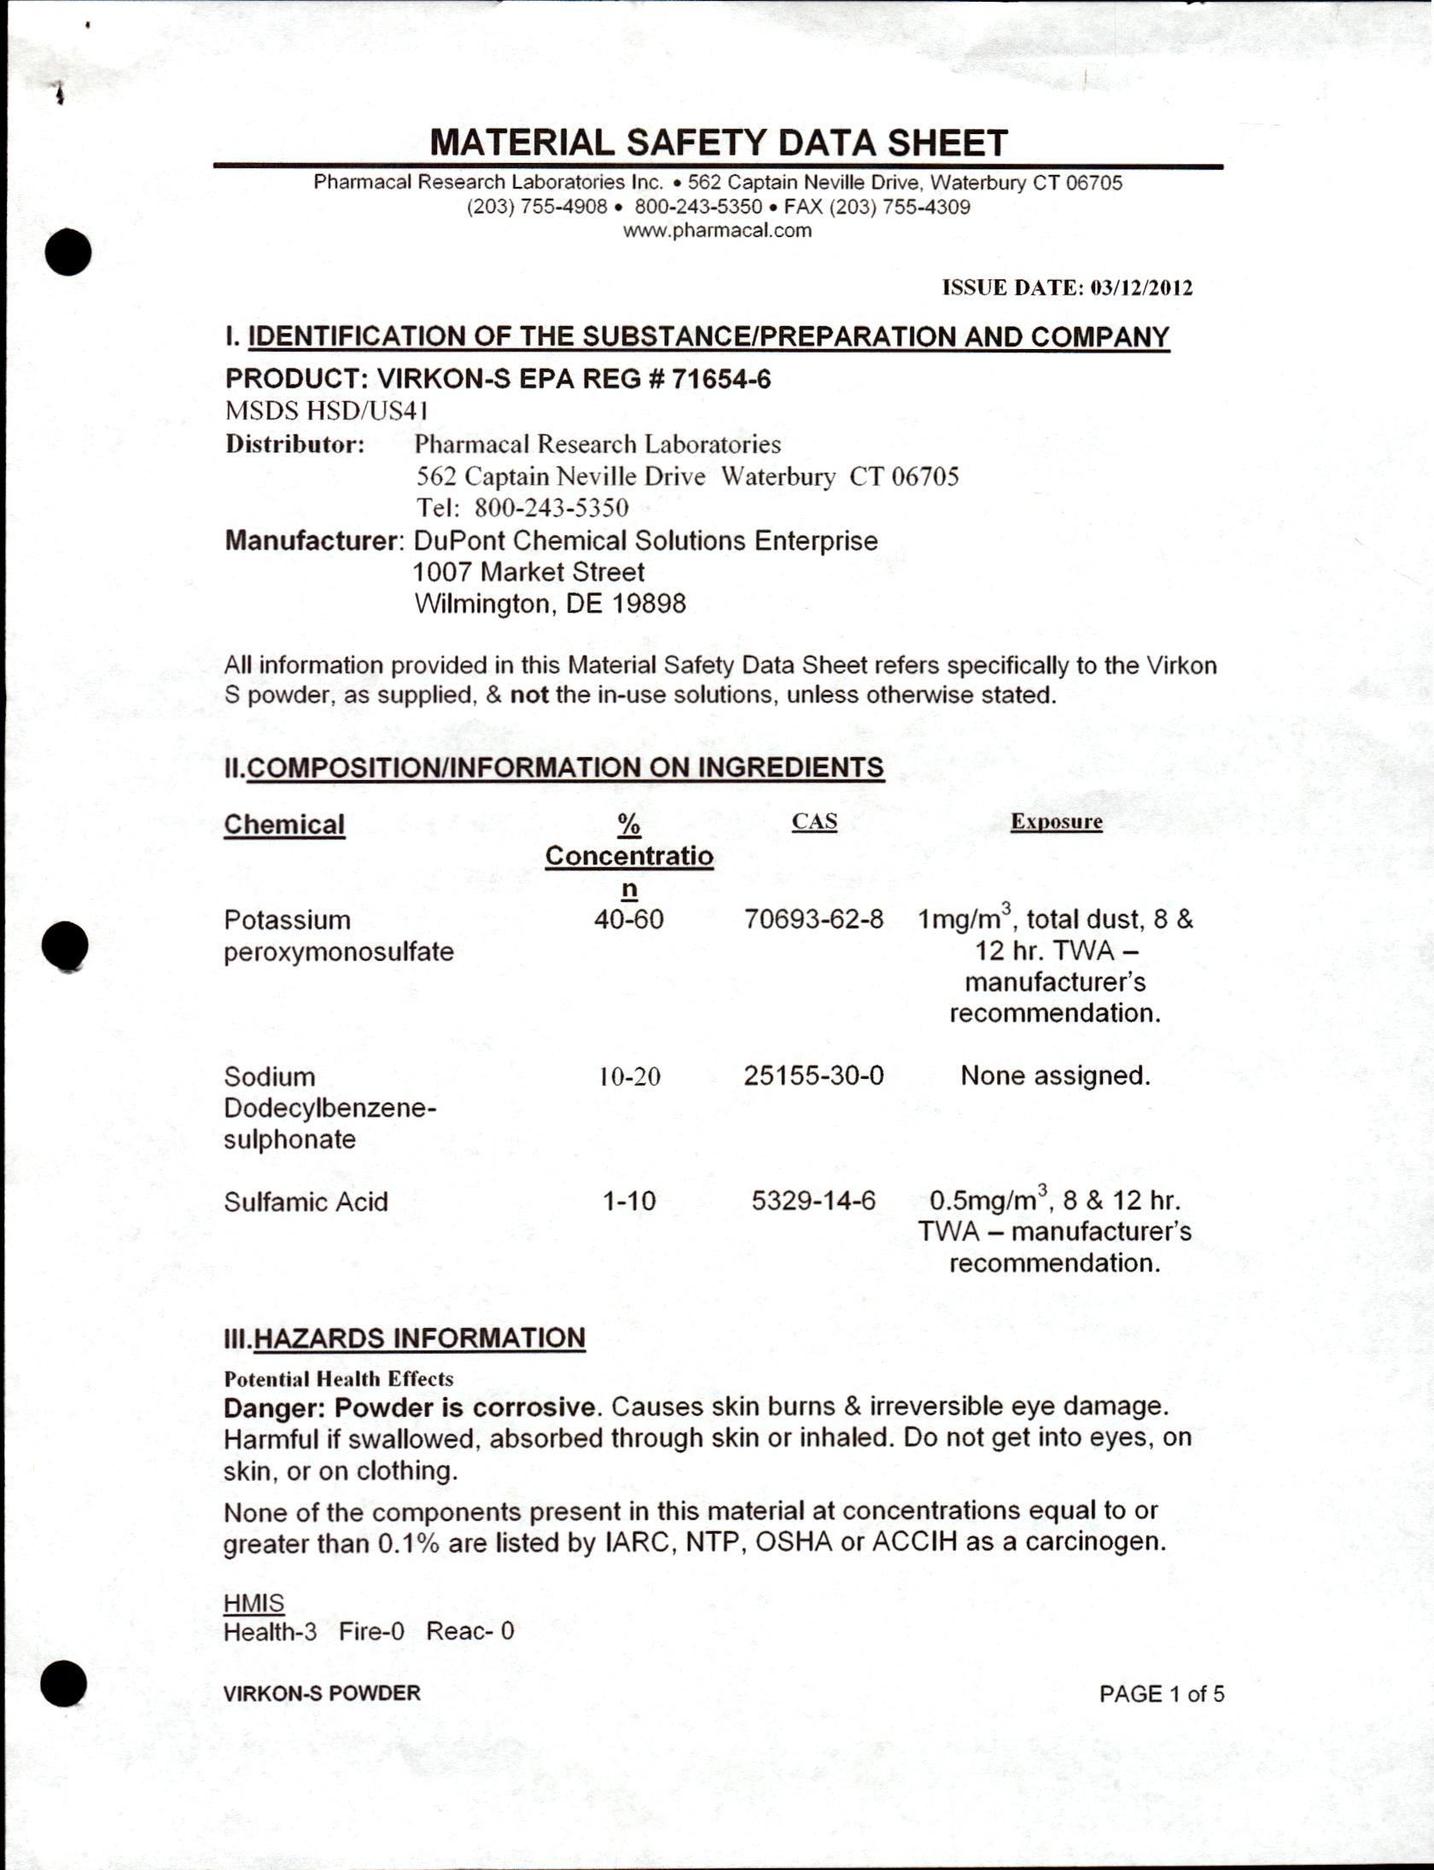
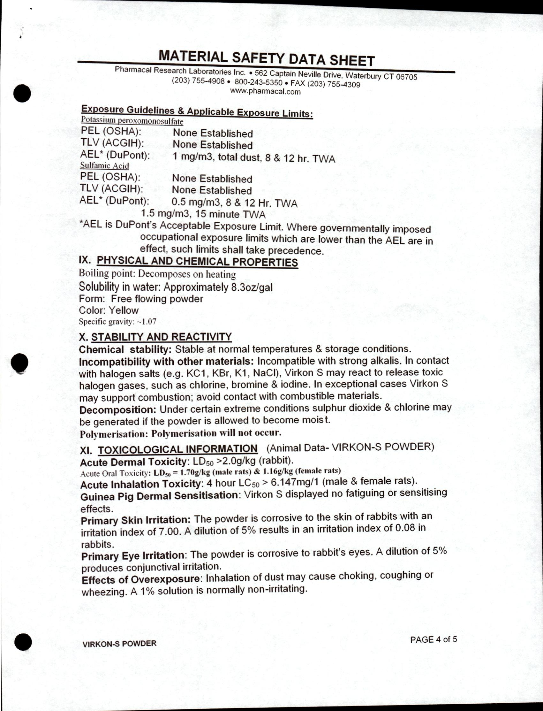
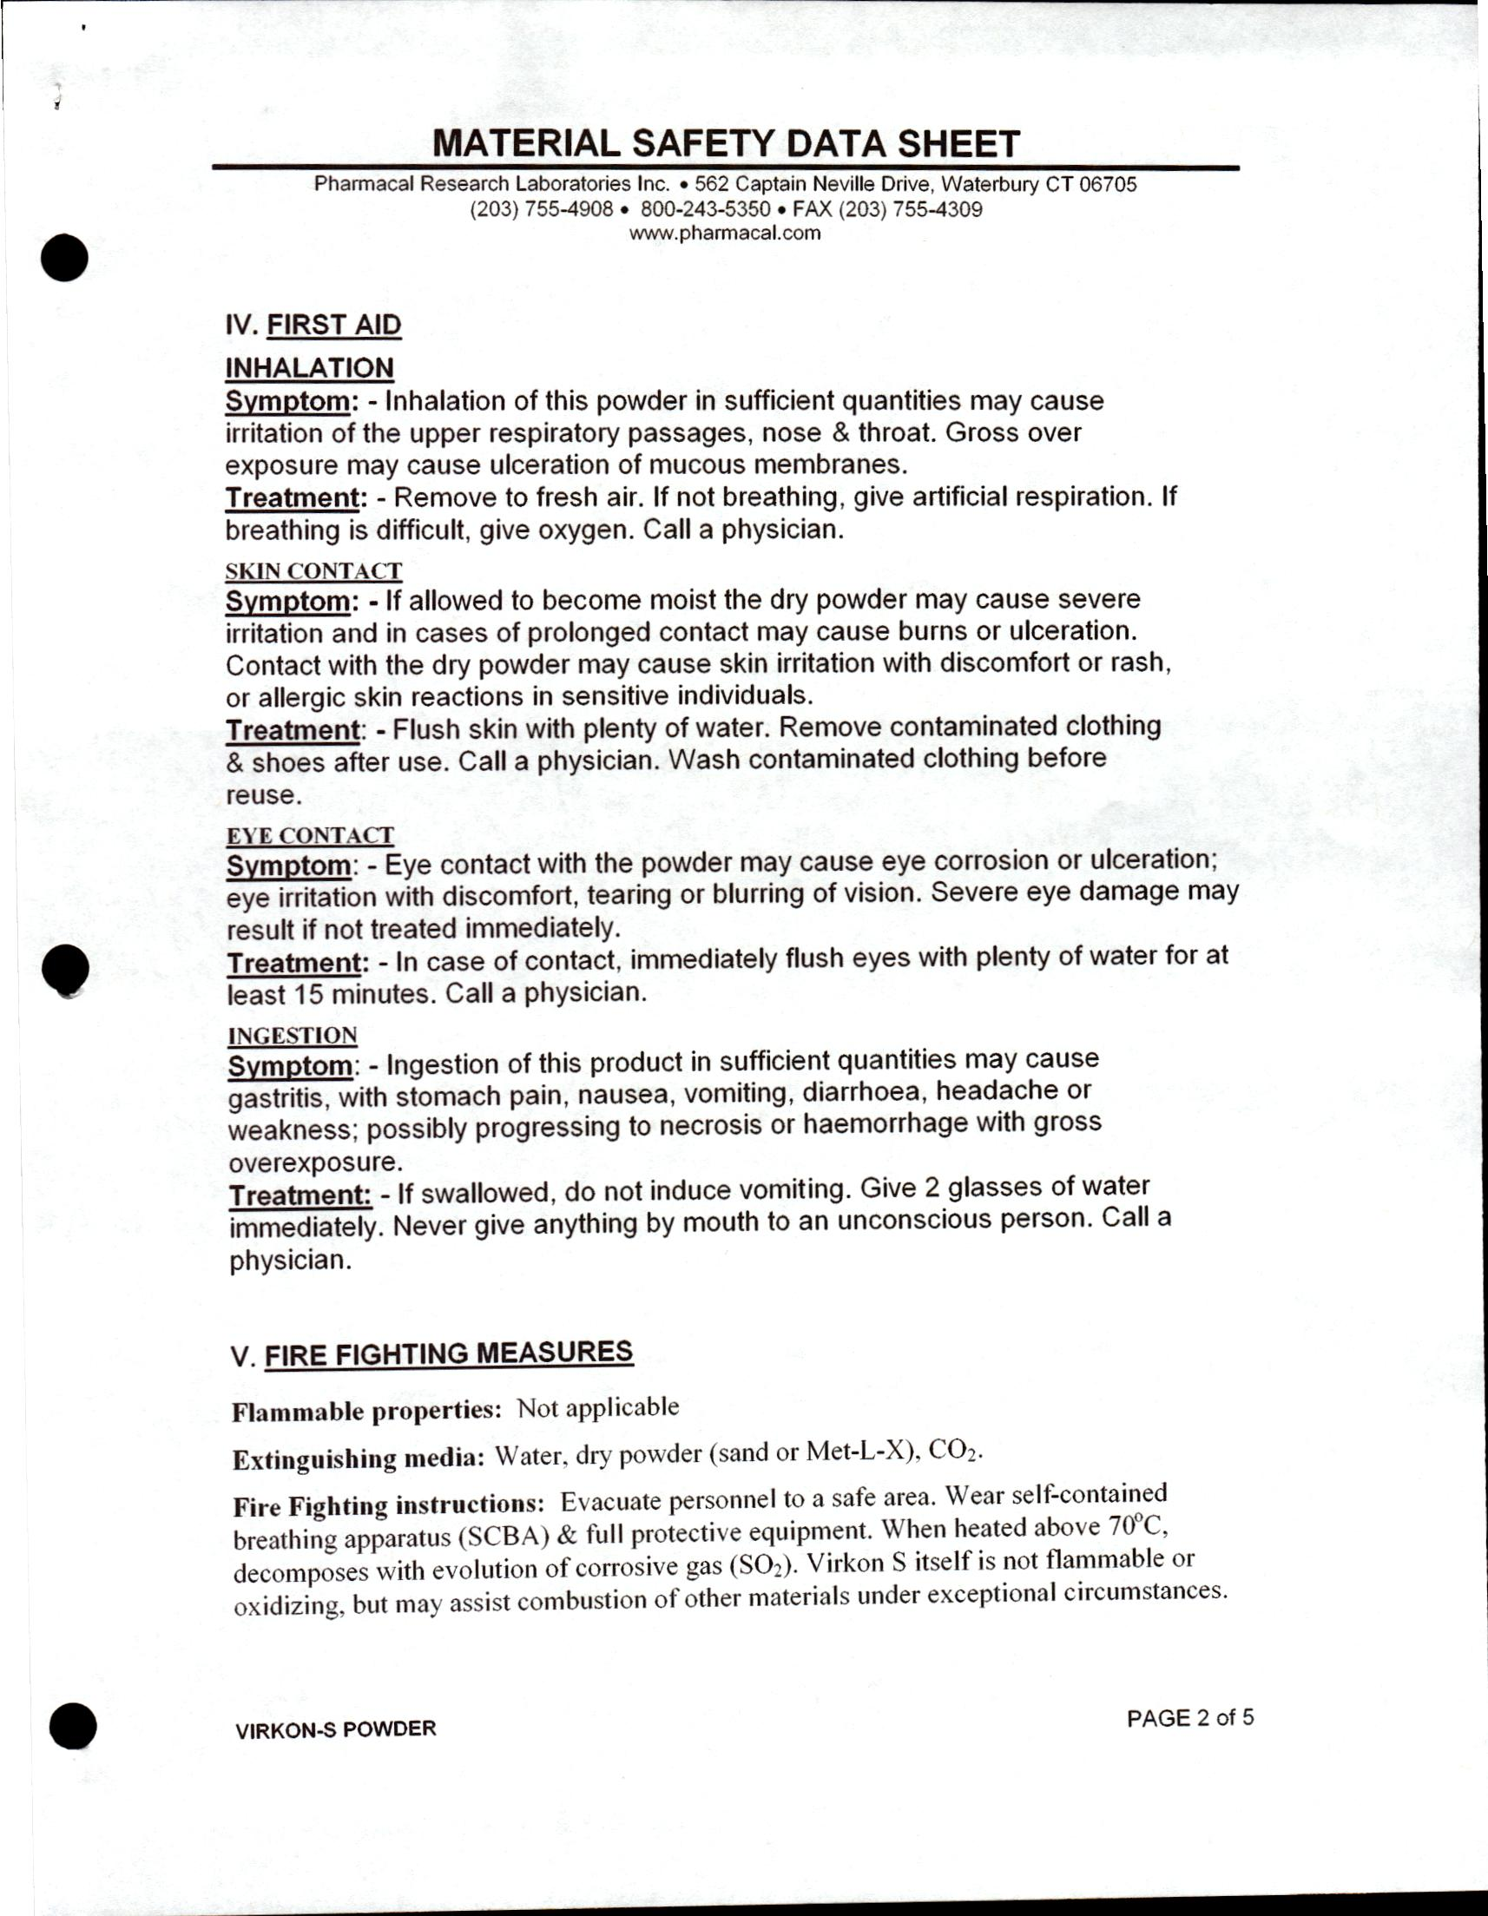
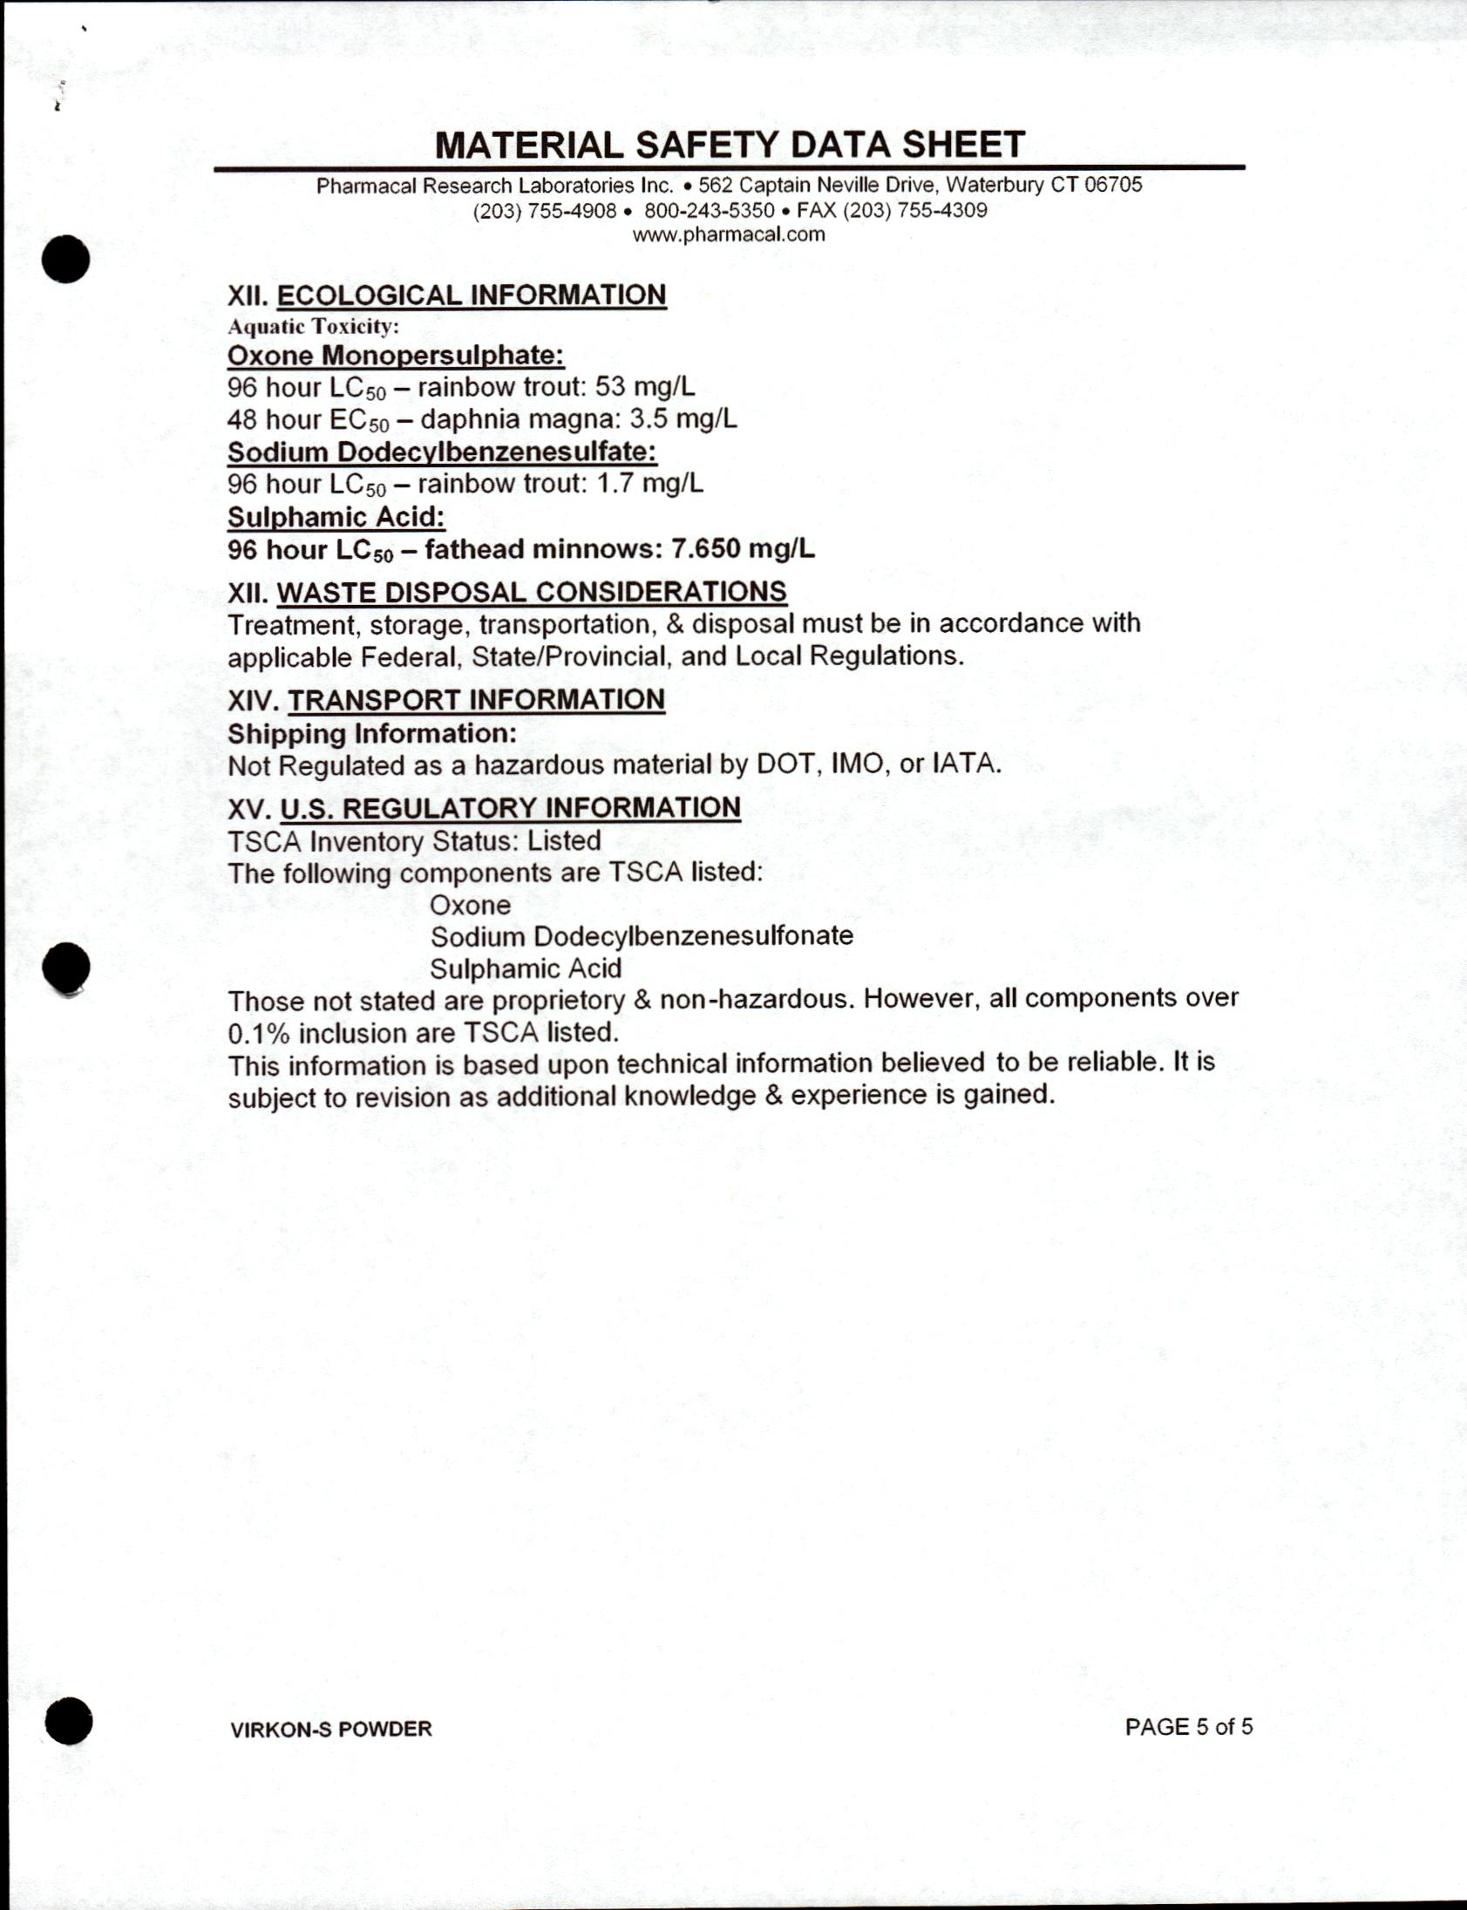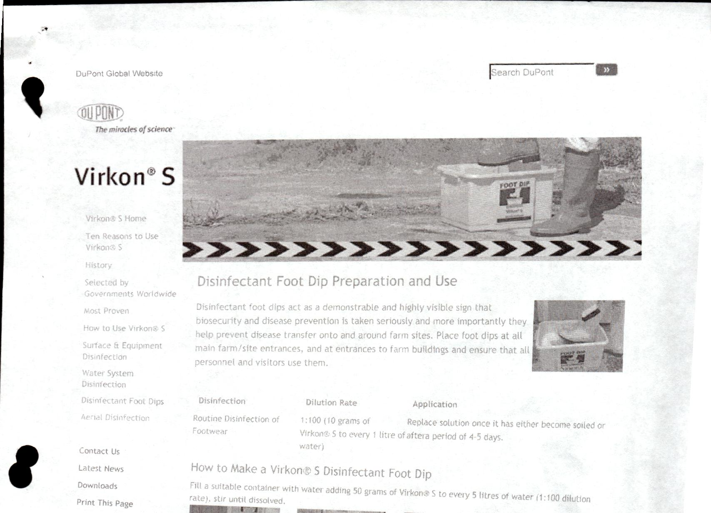
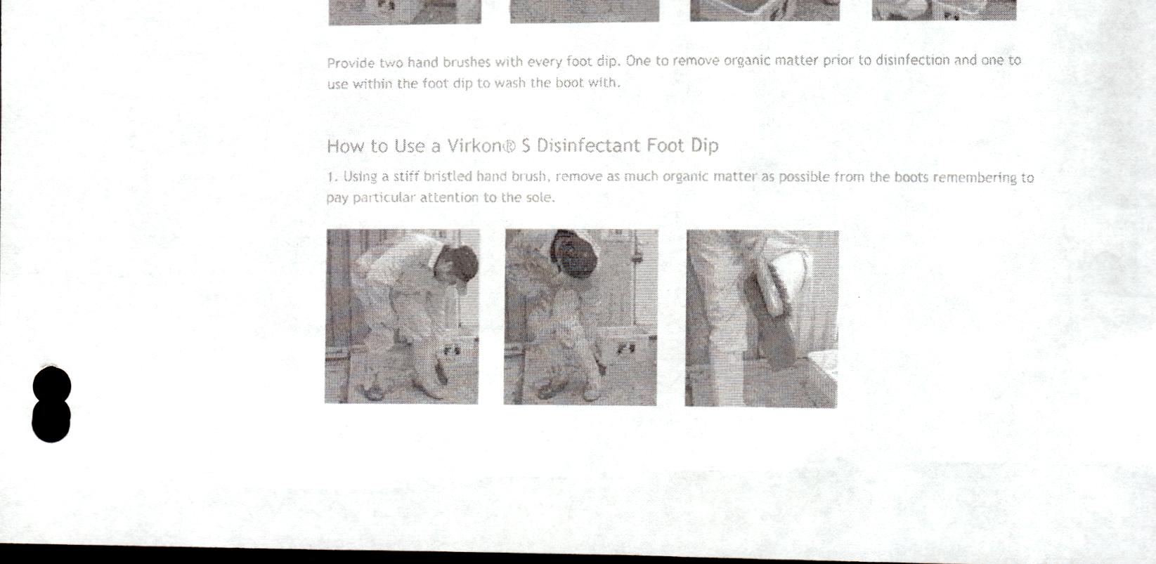
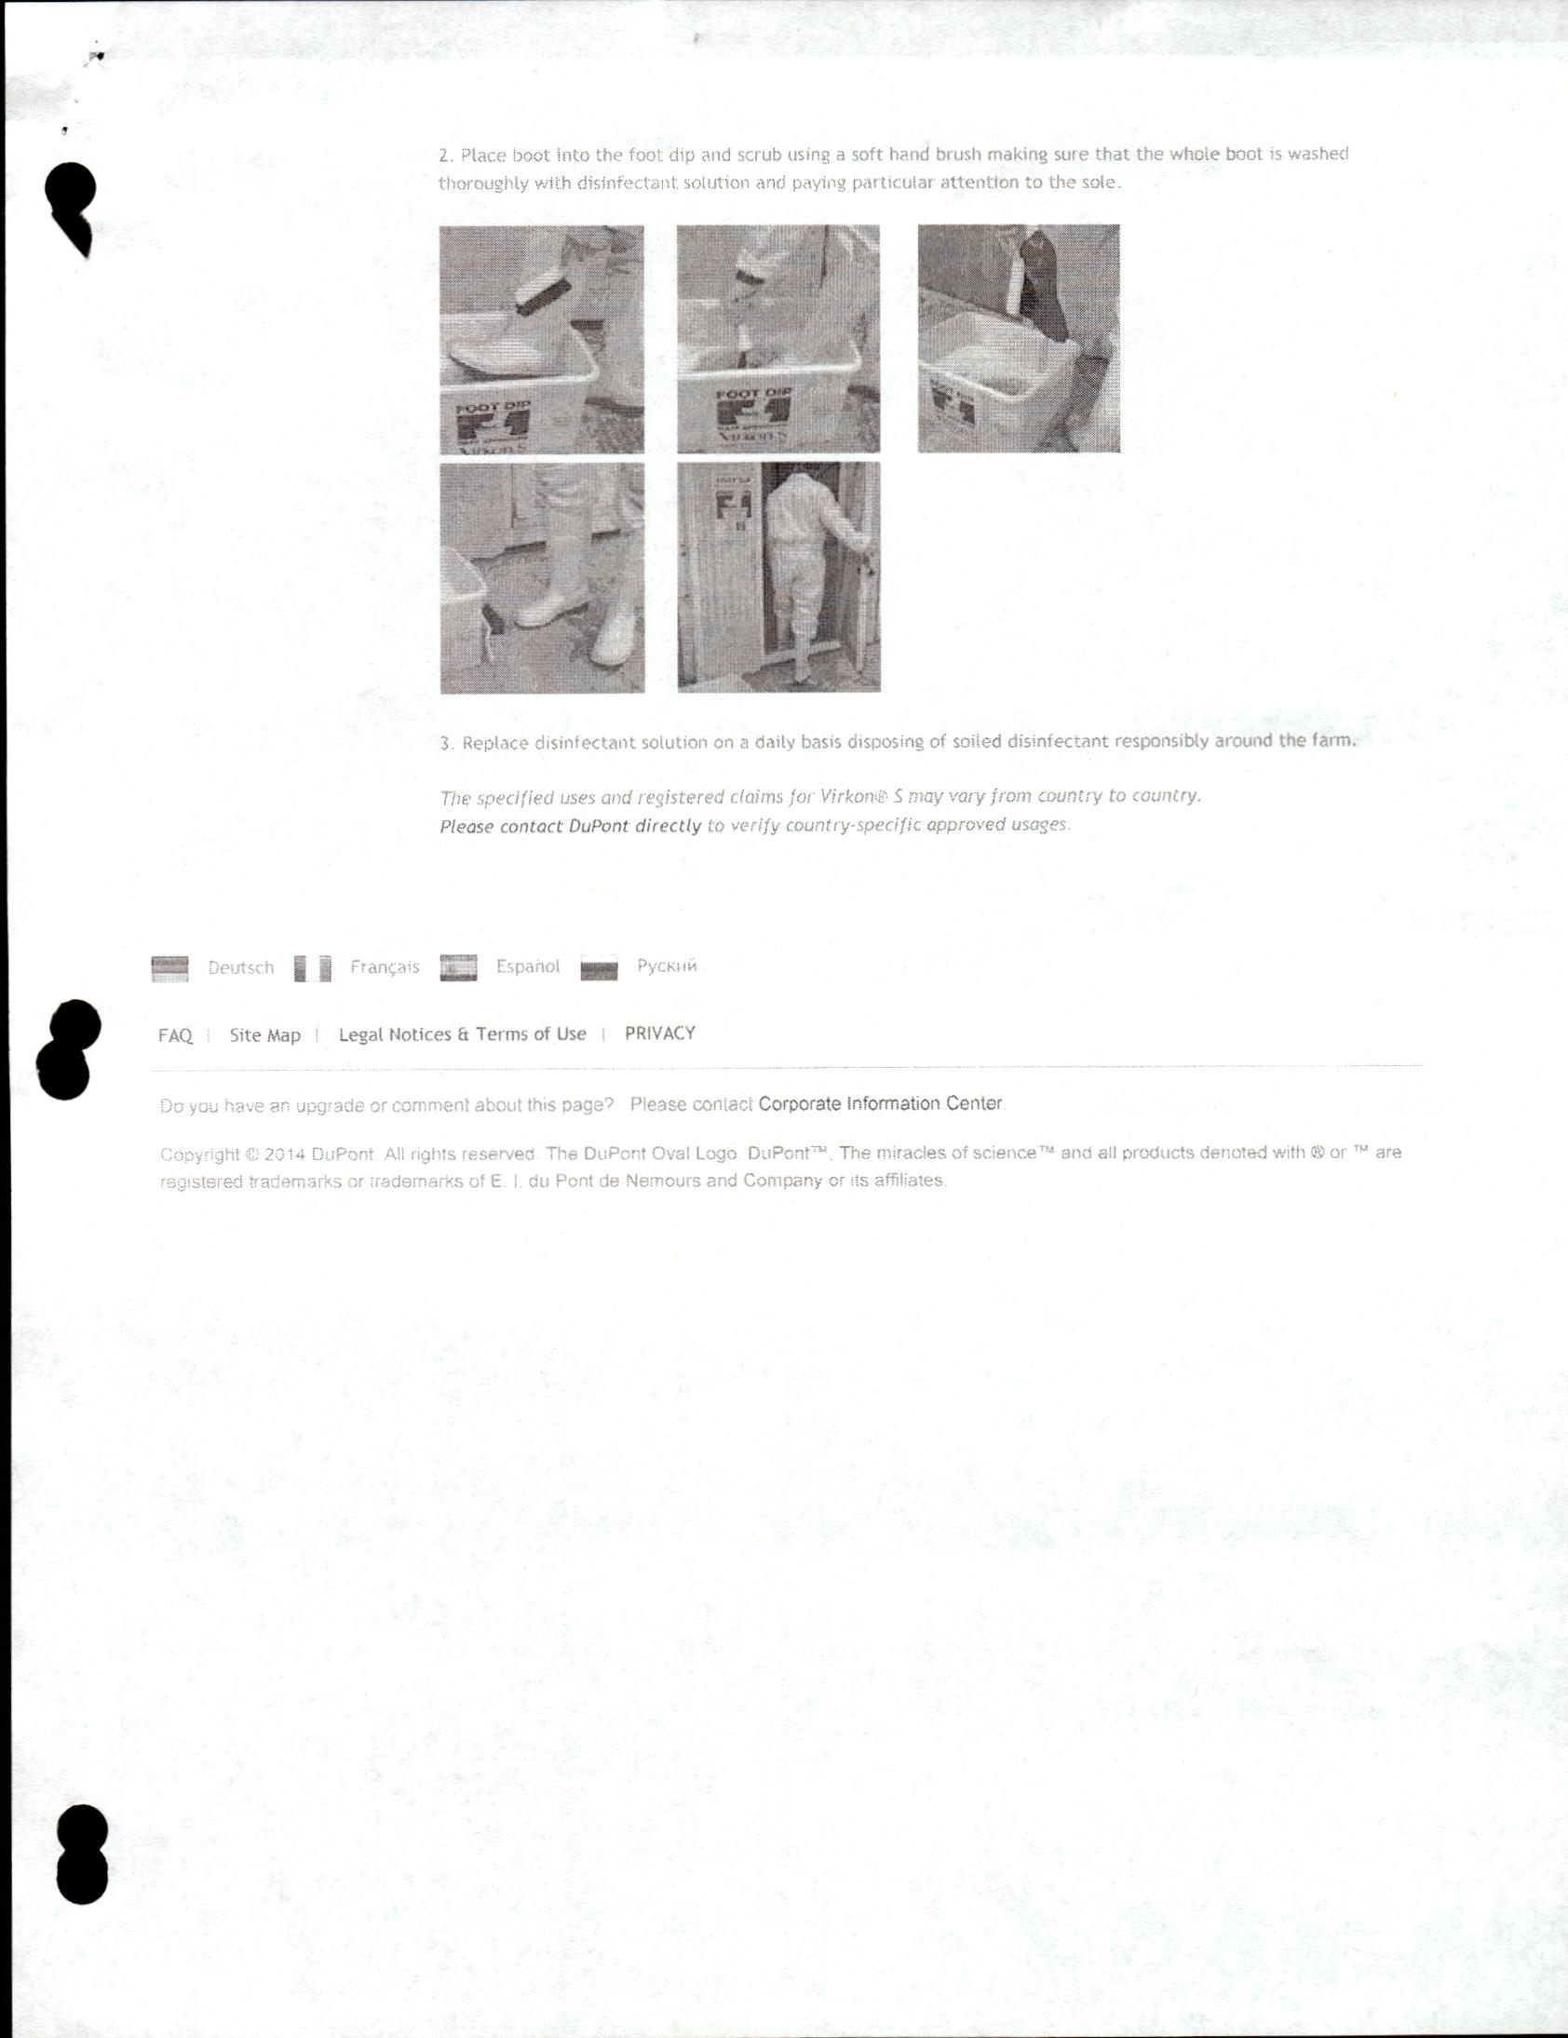
Attachment 4
Operational Period Objectives and Task List
Tasks
1
2
3
4
5
6
7
8
9
10
11
12
13
14
15
16
17
18
19
20
Ongoing Objectives
Ensure that decontamination corridor remains in operational condition.
Bag bio-hazardous waste and place in appropriate receptacle.

Attachment 5
Daily Log
 | Pre Entry Data |  |  |  |  |  | Post Entry Data
Name | Temp | Pulse | Resp | PPE Level | Entry Time | Exit Time | Temp | Pulse | Resp | Notes

Attachment 6
Ensemble
Protective Suit
Protective Boots
Inner Gloves
Outer Gloves
Respiratory Protection
Final Check for Level C PPE
Tape is sealed and tabs are present on boots and gloves
Pull tab on zipper as needed
PAPR filter is placed appropriately and tie is firmly secured
PAPR drape is not entangled and lies in the appropriate manner
PAPR battery is adequately charged (minimum of 1 green light)

Attachment 7

Packaging Guidelines for UN 3373 Shipments
Follow these instructions for packaging, marking and labeling Biological Substance, Category B (UN 3373) shipments for FedEx Express® services.

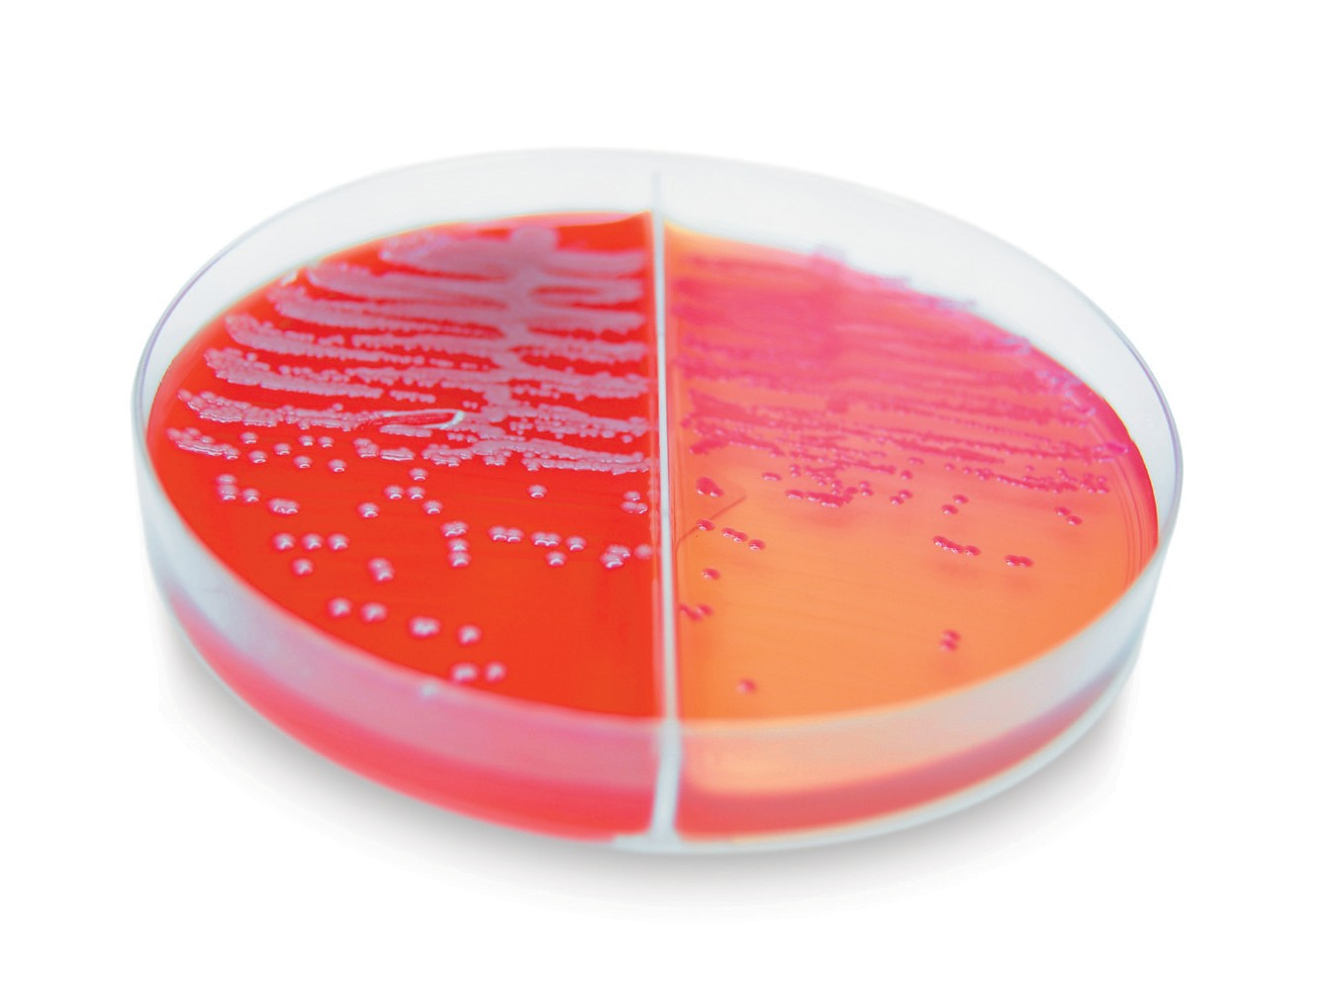

Requirements for Biological Substance, Category B (UN 3373) Shipments
This guide outlines the requirements for shipping with FedEx Express. In addition, all shipments must comply with all applicable local, state and federal laws governing packing, marking and labeling. Blood, urine, fluids, and other specimens containing or suspected of containing infectious substances must be shipped according to applicable government, International Air Transport Association (IATA) and International Civil Aviation Organization (ICAO) regulations.
Customers who ship Biological Substance, Category B (UN 3373) shipments must comply with local, state and federal laws governing identification, classification, packaging and package markings (which may be in label form). FedEx Express strictly adheres to the IATA, ICAO and U.S. government guidelines for materials categorized as Biological Substance, Category B (UN 3373).

General Packaging Requirements
For Biological Substance, Category B (UN 3373) shipments, cushioning material is required for both liquid and dried specimens. You must also include four layers of packaging:
- Primary watertight inner receptacle. Use primary receptacles made of glass, metal or plastic with a positive means of ensuring a leakproof seal; skirted stopper or metal crimp seal must be provided; screw caps must be reinforced with adhesive tape. For liquid specimens, the primary receptacle must not contain more than 1 L. For dried specimens, the primary receptacle must not exceed the outer packaging weight limit.
- Absorbent material. Place absorbent material between the primary and secondary receptacles, using enough material to absorb the entire contents of all primary receptacles. Absorbent material is required for Biological Substance, Category B (UN 3373) shipments containing liquids. Acceptable absorbent materials include cellulose wadding, cotton balls, super-absorbent packets and
paper towels.
- Secondary watertight inner receptacle. Use a secondary container that is leakproof for liquid specimens or siftproof for dried specimens. Choose only secondary containers certified by the manufacturer for Biological Substance, Category B (UN 3373) prior to use. Either your primary or secondary receptacle must be able
to withstand, without leakage, an internal pressure differential of not less than 95 kPa in the range of -40 C to 55 C (-40 F to 130 F). To prevent contact between multiple fragile primary receptacles, individually wrap or separate them inside the secondary container.
- Sturdy outer packaging. Use rigid outer packaging constructed of corrugated fiberboard, wood, metal or plastic, appropriately sized for the contents. Chipboard or paperboard boxes are unacceptable outer packaging.
Limit the total volume for liquid samples to 4 L and the total weight of dried samples to 4 kg per outer container. The minimum outer container size in the smallest overall external dimension is 4". Completed packages must be able to withstand a 4' (1.2-m) impact test as outlined in IATA 6.6.1 regulations. Before sealing the outer packaging, you must make an itemized list of the contents of the package and enclose the list between the secondary packaging and outer packaging.

Acceptable Primary Receptacles
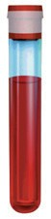

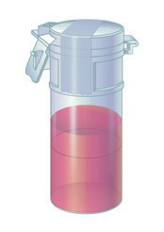

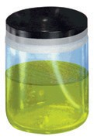

Taped plastic canister

Taped glass or plastic jar

Taped glass or plastic vial

Acceptable Absorbent Materials
Cellulose wadding Cotton balls

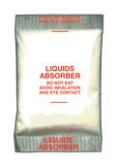

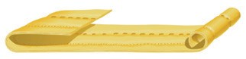

Super-absorbent packets

Paper towels

Acceptable Secondary Receptacles
Biological Substance, Category B (UN 3373) Marking Requirements

Sealed plastic bag

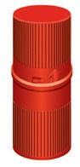

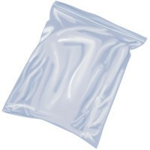

Plastic container

2-mm minimum
rule width

6-mm minimum text height

2" minimum

Screw-cap can

Biological Substance, Category B (UN 3373) Marking Requirements
- Clearly mark “Biological Substance, Category B” in 6-mm-high text on the outer package adjacent to a properly sized UN 3373 diamond-shaped marking. If you prefer, package markings may be in the form of a label.
- If you use the FedEx® UN 3373 Pak, duplicate all required dangerous goods markings on each package inside the overpak.
- The name and telephone number of a person responsible must be marked on the package or provided on the airbill.
- The name and address of the shipper and recipient must be marked on the package.

“Biological Substance, Category B” must appear in 6-mm-high text
on the outer package adjacent to a diamond-shaped mark like the one shown here. The UN 3373 marking must be in the form of a square set at an angle of 45 degrees. Each side of the UN 3373 diamond should measure a minimum of 2" (50 mm). The width of the diamond rule line must be a minimum of 2 mm, and the letters and numbers must be at least 6 mm high.

FedEx UN 3373 Pak
For your convenience, we offer the FedEx UN 3373 Pak as an overwrap for your Biological Substance, Category B
(UN 3373) shipments. We recommend the FedEx UN 3373 Pak for use when the sturdy outer packaging of your properly packaged shipment is smaller than 7" x 4" x 2" (minimum acceptable size).
To help increase your operational efficiencies and clearly identify this type of shipment, the FedEx UN 3373 Pak is preprinted with the required IATA UN 3373 marking, the proper shipping name and the OVERPACK marking.
The FedEx UN 3373 Pak can only be used to ship Biological Substance, Category B (UN 3373) shipments. If you need an overwrap for exempt clinical and environmental test sample shipments, use the FedEx® Clinical Pak.
To order the FedEx UN 3373 Pak, call 1.800.GoFedEx 1.800.463.3339.

NOTE: Never place a Biological Substance, Category B (UN 3373) shipment in a FedEx Express® Drop Box. Call 1.800.GoFedEx 1.800.463.3339 to be directed to a FedEx location that can accept these shipments.
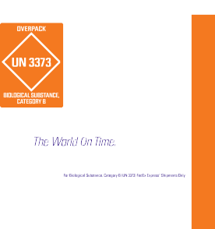

FedEx Office and FedEx World Service Center® locations do not accept shipments classified as Biological Substance, Category B (UN 3373). Call 1.800.GoFedEx 1.800.463.3339
to schedule a FedEx Express pickup, or to be directed to a FedEx location equipped to handle these shipments.

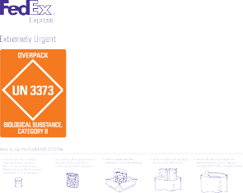

FedEx Packaging Services
FedEx Packaging Services offers package development consultation services. The FedEx Packaging Services lab does not test packaging containing Biological Substance, Category B (UN 3373) materials.

Packaging Restrictions
- Foam boxes, plastic bags and paper envelopes are unacceptable outer containers.
- The FedEx® Envelope, FedEx® Tube, FedEx® Pak, FedEx® Padded Pak and FedEx boxes, including FedEx brown packaging offered at FedEx shipping locations, are not acceptable as outer containers for Biological Substance, Category B (UN 3373) shipments.
- The FedEx Clinical Pak cannot be used to ship Biological Substance, Category B (UN 3373) shipments.
- Only shipments classified as Biological Substance, Category B (UN 3373) can be shipped in the FedEx UN 3373 Pak.
- Biological Substance, Category B (UN 3373) shipments that are shipped refrigerated, frozen, on dry ice, or in liquid nitrogen must comply with current IATA and ICAO regulations.
If you have questions about whether your shipments require a biohazard label, consult the Occupational Safety and Health Administration (OSHA) for the applicable regulations.

Contacts and Resources
- How to Pack guidelines at fedex.com/packaging.
- FedEx Dangerous Goods/Hazardous Materials Hotline, 1.800.GoFedEx 1.800.463.3339; press “81“ or say “dangerous goods.“

NOTICE:
FedEx Express will refuse to accept packages that do not meet FedEx Express, government, or IATA and ICAO requirements. This brochure is in no way
intended to replace requirements mandated by 49CFR and IATA. This is for informational purposes only.

NOTICE: This packaging brochure is provided to FedEx customers to help reduce loss or damage due to improper packaging. It is NOT intended to be a comprehensive guide for packaging items we accept for transit. We make no warranties, expressed or implied, regarding this information. Proper packaging is the sole responsibility of the shipper. For more information and comprehensive guidelines, contact the FedEx Dangerous Goods/Hazardous Materials Hotline at 1.800.GoFedEx 1.800.463.3339; press “81”or say “dangerous goods.“ Refer to the current FedEx Service Guide for terms, conditions and limitations applicable to FedEx® delivery services.
© 2010 FedEx. All rights reserved. 30905PL-Rev. 1/10

Attachment 8
Washing Station 1
Washing Station 2
Hot Zone
Drying Station
Washing Station 3

Attachment 9

Injury Report Form
Name of injured person:
Date and time of injury:
Assigned position at time of injury:
Immediate Supervisor at time of injury:
Current Tetanus vaccination status | Yes/No
Current Rabies status | Yes/No
Did the injury result in a breach of personal protective equipment? | Yes/No
Describe the nature of the injury:
Describe the circumstances surrounding the injury
Was an animal bite or scratch involved? | Yes/No
If yes, was the animal a vaccinated animal? | Yes/No
If a PPE breach occurred, was the area appropriately disinfected? | Yes/No
Witness:
Witness:
Witness:
Injured person signature:
Supervisor signature:
Safety Officer signature:

