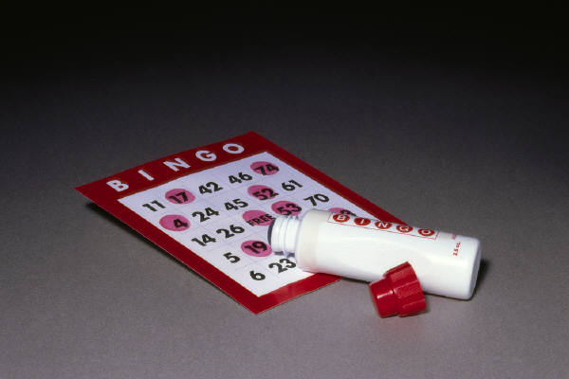

Body Systems Bingo

Activity Summary:
This game helps to reinforce the various functions of the organ systems and would be effective to use prior to the test. Students are given a "bingo" card that contains various organs of the cardiovascular, urinary, digestive, lymphatic and respiratory system. The teacher reads a description of an organ in each system or the function of one of the systems and the students must find the correct answer on their score card. The student that obtains "bingo" first, is rewarded with a pencil or reward pass. Included in this lesson plan are cards that could be used. However, the following url: http://teachers.teach-nology.com/web_tools/materials/bingo/ is a site that allows you to make your own bingo cards.
Subject:
Science:
Life Science

Grade Level:
Target Grade: 8
Upper Bound: 8
Lower Bound: 8
Time Required: 30-45 min.
Activity Team/Group Size: 1
Reusable Activity Cost Per Group [in dollars]:
Expendable Activity Cost Per Group [in dollars]:
Authors:
Graduate Fellow Name: Danielle Lewis
Teacher Mentor Name: Kelly Lazo
Date Submitted: 12/22/04
Date Last Edited:
Parent Lesson Plan(s):
This would be a fun game to play with the students after they have covered the urinary, respiratory, cardiovascular, digestive and lymphatic systems.

Activity Introduction / Motivation:
The student that fills their score card first receives a prize. In our classes we used pencils or "reward passes".
Activity Plan:
Each student is given a bingo card. The teacher reads the description of an organ or the function of one of the organ systems and the student has to think of the answer and find it on their score card.

Activity Closure:
This game is highly effective prior to the exam.
Assessment:
A test over the body organs systems should be sufficient to test their knowledge.

Learning Objectives:
To reinforce the organs of the body associated with the respiratory, digestive, lymphatic, urinary and cardiovascular system.

Prerequisites for this Activity:
This game is most effective after the student has covered each section. Below is a list of the organs that the student should be familiar with prior to playing this game.

Cardiovasular System Lymphatic System
function of cardiovascular system function of lymphatic system
heart lymph
veins thymus
arteries spleen
capillaries lymph nodes
tonsils

Respiratory System
function of respiratory system Urinary System
pharynx function of urinary system
larynx kidneys
trachea nephrons
bronchi ureter
lungs urine
alveoli

Digestive System
function of digestive system
saliva
esophagus
stomach
small intestine
large intestine
gall bladder
liver
pancreas

Background & Concepts for Teachers:
Students should be familiar with the parts and the function of the organ systems.

Vocabulary / Definitions:
See prerequisites

Materials List:
Paper
Laminator (if available but not required)
Pennies to use markers on the score card

Activity Extensions:
The bingo maker could be utilized for other sections besides the organ systems. The URL is easy to use and can quickly prepare several variations of whatever subject was to be covered. An addition to this game would be to include the nervous system on the cards.

Another game that could easily work with body systems is Jeopardy. The same questions could be put into a jeopardy game format. The following website has a powerpoint template for the jeopardy game that allows you to enter questions rather easily: http://www.elainefitzgerald.com/jeopardy.htm
The students could work in groups/teams of 3-4 to answer the questions.
Multimedia Support and Attachments:

Safety Issues:
None.

Troubleshooting Tips:

Activity Scaling:

References:

See the Peer site on organ systems for additional info:
http://peer.tamu.edu/curriculum_modules/OrganSystems/module_5/index.htm

Cool animations on how each organ system works:
http://www.kidshealth.org/kid/how_the_body_works.html

Bingo maker URL
http://teachers.teach-nology.com/web_tools/materials/bingo/

