Gas Exchange
Worksheet

1. What is the circulatory system composed of and what are the primary functions of this system?

2. Draw and label the parts of the heart. Show the direction of blood flow and also if the blood is oxygen rich or oxygen poor.

3. How is breathing measured? What can the results of a breathing test tell you?

4. Use a Venn diagram (overlapping circles or ovals) to compare and contrast arteries and veins, showing what each has in common and how each differs.

5. How do gases move in and out of the body? What tests are used to determine the concentration of these gases?

6. Describe what a capillary is and what it is meant to do.

7. Label the figure below and write a summary of what happens at each part.
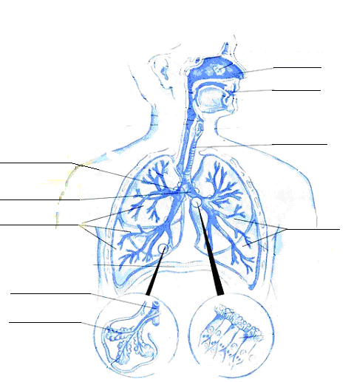

8. How is cigarette smoking a hazard to you? …to others? Compare the hazardous effects of smoking to those caused by air pollution.

