Click here to enter text.

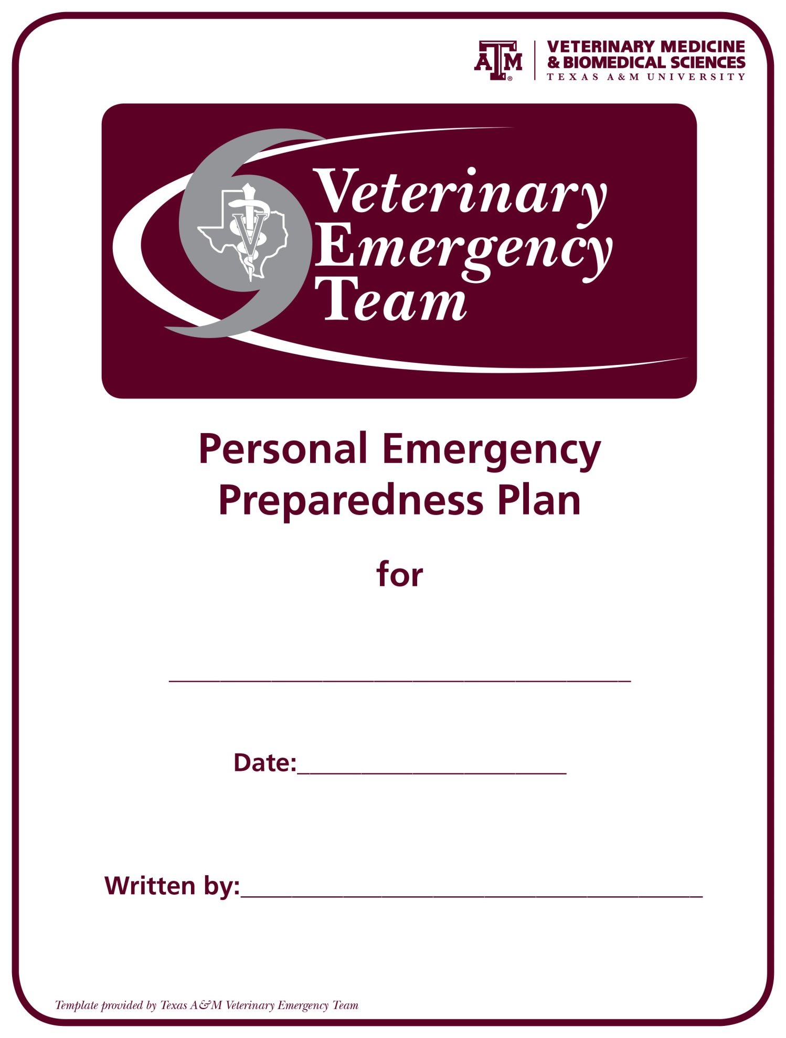
Click here to enter text.

Click here to enter text.
I. PURPOSE
This is a personal emergency preparedness plan written for Click here to enter text.. The purpose of this plan is to protect our family members, belongings, and animals during times of disasters or emergencies. This is an all-hazards plan but is written to provide protection in the worst-case scenario and for the plan to be carried out in my absence. The over-all goals are to allow survival through the potential disasters/emergencies outlined in the Situations and Assumptions section and provide for an efficient recovery after the disaster.

II. SITUATION AND ASSUMPTIONS
A. Out-of-town contact and meeting locations
Out-of-town Contact Name: Click here to enter text. | Telephone number: Click here to enter text.
Email Address: Click here to enter text.

Neighborhood meeting place: Click here to enter text. | Telephone Number: Click here to enter text.

Regional meeting place: Click here to enter text. | Telephone Number: Click here to enter text.

Evacuation Location: Click here to enter text. | Telephone Number: Click here to enter text.

B. Family member information
Name and Date of Birth | Click here to enter text.
Relation | Click here to enter text.
Social Security Number | Click here to enter text.
Medical Information | Click here to enter text.
Call in case of my injury or death | ☐Yes ☐No

Name and Date of Birth | Click here to enter text.
Relation | Click here to enter text.
Social Security Number | Click here to enter text.
Medical Information | Click here to enter text.
Call in case of my injury or death | ☐Yes ☐No

Name and Date of Birth | Click here to enter text.
Relation | Click here to enter text.
Social Security Number | Click here to enter text.
Medical Information | Click here to enter text.
Call in case of my injury or death | ☐Yes ☐No

B. Family member information (continued)
Name and Date of Birth | Click here to enter text.
Relation | Click here to enter text.
Social Security Number | Click here to enter text.
Medical Information | Click here to enter text.
Call in case of my injury or death | ☐Yes ☐No

Name and Date of Birth | Click here to enter text.
Relation | Click here to enter text.
Social Security Number | Click here to enter text.
Medical Information | Click here to enter text.
Call in case of my injury or death | ☐Yes ☐No

Name and Date of Birth | Click here to enter text.
Relation | Click here to enter text.
Social Security Number | Click here to enter text.
Medical Information | Click here to enter text.
Call in case of my injury or death | ☐Yes ☐No

Name and Date of Birth | Click here to enter text.
Relation | Click here to enter text.
Social Security Number | Click here to enter text.
Medical Information | Click here to enter text.
Call in case of my injury or death | ☐Yes ☐No

C. Common Locations of family members when they are away from home
Work Location One | Click here to enter text. | School Location One | Click here to enter text.
Address | Click here to enter text. | Address | Click here to enter text.
Phone Number | Click here to enter text. | Phone Number | Click here to enter text.
Evacuation Location | Click here to enter text. | Evacuation Location | Click here to enter text.

Work Location One | Click here to enter text. | School Location One | Click here to enter text.
Address | Click here to enter text. | Address | Click here to enter text.
Phone Number | Click here to enter text. | Phone Number | Click here to enter text.
Evacuation Location | Click here to enter text. | Evacuation Location | Click here to enter text.

C. Common Locations of family members when they are away from home (continued)
Work Location One | Click here to enter text. | School Location One | Click here to enter text.
Address | Click here to enter text. | Address | Click here to enter text.
Phone Number | Click here to enter text. | Phone Number | Click here to enter text.
Evacuation Location | Click here to enter text. | Evacuation Location | Click here to enter text.

Other Places You Frequent | Click here to enter text. | Other Places You Frequent | Click here to enter text.
Address | Click here to enter text. | Address | Click here to enter text.
Phone Number | Click here to enter text. | Phone Number | Click here to enter text.
Evacuation Location | Click here to enter text. | Evacuation Location | Click here to enter text.

D. Important information
 | Name | Telephone Number | Policy Number
Doctor(s) | Click here to enter text. | Click here to enter text. | Click here to enter text.
Other: | Click here to enter text. | Click here to enter text. | Click here to enter text.
Pharmacist: | Click here to enter text. | Click here to enter text. | Click here to enter text.
Medical Insurance | Click here to enter text. | Click here to enter text. | Click here to enter text.
Homeowners/Rental Insurance | Click here to enter text. | Click here to enter text. | Click here to enter text.
Veterinarian/Kennel | Click here to enter text. | Click here to enter text. | Click here to enter text.

E. Companion Animal Information
Name | Breed | Color | Behavior Issues | Medical Issues
Click here to enter text. | Click here to enter text. | Click here to enter text. | Click here to enter text. | Click here to enter text.
Click here to enter text. | Click here to enter text. | Click here to enter text. | Click here to enter text. | Click here to enter text.
Click here to enter text. | Click here to enter text. | Click here to enter text. | Click here to enter text. | Click here to enter text.
Click here to enter text. | Click here to enter text. | Click here to enter text. | Click here to enter text. | Click here to enter text.
Click here to enter text. | Click here to enter text. | Click here to enter text. | Click here to enter text. | Click here to enter text.

F. Livestock Information
Name | Breed | Color | Behavior Issues | Medical Issues
Click here to enter text. | Click here to enter text. | Click here to enter text. | Click here to enter text. | Click here to enter text.
Click here to enter text. | Click here to enter text. | Click here to enter text. | Click here to enter text. | Click here to enter text.
Click here to enter text. | Click here to enter text. | Click here to enter text. | Click here to enter text. | Click here to enter text.
Click here to enter text. | Click here to enter text. | Click here to enter text. | Click here to enter text. | Click here to enter text.
Click here to enter text. | Click here to enter text. | Click here to enter text. | Click here to enter text. | Click here to enter text.

G. Persons authorized to put your emergency preparedness plan into action
Name | Telephone Number | Email | Section of the plan they are responsible for
Click here to enter text. | Click here to enter text. | Click here to enter text. | Click here to enter text.
Click here to enter text. | Click here to enter text. | Click here to enter text. | Click here to enter text.
Click here to enter text. | Click here to enter text. | Click here to enter text. | Click here to enter text.

H. Potential Hazards
Hazard | Likelihood | Geographic area of risk
Click here to enter text. | Click here to enter text. | Click here to enter text.
Click here to enter text. | Click here to enter text. | Click here to enter text.
Click here to enter text. | Click here to enter text. | Click here to enter text.
Click here to enter text. | Click here to enter text. | Click here to enter text.
Click here to enter text. | Click here to enter text. | Click here to enter text.
Click here to enter text. | Click here to enter text. | Click here to enter text.
Click here to enter text. | Click here to enter text. | Click here to enter text.
Click here to enter text. | Click here to enter text. | Click here to enter text.
Click here to enter text. | Click here to enter text. | Click here to enter text.
Click here to enter text. | Click here to enter text. | Click here to enter text.
Click here to enter text. | Click here to enter text. | Click here to enter text.

I. Assumptions
Click here to enter text.
Click here to enter text.
Click here to enter text.
Click here to enter text.
Click here to enter text.
Click here to enter text.

III. CONCEPT OF OPERATIONS
A. Operational Timeline
Click here to enter text.
Click here to enter text.
Click here to enter text.
Click here to enter text.
Click here to enter text.
Click here to enter text.
B. Communications
Click here to enter text.
C. Mode of Transportation
Click here to enter text.
D. Important Documents
Click here to enter text.
E. Financial Instruments
Click here to enter text.
F. Medical Requirements
Click here to enter text.

IV. ORGANIZATION AND ASSIGNMENT OF RESPONSIBILITIES
Click here to enter text.

V. ADMINISTRATION AND SUPPORT
Click here to enter text.

VI. PLAN MAINTENANCE
Click here to enter text.

