Name:_________________
Date:__________________

Acid Rain Worksheet
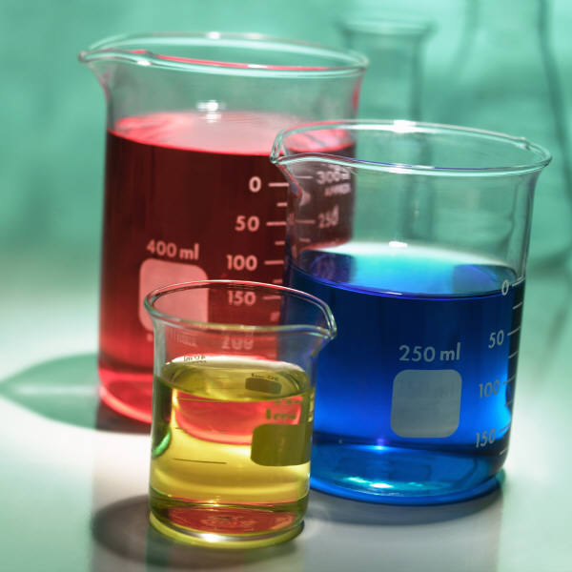

pH of vinegar:______
pH of water:________

Record your observations for each day.

Day 1 Day 2
Vinegar: Vinegar:

Water: Water:

Day 3 Day 4
Vinegar: Vinegar:

Water: Water:

Day 5
Vinegar:

Water:

Questions:
1. What changes, if any, took place in the water glass after 5 days?

2. What changes, if any, took place in the vinegar glass after 5 days?

3. What do you think caused these changes?

4. What did the pennies look like when you rinsed them off after the 5 days?

