Industrial Revolution Inventions

-The Cotton Gin
Invented in 1793, by Eli Whitney, the cotton gin made it possible to separate the seeds from the cotton. Until this point, separating seeds was a laborious process that took several days to complete. Slaves did most of the labor, often until their fingers bled, until the invention of the cotton gin.
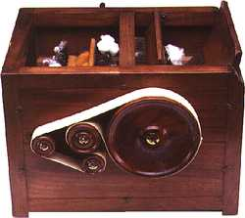

-The Franklin Stove
Invented in the 1740’s by Benjamin Franklin, the Franklin Stove proved useful for cooking heat and lighting a room. Franklin hoped that the additional heat his invention created would improve health and well-being of the occupants of the room by preventing colds and keeping a steady temperature in the room.
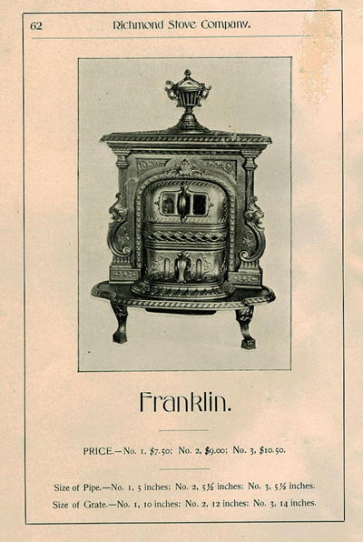

-The Flour Mill
In 1782, Oliver Evans created the automatic flour mill. The mill was powered by water from a near-by stream. Elevators moved the grain from one place to another. The mill workers only needed to put the grain in and cover the barrels of ground flour.

- Hand Cards
Hand cards were used to align the fibers of wool or cotton before making yarn. They were made by driving long nails through a piece of wood. An American named Amos Whittemore invented a machine that made cheap hand cards. His hand cards were frequently smuggled to England because of how cheap they were.
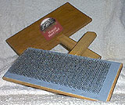
Picture taken from http://www.howardbrush.com/handcards.html

- Blast Furnaces
Traditionally, metal could only be melted to a certain temperature before the container holding the metal began to melt. With the invention of the blast furnace in the late 1700’s, iron could be heated to a much higher temperature, which made it stronger. Stronger iron meant stronger, taller buildings.

- The Steam Engine
Robert Fulton invented the steam engine, which made it possible for boats to travel both up and down a river, without having to worry as much about wind and water currents.
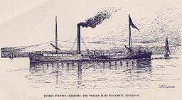

The Electric Telegraph
William Cooke and Charles Wheatstone invented the electric telegraph and installed the first working model in 1839 in the Great Western Railway office. Their design was revolutionary because it included only six wires, instead of 26 (one for every letter of the alphabet). Later, Samuel Morse (inventor of Morse Code) installed a single wire invention, which then became widely used.

The Internal Combustion Engine
The first really successful internal combustion engine was built in 1860 by Etienne Lenoir. The internal combustion engine was the beginning of the modern vehicle. It replaced horse-powered carriages and the cumbersome steam engine.

Box Telephone
Alexander Graham Bell was experimenting with a telegraph machine when he discovered that voices could be transmitted over a wire. In 1876 he was able to transmit sound from Cambridge to Salem Massachusetts. His invention sparked the beginning of the telephone era.
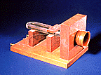picture taken from: http://mcgee.berlinschools.org/Library/Industrial_Revolution_Inventions.htm

The McAdam Road
In 1800, John McAdam created a way of making road beds. He put larger stones on the bottom and covered the larger stone with smaller, smoother stones. The McAdam road is still in use today.
http://www.teachersfirst.com/lessons/inventor/trans1.htm

Sources for additional information: http://www.neo-tech.com/businessmen/part6.html

