Purpose:
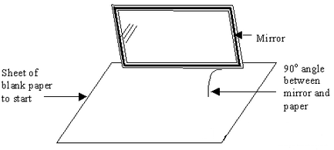
In this activity, students will shine a laser onto a flat mirror and measure the lasers incoming and outgoing rays of light.

Materials:

- Flat mirror
- Laser
- Piece of white paper
- Pencil
- Protractor

Procedure:

- Break up into groups of 3-4.
- Place the sheet of paper flat on a desk.
- Hold the mirror perpendicular to the paper.
- Have each group member shine the laser onto the mirror, each at different angles.
- Trace the incoming and outgoing rays on the piece of paper, labeling each line.
- Measure the angle of the incoming and outgoing rays drawn on the paper with the protractor.

Data:
Your incoming angle: _______________________
Your outgoing angle: ________________________

Conclusion:
What do you notice about the incoming and outgoing angles?

