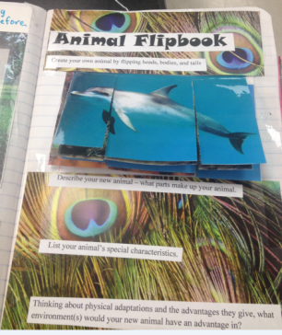
Lesson Summary: The purpose of this lesson is for students to explore the unique characteristics of different animals and the utilization/advantages of having those characteristics. In a hands- on activity, students will create their own animals by flipping heads, bodies, and tails. They will have to think about the purpose of the different adaptations and imagine the functionality of the new animal they have created.

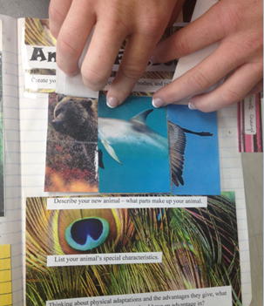
Subject TEKS:
Science (7.10) A, B; (7.11) B, C; (7.12) A; (7.13) A; (8.11) C.

Grade Level: 7th grade

Time Required: One class period
Materials:
- Pictures of different identifiable animals. Approximately
three to six animals per group. Pictures should be approximately
the same size and scale.
- Scissors
- Stapler

Activity Introduction/Preparation: Review addition material provided by this lesson plan (Ex: PowerPoint presentations, quizzes, and alternate activities)
Activity Instructions:
- Students will begin with three to six pictures of different animals.
- Students will cut the pictures into three sections, a head, midsection, and rear section.

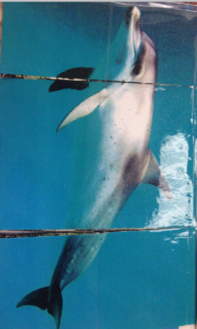
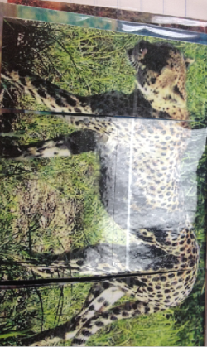

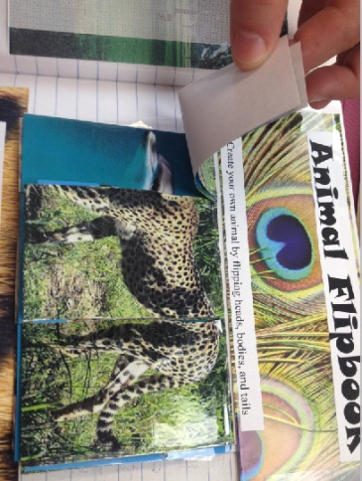
- These pictures will be placed in one stack and attached at the top (by stapler, tape, etc.) so that any one section can be flipped to create a new creature.
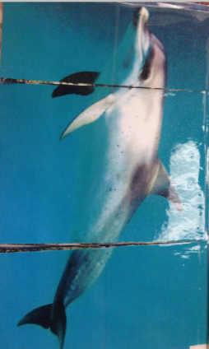
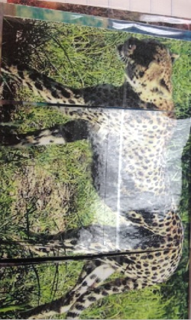

- Have the students (either individually, in a group, or as a class if one flip book is made) flip the three sections of the book to create three (or more) new animals.
- Optional: the students can name the new creatures.
- The students will write a one-paragraph description of each of their new creatures that will include the following:
  - The students will identify and describe the characteristics/adaptations of their new creature.
  - The student will consider in which environment(s) their new creature would have an advantage according the physical adaptions and describe that environment.
- A discussion comparing the creatures could be held.

Assessment: Paragraphs can be graded. Students could present their new creatures.

Authors:
Undergraduate Fellow Name: Katie Clark, Jennifer Graham, Kristen Bowen
Education Specialist: Michele Ward

