Name ______________________ Class _________________ Date ____________________

Animal Restraint Worksheet

Multiple Choice. Circle the choice that best answers the question.
- Which of the following is NOT a restraining device?
A – Elizabethan collar
B – Leash
C – Muzzle
D – Towel
- Which is a picture of an Elizabethan collar?
A - 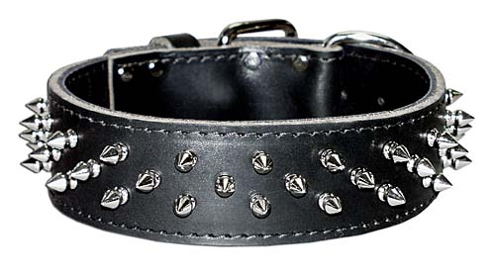 B - 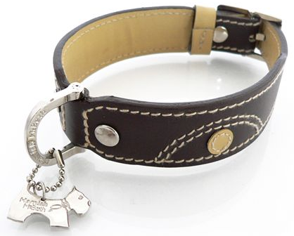
C - D - 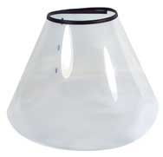

- Which is NOT a correct method for carrying an animal?
A - 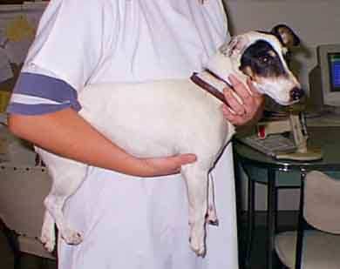 B - 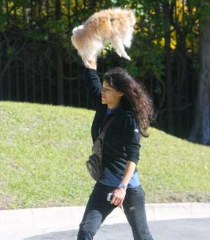
C - 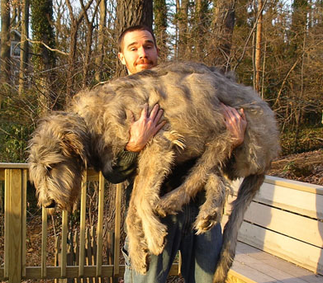 D - 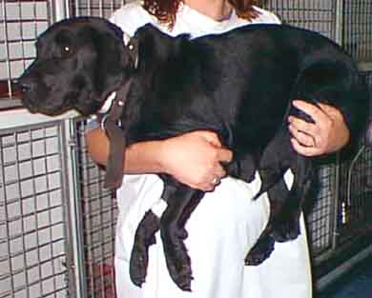

- Animals heavier than ____ pounds should be carried by 2 or more people.
A – 40
B – 50
C – 60
D – 70
- What does “recumbency” mean?
A – To lay down
B – To sit down
C – To stand up
D – To be at rest
- If an animal is not moving when on a leash, you should:
A – Drag it along with you.
B – Kick it.
C – Yell at it
D – Carry it.
True or False. Circle T for True and F for False.
- T F Towel and restraint bags have the same purposes.

- T F Use as much restraint as possible. More is always better.

- T F During an examination, talk loudly so that the animal knows that you are
in charge.
- T F Proper animal handling benefits only the animal.

- T F Drugs are used when the patient is aggressive.

- T F Gauze can be used as a muzzle.

- T F Fabric muzzles can be used for long periods of time.

