Disease

Caused by the bacterium Clostridium tetanii
Tetanus

This is the life cycle of: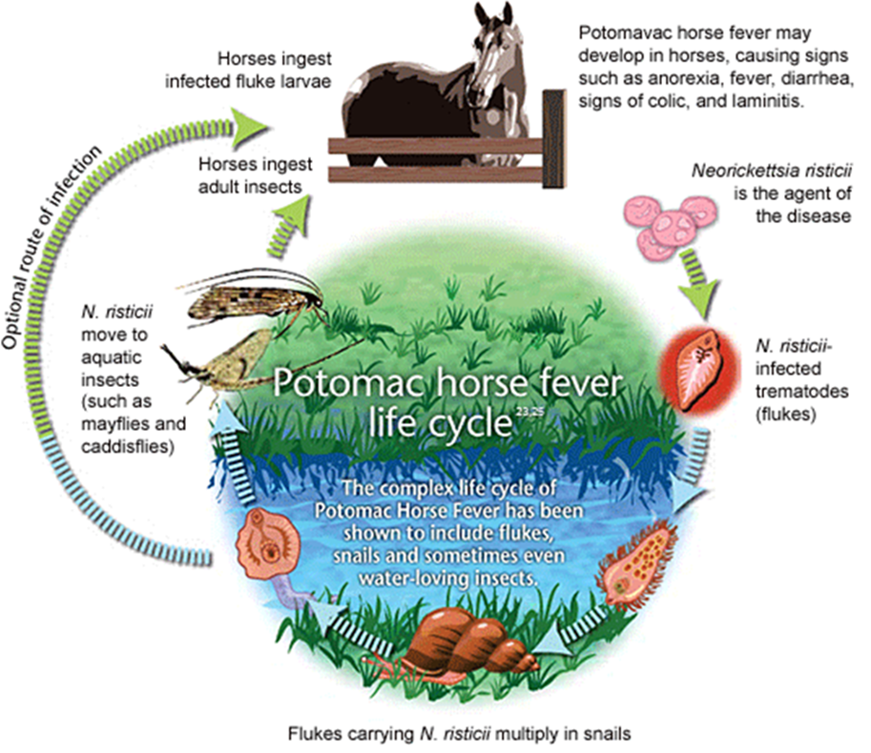
Potomac Horse Fever

Treatment for this disease includes anti-inflammatory drugs, IV fluids, & head/leg protection
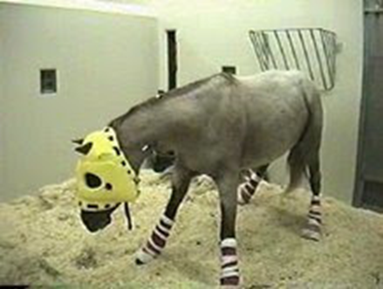
West Nile Virus

There are two types of this virus which may cause respiratory distress and/or abortion

Equine Herpes Virus

This zoonotic disease has two forms: furious and dumb

Rabies

This disease is characterized by abscesses around the jaw and throatlatch.
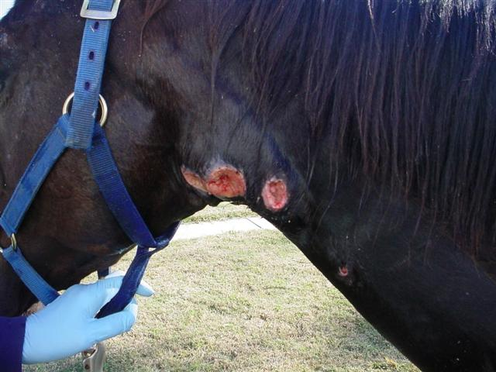
Strangles

This animal is a carrier for:
Equine Protozoal Myeloencephalitis (EPM)

This disease has 3 types:
    - Acute: death in 3 -14 days, high fever, depression, rapid muscle loss
    - Sub-acute: following survival of acute phase; acute symptoms occur during times of stress
    - Carrier: show no clinical signs

Equine Infectious Anemia

This horse has:
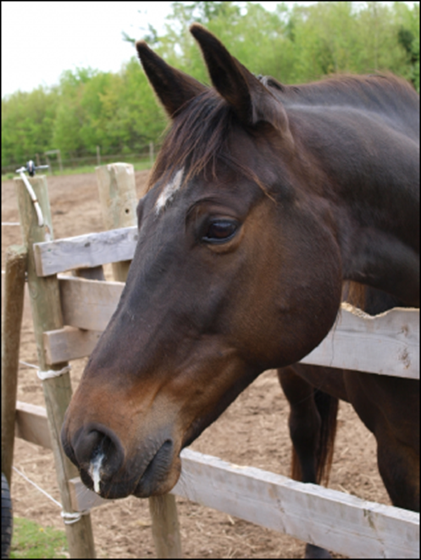
Equine Influenza

This disease has 3 strains which cause severe inflammation of the brain and/or spinal cord.

Equine Encephalomyletis

This is a malfunction of a structure or job of a structure that is caused by an organism that creates signs and symptoms of its living state in a human, animal, or plant.

