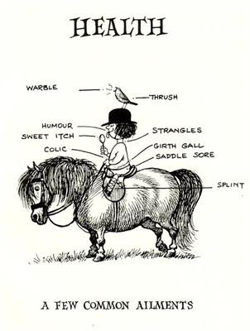
Lesson Summary: The purpose of this lesson is for students to learn the names, symptoms, and treatments for common equine skin diseases. The activity follows a set of cards around the room where each card has an answer from the previous question and then a new question on it. This will help students self-test to see if they know the information previously presented.

Subject:
Ag Science: Equine Science

Grade Level: 10th, 9th-12th

Time Required: One class period.
Materials:
- Pen and Paper for each student
- Something hard for them to carry around and write on
- The printed set of questions
- Tape to hang the questions around the room

Activity Introduction/Preparation: The PowerPoint Common Equine Skin Diseases can be used as an introduction to this activity. It will cover the common disease and have the answers to the questions that the students will be asked.

Activity Plan:
- Have all the questions and answer sheets taped up around the room with the answers covered in a manner that allows students to reveal the answer and recover it.
- Have the students spread out with only 2-3 students at each paper
- The first card that they are at will also be the spot that they should end at. This is how the students know that they answered all the questions and in the correct order
- At the first card students should write both the question and what they believe to be the correct answer on their paper.
- Students should then move around the room until they find the hanging sheet that has that answer on it. Then proceeded to answer the next question.
- Once they are back to where they started they have finished!

Assessment: This activity will allow you to see if the students have learned the material. If students seem to be struggling and looking around the room for the answers then it may be beneficial to review some of the diseases.

Lesson Extensions:
- To make the activity harder you could remove the answers and have the students just walk around the room and answer the questions.
- Also you can make the question harder by modifying them or asking the students to then write two other facts they know about the disease they just answered one question about.
References: Here are some websites that may be helpful
- http://www.gvequine.com/Pages/articles24.php
- http://www.wvu.edu/~agexten/forglvst/EquineFactSheet.pdf
- http://www.clydevetgroup.co.uk/equine/newsletters/oct05.htm#

TEKS: Agriculture- Equine Science
130.5
(b) Introduction. To be prepared for careers in the field of animal science, students need to enhance academic knowledge and skills, acquire knowledge and skills related to animal systems, and develop knowledge and skills regarding career opportunities, entry requirements, and industry expectations. To prepare for success, students need opportunities to learn, reinforce, apply, and transfer their knowledge and skills in a variety of settings. Suggested animals which may be included in the course of study include, but are not limited to, horses, donkeys, and mules.
(c) Knowledge and skills
(4) The student compares and contrasts issues affecting the equine industry. The student is expected to:
(A) Describe issues concerning biotechnology related to the equine industry; and
(B) Identify animal welfare policy pertaining to the equine industry.

Authors:
Undergraduate Fellow Name: Mikaela Stanislav

