Disease

What disease is this?
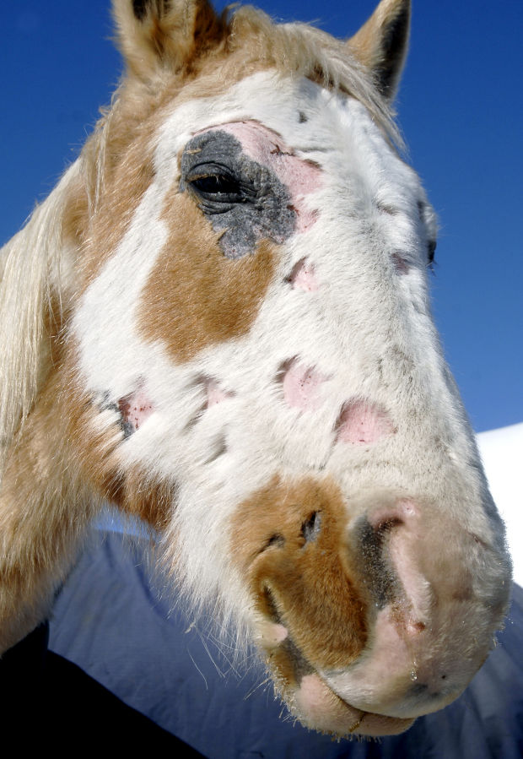
Ring Worm

True or False:
Rain Rot is cause by a fungus

False

This is a parasitic disease that causes a large amount of hair loss, itching, lesions and discomfort
Mange

Laser therapy can be used to get rid of:

Sarcoids

The heel and leg of the equine can become swollen, have puss and thicken the skin
Pastern Dermatitis

This is a malfunction of a structure or job of a structure that is caused by an organism that creates signs and symptoms of its living state in a human, animal, or plant.

