What type of lever does this picture represent? (1st, 2nd, or 3rd class?)

C:\Users\ljlab\AppData\Local\Microsoft\Windows\Temporary Internet Files\Content.IE5\PFM60YO8\MC900232150[1].wmf

What color is the fulcrum in this picture of a lever?

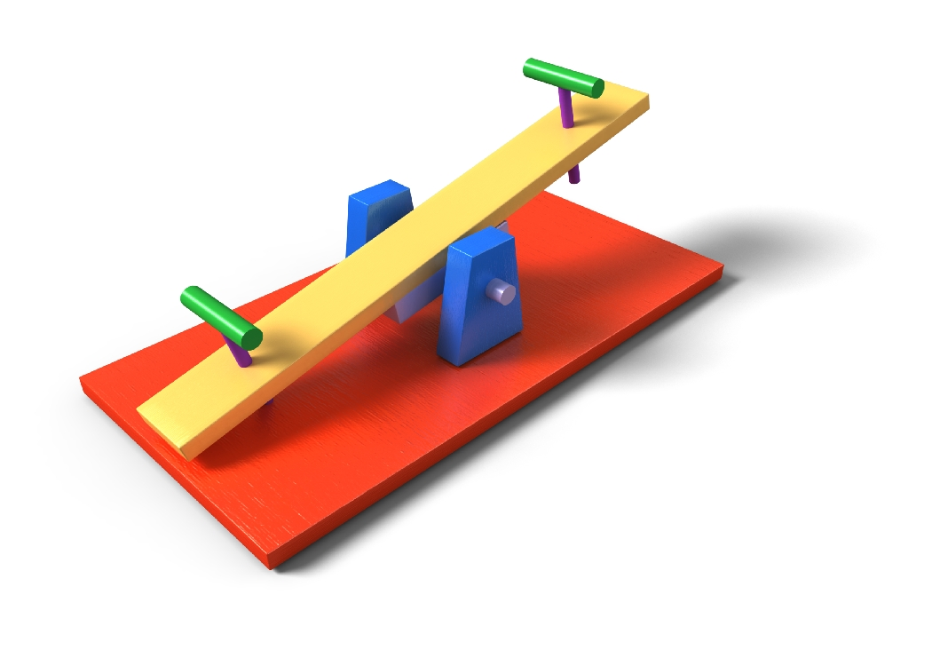

Answer: First class

Answer: Blue

What type of lever does this picture represent?

C:\Users\ljlab\AppData\Local\Microsoft\Windows\Temporary Internet Files\Content.IE5\KJEZN6MK\MC900310176[1].wmf

Which arrow represents the force/ effort?

C:\Users\ljlab\AppData\Local\Microsoft\Windows\Temporary Internet Files\Content.IE5\KJEZN6MK\MC900310176[1].wmf

Answer: Third class

Answer: Red

Which color dot represents the fulcrum in this lever?



If the person is exerting a force down on the lever, which direction will the paint lid go?

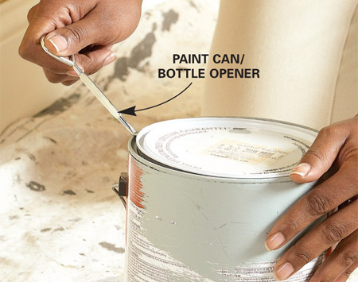

Answer: Orange

Answer: Up

A person uses the wheel barrow to move a load. What type of lever is this?

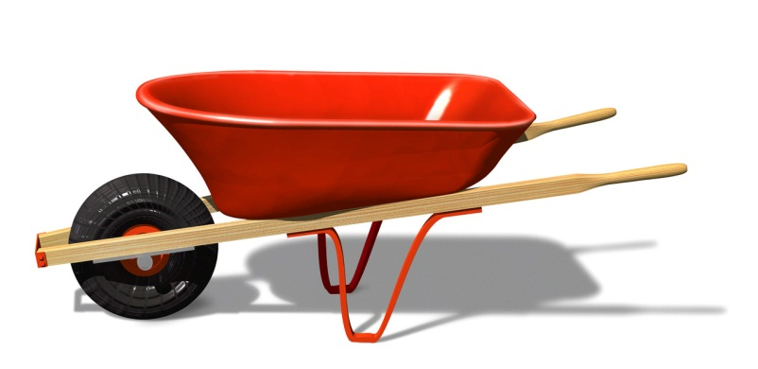

Which part of the wheelbarrow is the fulcrum in this lever?

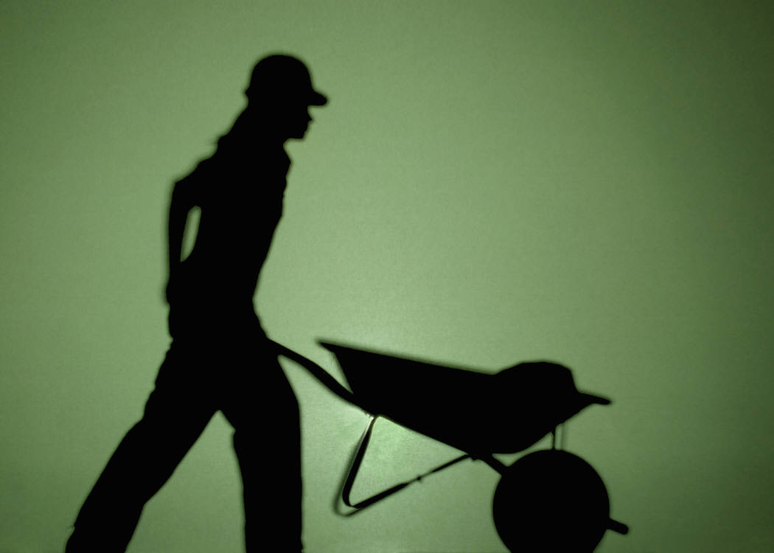

Answer: Second Class

Answer: The Wheel

Which part of this system represents the force/effort?



Your hand presses down on the middle of this stapler. What type of lever is this?

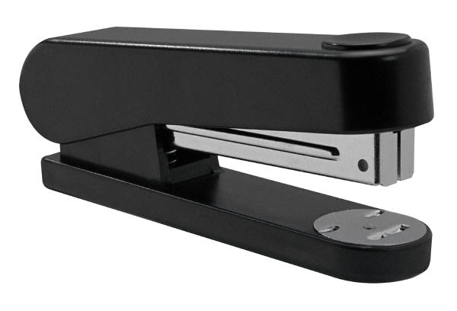

Answer: The person pulling up on the wheelbarrow handle .

Third Class

In a _______ class lever, the fulcrum is between the load and the effort.

In a ______ class lever, the load is between the fulcrum and effort.

Answer: First

Answer: Second

In a third class lever, the _____ is between the fulcrum and _____.

In second and third class levers, the force is in the _______ direction as the load.

Same or opposite?

Answer: effort, load

Answer: Opposite

What type of lever does this represent?

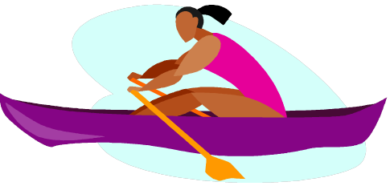

What type of lever does this represent?



Answer: First Class

Answer: Second Class

What type of lever is a pair of scissors?



What type of lever does this fisherman and his fishing pole represent?



Answer: First Class

Answer: Third class

What type of lever turning the door handle down represent?



What type of lever does the paint can opener represent?

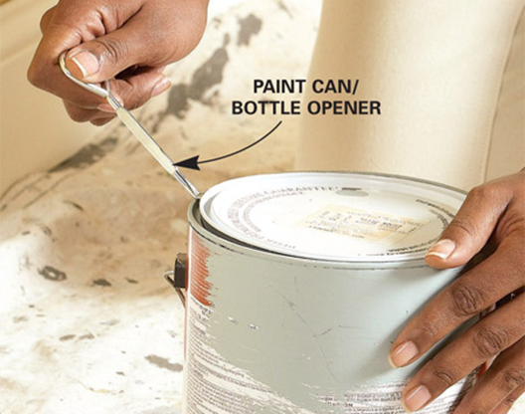

Answer: Second Class

Answer: First Class