Name: Date:
Fetal Pig Dissection Assessment
**The last sheet has pictures of the dissected fetal pig. Make sure you label the organs that have lines pointing at them**
- Name two safety rules while working with the fetal pig.
  - Do not take any materials out of the classroom
  - Do not point sharp objects at yourself or others
    - (can be many more)

- What is the dorsal side of the pig? Refers to the belly

- Name the three glands that make up the salivary system.
  - Parotid
  - Sublingual
  - Mandibular

- Where is bile produced? Liver

- What are the 2 functions of the epiglottis? Allows for air to flow into larynx and trachea and directs food into the esophagus

- Where does gas exchange take place in the lungs? Alveoli

- Name the chambers of the heart.
  - Right Atria
  - Right Ventricle
  - Left Atria
  - Left Ventricle

- What hormone is produced by the testes? Testosterone

- Where does fertilization occur? Oviduct

- What is the functional unit of the kidney? Nephron

- What glands are on the kidneys? Adrenal glands

- What part of the kidney produces adrenaline? Adrenal Medulla

- Name the parts of the small intestine.

  - Duodenum
  - Jejunum
  - Ileum
- Where is insulin produced? Pancreas

- Explain how the diaphragm works. Expands to allow fresh air in (diaphragm contracts) and Compresses to expel stale air (diaphragm relaxes)

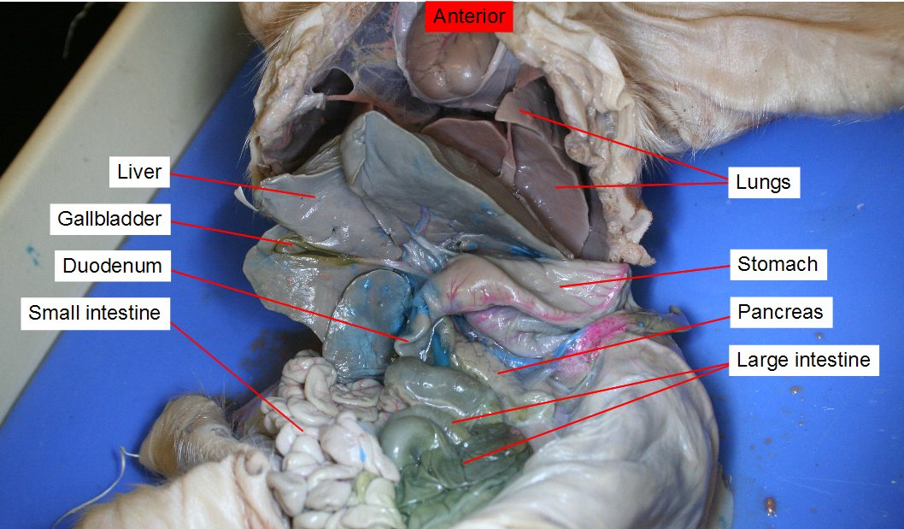
Liver Stomach
Gallbladder
Small Intestine

17.
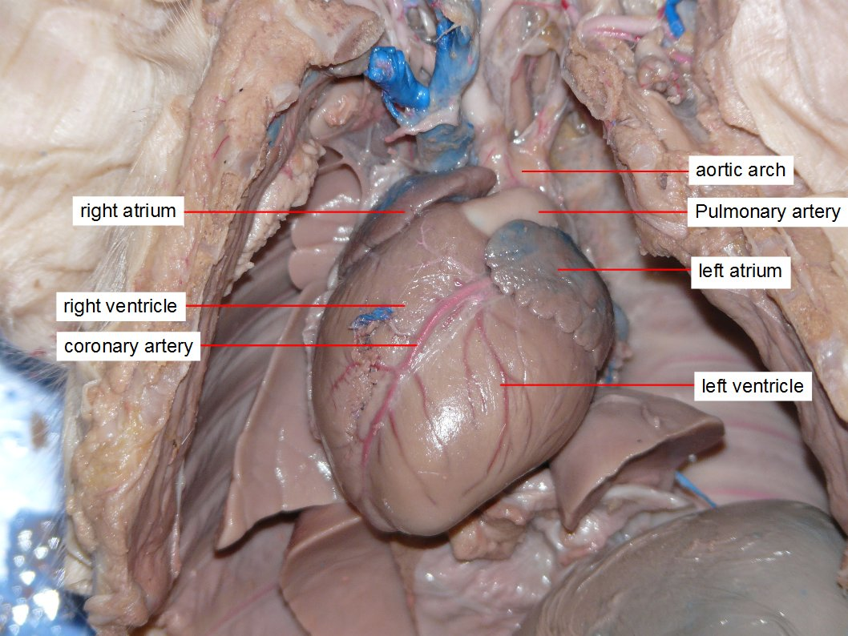
Right Atria Pulmonary Artery
Right Ventricle Left Atria
Left Ventricle
18.
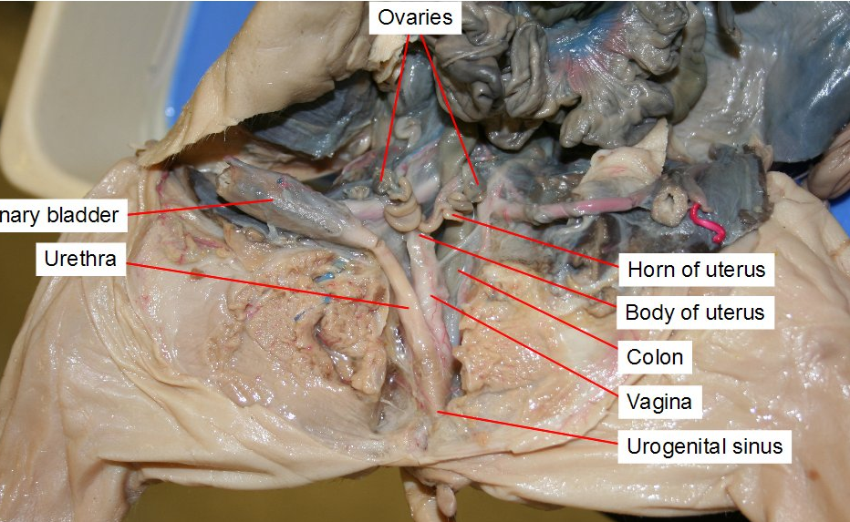
Ovaries
Bladder Uterine horns
Urethra Urogenital
Sinus

