Name: Date:
Fetal Pig Dissection Assessment
**The last sheet has pictures of the dissected fetal pig. Make sure you label the organs that have lines pointing at them**
- Name two safety rules while working with the fetal pig.
a.
b.
- What is the dorsal side of the pig?

- Name the three glands that make up the salivary system.
a.
b.
c.
- Where is bile produced?

- What are the 2 functions of the epiglottis

- Where does gas exchange take place in the lungs?

- Name the chambers of the heart.
a.
b.
c.
d.
- What hormone is produced by the testes?

- Where does fertilization occur?

- What is the functional unit of the kidney?

- What glands are on the kidneys?

- What part of the kidney produces adrenaline?

- Name the parts of the small intestine.

- Where is insulin produced?

- Explain how the diaphragm works.

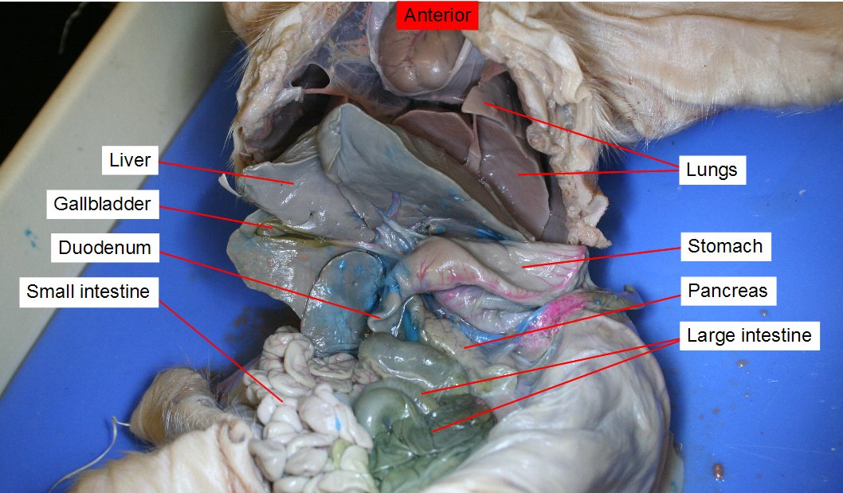

17.
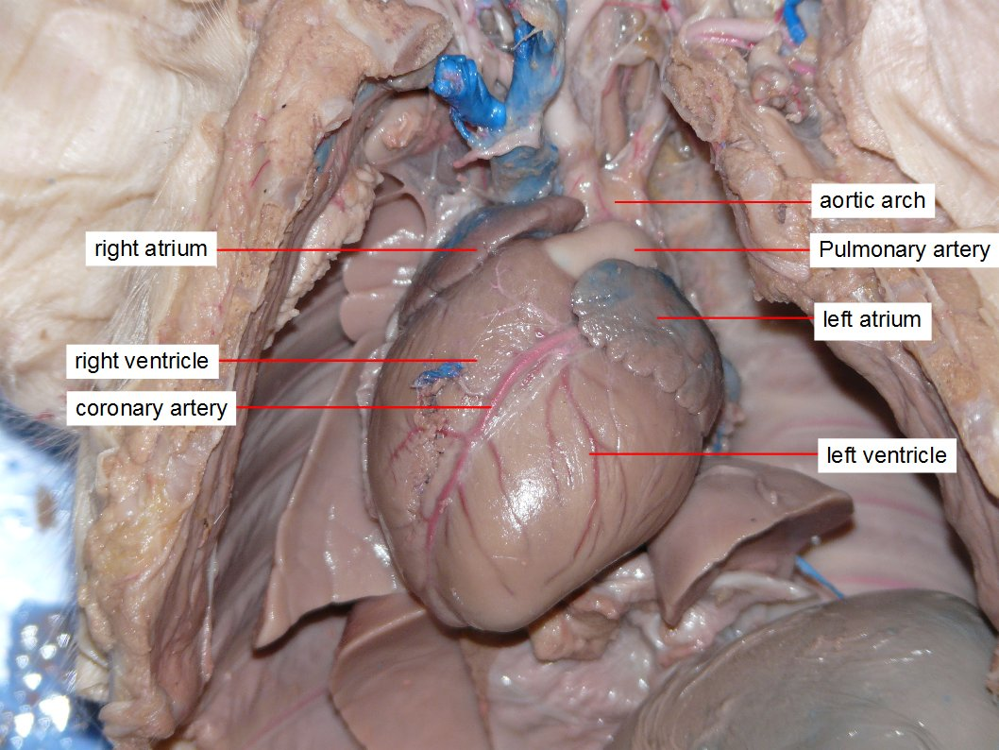

18.
