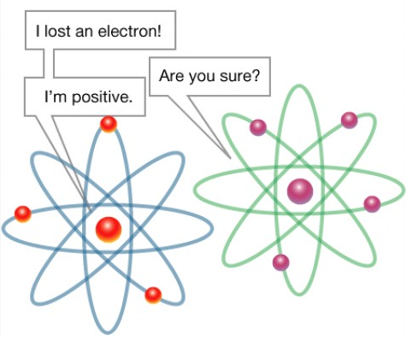
Lesson Summary: The purpose of this lesson is for students to learn the names and symbols of different elements on the periodic table. Played just like Bingo, each student will be given a card that has rows and columns of different element symbols. Tested on their knowledge of the names of these elements, the students will have to match the name that is called out with the symbol on the card.
Subject:
Science: Chemistry

TEKS: Science-
6.5 A,B
8.5A,B,C

Time Required: One class period.
Materials:
- ATOMS Bingo Cards (class set)
- Element Draw Cards (one teacher set for a draw pile)
- Bingo Markers

Activity Introduction/Preparation: The PowerPoint, Learning the Periodic Table, may be used as an introduction to teach the Periodic Table of Elements as it references many of the properties of elements and could be a useful preparation guide for the students before this activity takes place.

Activity Plan:
- Pass out ATOMS Bingo Cards and bingo markers to each student.
- Select an Element Draw Card out of a box or similar container and call out the selected element by name, not symbol. Keep the selected draw cards to the side to later check the winning bingo card.
- The students should then match the name with the symbol on his or her ATOM bingo card by placing a bingo marker on the symbol.
- Once a student has called out “ATOMS,” check the student’s card to declare him or her a winner.
- Play as many times as desired or as class time permits.

Assessment: During the activity, periodically ask students how successful they are in matching the names and symbols. Let the students know that they can raise their hand to ask about a name or symbol at any time when they are unsure. After a student wins, test the winning student by having him or her identify the name associated with each symbol in his or her winning row or column.

Lesson Extensions:
- Play the game differently by calling out properties and have the students mark all of the symbols of the elements that fall under those properties (i.e. call out “metals” and have the students mark all of the metal elements on their cards, etc).
- Give the students a copy of the periodic table and ask them several questions about identifying an element (i.e. give them the name and ask the symbol and vice versa).
- Have the students write their answers down on a whiteboard, piece of paper, or notebook and keep track of how well they do.
References: Here are some websites that may be helpful
- http://www.chem4kids.com/files/elem_pertable.html
- http://www.rsc.org/chemsoc/visualelements/pages/periodic_table.html

Authors:
Undergraduate Fellow Name: Brittany Sanchez
Please email us your comments on this lesson:
E-mail to ljohnson@cvm.tamu.edu
Please include the title of the lesson, whether you are a teacher, resident scientist or college faculty and what grade you used it for.

Teacher's Comments:

