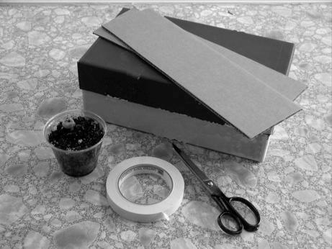
We know that the plant hormone auxin stimulates the plant to respond to its environment. What we want to test is, “How does phototropism and geotropism happen?”
Auxin Experiment
Materials needed
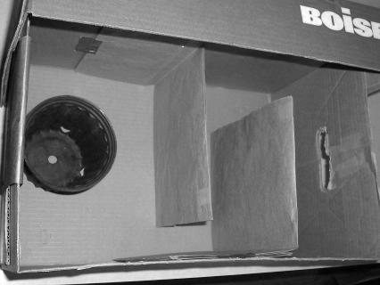
1 Shoebox
Scissors
Tape
Cardstock
Permanent Marker
2 Plastic cups each potted with a 3” tall Bean plant
Water
Light Source (window or lamp)

Preparing the experiment
- Gather your materials and make sure your bean plants are well watered. Label each plant with the permanent marker with “(group #)___C” and “(group #)___V”
- Place your first bean plant (“C”) on its side, in a place with good lighting.
- Next, take your shoebox and cut a 3” hole in one of the sides. This will become the top of your enclosure so be sure that you choose a side that allows the box to stand tall.

- Using your scissors, tape and cardstock, design and create a maze in the interior walls of the box.
- Stand the box up and insert your second bean plant (“V”) setting it on the bottom of the box on its side. Be sure to close the lid and set the box in a place with good lighting,
next to the first bean plant (“C”).
The experiment
After preparing the bean plants for this experiment, the last step is to observe and make conclusions about auxin. Let the bean plants sit for 5 days. Observe the plants’ growth every 24 hours and take notes on how each set changes. If you choose, take a picture each day and compare the pictures after completing the experiment. On the final day of this experiment, determine how bean plant was affected by auxin, if at all. Discuss with your group why this happened. From this experiment, we can learn about how auxin effects the stimulation of geotropism and phototropism.
Questions
Hypothesis
Observations:
Each day, record your observations for each of the fruit sets.
 | Control Set “C”  ____________________ |  |  | Variable Set “V”  ________________________
Day 1
Day 2
Day 3
Day 4
Day 5
What did we learn?

