C:\Users\Ljlab\AppData\Local\Microsoft\Windows\Temporary Internet Files\Content.IE5\X90VGEFU\MC900034169[1].wmf**Lesson Summary:** The purpose of this lesson is for students to understand the purpose and advantages of camouflage. In a hands- on activity, students will create new physical and environmental circumstances for a common hare that will make them expand their view on the point and possibilities of camouflage in nature.

**Subject TEKS:**

Science (7.10) A, B; (7.11) B, C; (7.12) A; (7.13) A; (8.11) C.

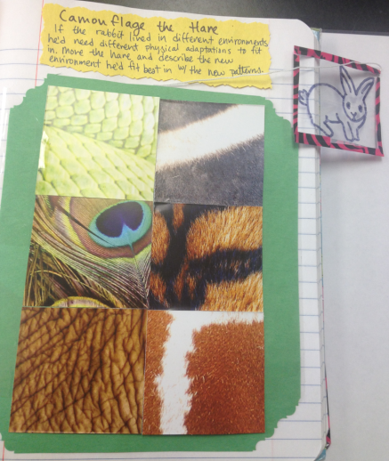**Grade Level:** 7th grade

**Time Required:** One class period  
  
**Materials:**

* Several partial cut- outs of different

identifiable natural environments

(or physical characteristics of varieties

of animals, ex: snake skin, zebra hair)

* 1 moveable, transparent outline of a

common hare

**Background and Concepts for Teachers:**

* Teachers should understand adaptions and how organisms respond to stimulation from their environment. They understand natural selection and how an organism survives in a particular environment, and how a particular environment can support all forms of life.

**Activity Introduction/Preparation:** Review addition material provided by this lesson plan.(Ex: PowerPoint presentations, quizzes, and alternate activities)

* Create a picture grid of patterns found in nature
* Create a transparent picture of a hare (perhaps using tape or overhead paper)

(Optional)

* Have the students cut out the patterns they find from magazines before the activity is explained and before they know why they are cutting them
* Collect and then redistribute the patterns they have chosen for an interesting, more interactive twist!

**Activity Plan:**

* Have the students (either individually or in a group) move the transparent hare over each cut- out pattern, one at a time.
* The hare will be camouflaged with its new environment
* The student will now identify and describe the new environment in which the hare will thrive in based on the new pattern or physical adaption

**Assessment:** Let the students know that they can raise their hand to ask about a picture or environment if they are unsure. Periodically ask the students to why the hare would want to be camouflaged. Have the students compare answers and share thoughts about the purpose and advantages to camouflage.

**Authors:**   
Undergraduate Fellow Name: Katie Clark, Jennifer Graham, Kristen Bowen

Please email us your comments on this lesson:   
E-mail to [ljohnson@cvm.tamu.edu](mailto:ljohnson@cvm.tamu.edu)  
Please include the title of the lesson, whether you are a teacher, resident scientist or college faculty and what grade you used it for.