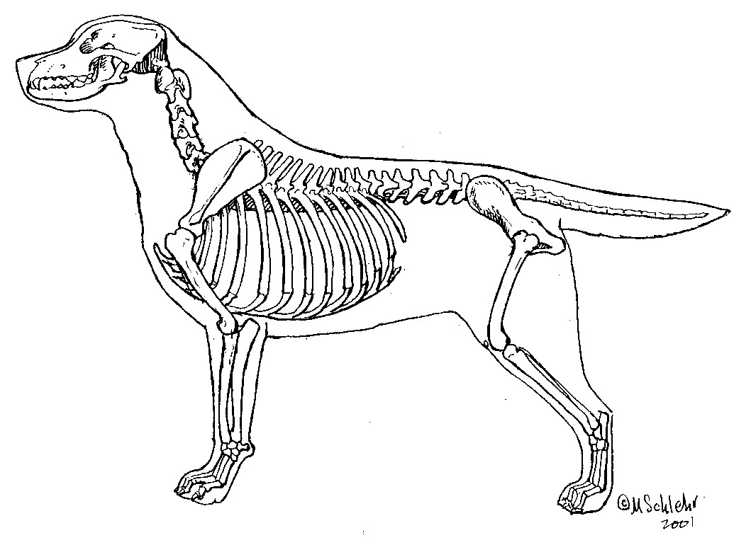

Name:________________ Date:__________

**Canine Skeletal System**