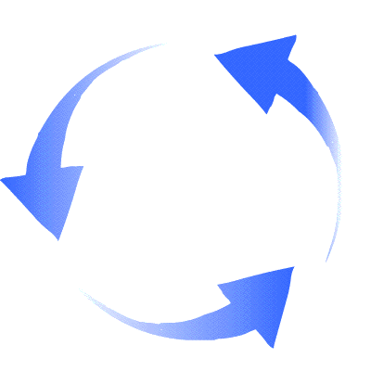
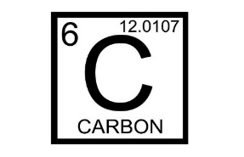
The Carbon Cycle Fill-in Diagram
Fill in the following diagram with the processes of the carbon cycle that you learned about in the carbon cycle presentation (Hint: two of the boxes shown use the same process).
Hydrosphere Carbon Pool
Lithosphere Carbon Pool
Biosphere Carbon Pool
Precipitation
Diffusion
Subduction
Weathering
Volcanism and burning fossil fuels
Shellfish
Photosynthesis
Photosynthesis
Decomposition
Cellular Respiration and ruminant digestion

Atmosphere Carbon Pool

