**The Carbon Cycle Fill-in Diagram**

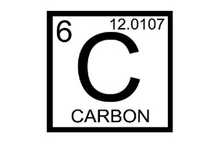

Fill in the following diagram with the processes of the carbon cycle that you learned about in the carbon cycle presentation (Hint: two of the boxes shown use the same process).

Hydrosphere Carbon Pool

Lithosphere Carbon Pool

Biosphere Carbon Pool

Precipitation

Diffusion

Subduction

Weathering

Volcanism and burning fossil fuels

Shellfish

Photosynthesis

Photosynthesis

Decomposition

Cellular Respiration and ruminant digestion

Atmosphere Carbon Pool