**The Carbon Cycle Fill-in Diagram**

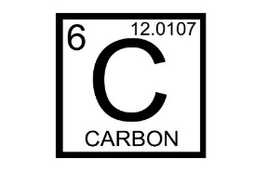

Fill in the following diagram with the processes of the carbon cycle that you learned about in the carbon cycle presentation (Hint: two of the boxes shown use the same process).

Hydrosphere Carbon Pool

Lithosphere Carbon Pool

Biosphere Carbon Pool

Atmosphere Carbon Pool