Careers in Veterinary Medicine Matching Quiz
Answer ONE letter per question (NO letter will be used more than once)
Word Bank
A. Registered Veterinarian Technician
B. United States Department of Agriculture (USDA)
C. Specialization Private Practice
D. Guardians of Animal Welfare
E. Type of Clinic
F. Certified Veterinarian Assistant
G. Center for Disease Control and Prevention (CDC)
H. Zoological Medicine
I. Nonprofit Organization
J. Principles of Veterinary Medical Ethics (the Principles)
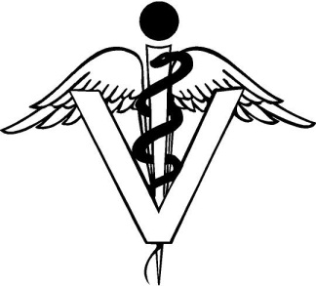
- The primary purpose is to serve society: ________
- Vet-I-Care is a: ________
- Every licensed veterinarian is expected to follow the :________
- A person who has completed a program through TVMA and is certified by the TVMA and hired by a licensed vet: __________
- The government department that regulates food safety and quality: _________
- Emphasis on “Zoo” animal health: _________
- The type of private practice that only certain species of animals are treated: _______
- Which government department regulates animals crossing state borders: ________
- What determines the amount of physical work that will be required of you?: _________
- You must be at least 18 years old to become this: ________

