Catch A Cloud!
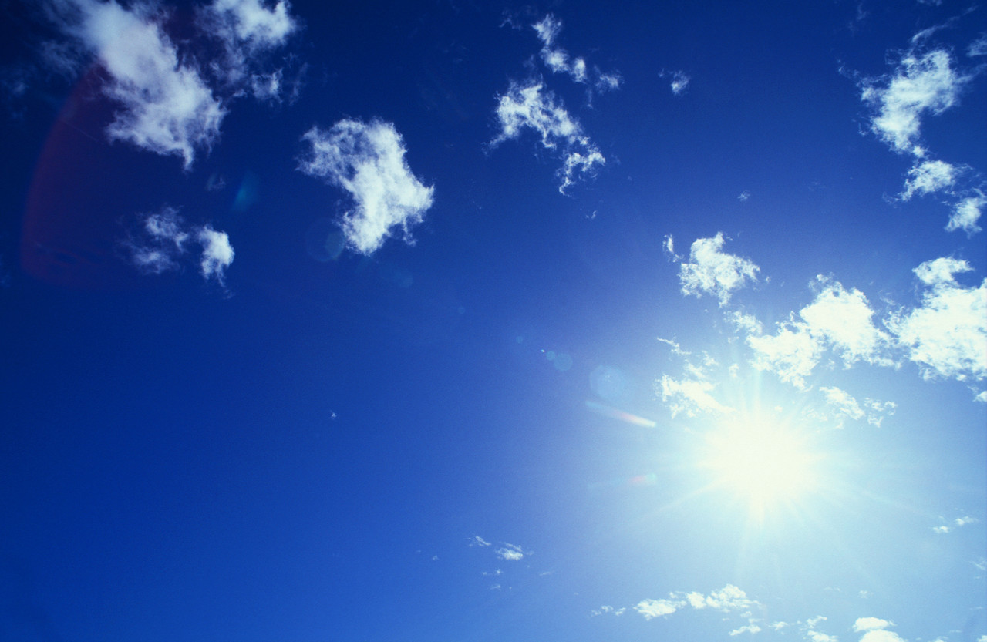

Summary:
In this activity, students will explore the relationships between solar energy, water, and the weather by creating their own clouds. In doing so, students will better understand how weather is formed and regulated out of what may seem like “thin air.”
Subject:
Science:
8.10 (A) Illustrate interactions between matter and energy
8.10 (B) Describe interactions among solar, weather, and ocean systems

Grade Level:
Target Grade: 8
Upper Bound: 8
Lower Bound: 8

Time Required: 30-45 minutes
Activity Team/Group Size: 4

Materials:
- Large (2 liter), clear plastic bottles with caps
- Cold and hot water
- Matches
- Copy of the Worksheet for each team

Reusable Activity Cost Per Group [in dollars]: $2
Expendable Activity Cost Per Group [in dollars]: $2
Learning Objectives:
- Present Water Cycle PowerPoint
- Explain how clouds form from the water cycle and contribute to weather.
  - The water vapor rises in warm air and eventually condenses in cooler air around small particles like dust.
  - Cold and warm fronts form clouds of different types.
    - Cold fronts, which have high density (high pressure) and low temperatures, typically cause a narrow band of showers and thunderstorms to form.
    - Warm fronts, which have lower density (lower pressure) and higher temperatures, can cause fog or stratiform thunderstorm clouds to form.
- Discuss how weather forms from differences in atmospheric pressure caused by solar heating.
  - Wind is the flow of air that travels in the direction of high pressure to low pressure.
  - Storm systems generally result from a combination of cold and warm fronts.
    - Core of low pressure surrounded by high pressure creates wind and storm clouds.

Lesson Introduction / Motivation:
Begin by pointing out clouds in the sky or showing pictures of different kinds of clouds, and then asking the students what they are made of, how they are formed, etc. This may seem very easy to the class, so the teacher can then ask how clouds relate to the weather. Then, the students can be told to simulate weather for themselves by creating clouds in the activity.
Lesson Plan:
- Fill a large (2 liter), clear, plastic bottle about 1/3 full with cold tap water and close the bottle with a cap.
- Shake the bottle for about 30 seconds and set it on the table.
- Squeeze the bottle and release pressure, repeating this process several times.
- Remove the cap and light a match above the bottle, dropping the match inside and quickly tightening the cap on the bottle.
- Slowly squeeze the bottle and release pressure, repeating this process several times, and observe.
- Rinse out the bottle and refill it 1/3 full with hot water and close the bottle with a cap.
- Repeat steps 2-5.
- If two bottles are used for each group, the students could combine the two clouds by joining the open ends of the bottles to simulate how cold and warm fronts interact.
Lesson Closure:
Class can discuss how certain weather events occur from the concepts explored in this activity, and where these conditions might be found. Possible examples: (tornadoes – change in wind direction and increase in wind speed forms rotating column of air that rises vertically in updraft; thunderstorms – ice crystals formed as cloud grows upwards, causing electrical charges to form; hurricanes – warm water evaporates from the ocean to form clouds as wind flows upward and then outward).
Assessment:
The student groups should turn in their Catch A Cloud! Worksheet so they can be assessed for their participation in the activity and understanding of how weather forms.
Vocabulary / Definitions:
- Weather – The set of phenomena in a given atmosphere at a given time.
- Evaporation – Process by which molecules in a liquid become gaseous without being heated to boiling point.
- Condensation – Process by which molecules in a gas become a liquid.
- Precipitation – Form of water that has condensed and fallen to the ground as rain, snow, sleet or hail.
- Front – Boundary between two air masses of different densities, and the main cause of significant weather; a cold front is where a cool air mass advances past a warm air mass and a warm front is where a warm air mass advances past a cool air mass.
- Updraft – A warm column of air that rises within a cloud.
- Downdraft – A sudden descent of cool or cold air to the ground, usually with precipitation.
- Humidity – The amount of water vapor in a sample of air compared to the maximum amount of water vapor the air can hold at any specific temperature.

Background and Concepts for Teachers:
- Teachers should have an understanding of the water cycle and the concepts behind the formation of weather systems.

Lesson Scaling:
The lessons of this activity can be taught in greater detail. For instance, the concepts of water cycling and weather formation can be taught all the way to the molecular level. Also, more can be discussed on the ocean and land environments that contribute to weather.

Safety Issues:
This activity should be conducted outside, since matches are used and smoke is produced. The teacher should light matches to prevent the students from harming themselves or others.

References:
http://www.weatherwizkids.com/
http://weathereye.kgan.com/cadet/cloudless/teachers.html
http://www.weatherwizkids.com/cloud1.htm

Keywords:
- Weather
- Solar
- Oceans
- Water
- Cloud

Please email us your comments on this lesson:
E-mail to ljohnson@cvm.tamu.edu
Please include the title of the lesson, whether you are a teacher, resident scientist or college faculty and what grade you used it for.

Undergraduate Fellow: Chris Prigmore
Graduate Fellow: Ruth Mullins
Date Submitted: June 19, 2009
Teacher’s Comments:

