PEER Teacher Requested Resource
Lesson Plan | Cellular Respiration

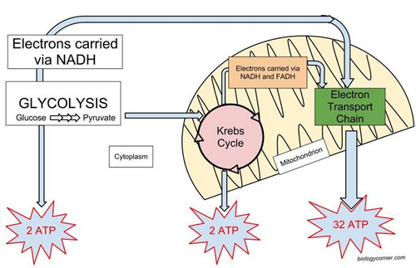
Cellular Respiration

Download all Associated Files for this lesson from our Website

Summary: The students will learn about cellular respiration as it takes place in mammals. They will gain an understanding of glycolysis, the citric acid cycle, oxidative phosphorylation, and fermentation. The PowerPoint presentation and accompanying videos will allow the students to grasp the complicated process of cellular respiration. The crossword puzzle will serve as both an activity and an assessment of their mastery of the subject.
Keywords: aerobic, anaerobic, ATP, citric acid cycle, fermentation, glycolysis, lactic acid , oxidative phosphorylation

Subject TEKS: Biology (9)B: compare the reactants and products of photosynthesis and cellular respiration in terms of energy and matter.

Grade Level: 9-12th

Learning Objectives:
The learner will be able to:
- Discribe the processes involved in cellular respiration including glycolysis, fermentation, oxidative phosphorylation and the citric acid cycle
- Identify the reactants and products produced in each pathway of cellular respiration
- Differentiate between anaerobic and aerobic processes
- Complete the crossword puzzle without any errors

Time Required: One class period.

Materials: Cellular Respiration PowerPoint and Cellular Respiration Crossword Puzzle

Background/Concepts for Teachers: Cellular respiration is a set of metabolic reactions and processes that take place in the cells of organisms to convert biochemical energy from nutrients into energy in the form of adenosine triphosphate (ATP).

Vocabulary / Definitions:
- Aerobic: refers to oxygen requiring cells or organisms
- Anaerobic: refers to the lack of oxygen requirement for cells or organisms
- ATP: adenosine triphosphate, provides energy for the cell.
- Citric Acid Cycle: series of chemical reactions used by all aerobic organisms to generate energy through the oxidation of acetyl-CoA.
- Fermentation: metabolic process that converts sugars to acids, gases, or alcohol.
- Glycolysis: metabolic pathway that converts glucose into pyruvate.
- Lactic acid - a colorless syrupy organic acid formed in sour milk and produced in the muscle tissues during strenuous exercise.
- Oxidative Phosphorylation: metabolic pathway that uses the mitochondria’s structure, enzymes, and energy released by the oxidation of nutrients to form ATP.

Lesson Introduction/Motivation: https://youtu.be/Of0-MQg1YPg This short video describes the diet of Olympic swimmer Michael Phelp. After watching the video ask students to explain:
- Why Phelps eats so many calories (try to guide them into explaining that he needs the energy)
- How those calories are transformed into energy
Presentation/Explanation: The presentation includes several stopping points to check student understanding. A variety of videos on cellular respiration will help students retain information.

Activity/Application:
- Demonstration – Students can observe the product of cellular respiration (carbon dioxide) by exhaling through a straw into Lime water: https://www.onlinemathlearning.com/limewater-test.html
- http://www.phschool.com/science/biology_place/labbench/lab5/intro.html This is a great walk through of a cellular respiration experiment including a processing questions and a quiz. It would be best if students can actually perform the experiment as well.

Assessment/Evaluation: Cellular respiration crossword puzzle will be a fun assessment that will test their understanding of the lesson.

Lesson Closure: Have students work with a partner and diagram the process of cellular respiration.

Lesson Extensions: For some students, cellular respiration is a chance for them to make connections between what we eat and how we use the energy. Have students discuss which types of energy (fats, carbohydrates) enter cell respiration at different points of the pathway.

Safety Issues: None.

Resources:
- http://www.sciencemusicvideos.com/ap-biology/module-10-cellular-respiration/
- https://bloomboard.com/users/Jeffrey.Sack/collections/a-collection-of-cellular-respiration-labs-and-interactive-activities-for-high-school-students/87c81c93-e922-4999-b98c-bcc93e1714eb
- Cell respiration demonstration
- Citric acid cycle
- Oxidative phosphorylation
- Cell respiration and energy

References:
- Phschool
- Biologypages
- Hyperphysics

Authors:
Undergraduate Fellow Name: Chanel Berns

