Carbon Dioxide CO₂ in Cellular Respiration
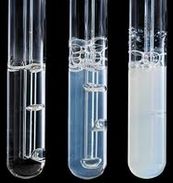
A byproduct of cellular respiration (a catabolic reaction) is carbon dioxide. In every catabolic reaction carbon dioxide is a byproduct.
Purpose: To observe the byproduct carbon dioxide from cellular respiration.
Materials:
Drinking straw
Beaker
A solution of Limewater Ca(OH)₂ available at hardware stores, paint stores, or fertilizer stores. (also available online: http://www.mansionschools.com/limewater-solution-1-liter-46533-chemicals.html)
Procedure:
1. Pour limewater to fill up half the beaker.
2. Submerge the bottom end of the straw in the lime water.
3. Have a volunteer breathe out into the straw slowly and carefully.
4. Watch as the carbon dioxide reacts with the limewater.

What did you see: _______________________________________________________________
______________________________________________________________________________
______________________________________________________________________________
Explain why this happened: _______________________________________________________
______________________________________________________________________________
______________________________________________________________________________
______________________________________________________________________________

