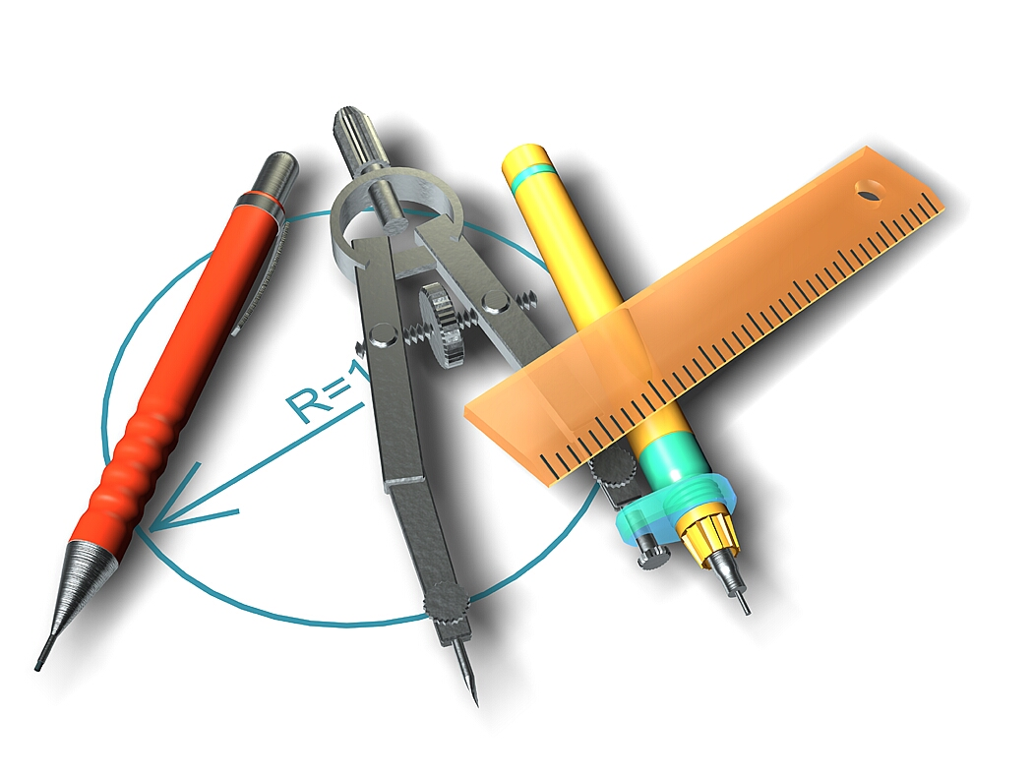
Circles from Space

Summary:
This activity will help students become more interested in the importance of circles. It is a good hands-on activity where students will be able to use a compass to draw circles and at the same time look at the important parts of a circle. They will be able to use the radius or diameter to find the circumference of a circle. Also, they will have an interesting scenario where UFO’s crash on Earth. This helps in getting them excited about the activity.
Subject TEKS:
- Math:
  - 6.6C: Geometry and spatial reasoning; describe the relationship between radius, diameter, and circumference of a circle.
  - 6.8A: Measurement; estimate measurements and evaluate reasonableness of results.
  - 6.11A: Identifies and applies mathematics to everyday experiences.
  - 6.11D: Student uses tools such as real objects to solve problems.
Grade Level:
- Target Grade: 6
- Upper Bound: 6
- Lower Bound: 6
Time Required: 45 minutes (one class period)
Activity Team/Group Size: Individual work

Materials:
- Compass
- Pencil
- U.S. Map (attached)
- Worksheet (attached)

Reusable Activity Cost Per Group [in dollars]: $20-$40 for a class of 20 students.
The compasses are the only items that can be reused. Check with the school, they might have some available, if not, they are about $1-$2 dollars at any local store (i.e. Wal-Mart, Target).
Expendable Activity Cost Per Group [in dollars]: $0

Learning Objectives:
- Finding circumference of circles given radius or diameter
- Knowing relationship between radius and diameter
- Knowing how to use a compass
Lesson Introduction / Motivation:
When I presented this activity to the students, I began by asking them if they had ever thought about what would happen if a UFO crashed into Earth. Some students started laughing while others thought it was just dumb. The students did confess to have thought about it before so then I asked them what would happen if a UFO crashed. Being careful not to let them go off topic, I let them tell me about how craters would form. It was important that they understood that if an UFO or a meteor hit a place on Earth, or in our case, the United States, that place would not be the only one affected. Other surrounding areas would also be affected. It was up to the class to find out how this would happen.
Lesson Plan:
After going through the introduction, which can also be found in the first couple of lines on the worksheet attached, I gave the students a printout of the United States map with some major cities labeled. Let a student read the scenario paragraph out loud, or read it yourself but let them know that they are responsible for following along. The students will be responsible for knowing how to use a compass and some have never used one before so allow for some time to explain how to use it. The activity consists of going through each crash site scenario described and having students find the circumference of each crash site. The fun part consists of drawing the circles on the map (make sure they use a scale) to determine what other cities were affected. If there is a more advanced group, a good way to enhance the lesson is to let them also find the area of each circle. The students should also answer all the questions included in the worksheet.

Lesson Closure:
After they have finished the activity, if there is time to talk about it, ask them if they know of any other scenarios similar to this one where they can use circles to determine the consequences of a particular action.
Assessment:
The teacher should be able to walk around the classroom as the students are working to see if they know how to use a compass and to see if they are grasping the concepts correctly. Some students still have a difficulty using the circumference formulas and they might need some help with that. After the activity, you can ask for the answers to see if they all got the same answer.

Vocabulary / Definitions:
- Diameter: length of line that passes through the center of a circle
- Radius: the length of a line that goes from the center of a circle to any point on the edge of the circle
- Circumference: the length around the edge of a circle
Background and Concepts for Teachers:
- How to calculate circumference
- How to use a compass
Prerequisites for this Lesson:
- How to use a compass
Lesson Scaling:

If there are students that are more advanced, you can also ask them to find the area of the given crash sites.

Multimedia Support and Attachments:
- PowerPoint on US Map
- Word Document on Circles from Space
Keywords:
- Diameter
- Radius
- Circumference
Authors:
Graduate Fellow Name: Tanya Mendez
Teacher Mentor Name: Sondra Junek
Undergraduate Fellow Name: Dina Mundella
Date Submitted: 02/20/2007
Date Last Edited: 02/20/2007
Please email us your comments on this lesson:
E-mail to ljohnson@cvm.tamu.edu
Please include the title of the lesson, whether you are a teacher, resident scientist or college faculty and what grade you used it for.

Teacher’s Comments:

