Monogastric and Hindgut Digestion Activity
Activity Objectives:
To improve the student’s comprehension of the monogastric and hindgut digestive systems through an interactive class activity.
Materials:
- Meter stick, ruler, or measuring tape
- Tape and/or string
- Scissors
- Marker
Procedure:
Get students involved! Take the class to a long, straight hallway, sidewalk, or football field. Using a meter stick, ruler, or measuring tape; have the students measure out and compare the varying lengths of the small and large intestines in the human, pig, and horse.
- Have a student stand in place, marking the beginning of the ilium (for small intestine) or cecum (for large intestine).
- Have a second student begin measuring out one of the following distances (a diagram is included on the following page for clarification):
  - Small intestine:
    - Human: 22 feet
    - Pig: 55 feet
    - Horse: 70 feet
  - Large intestine:
    - Human: 5 feet
    - Pig: 17 feet
    - Horses: 24 feet
- A third student should follow behind the second student with string or mark the end of the ‘ilium/cecum’ with tape and/or standing in that place
- Label each of the distances with the species and type of intestine (small or large) represented with each pathway
- Repeat 5 more times so that a distance is measured for both the small and large intestine for each of the three species
- Have the students record these distances using a bar graph.
- Students should then research the amount (in pounds) of daily forage recommended for each species and record this information on the same graph. Using all of this information discuss why the difference in length of digestive tract might exist between species.
Discussion:
Ask the students the following questions and hold a class discussion with them, allowing them to thoroughly process these questions.
- What is the greatest limitation of this activity when comparing how much food is actually stored in each section of the digestive system?
ANSWER: The VOLUME is not measured. For example, horses have a much longer small intestine than large intestine, but the large intestine holds MUCH more food than the small intestine because its diameter is much larger.
- Why would these animal species all have different lengths of intestine?
ANSWER: the animals have adapted to best fit their diet. Herbivores (like horses) need a long time to ferment the high cellulose (fiber) content in their diet, which cannot be broken down through enzymatic digestion. Since fiber must be fermented, they have adapted to have a more extensive large intestine than the other species. Both humans and pigs are omnivores, meaning that most individuals consume both meat and forages. Humans have the smallest percent of GI tract dedicated to the large intestine because our diet also consists of the smallest amount of forage when compared to swine and horses. Pigs are very similar to humans but have a slightly larger large intestine. This is due to the higher intake of forage than humans.

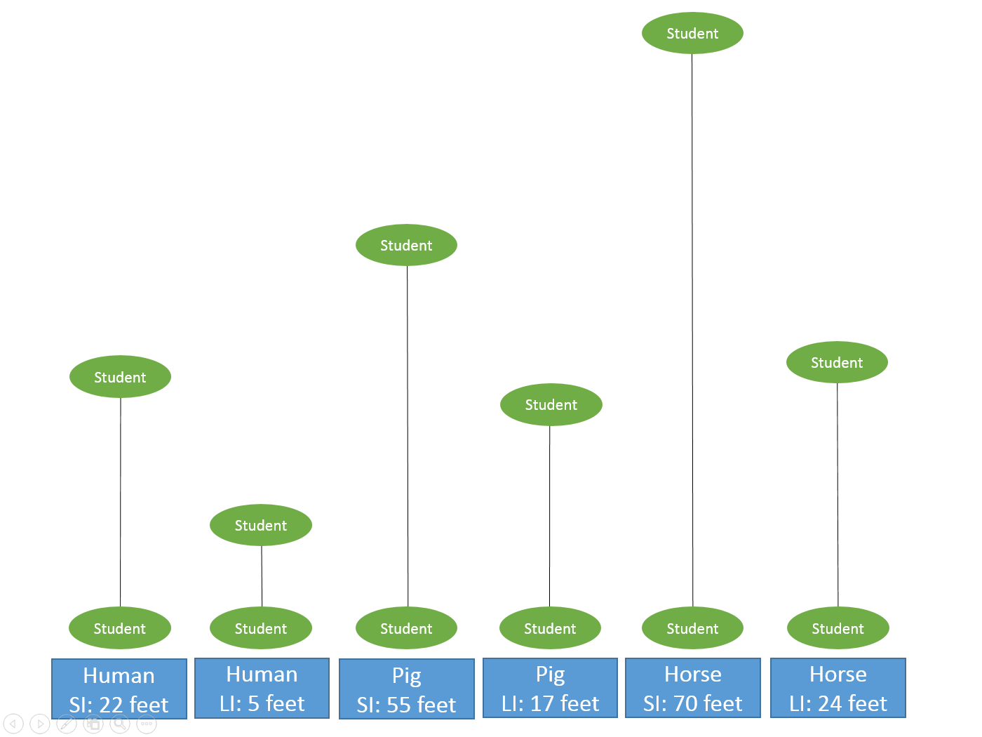
Black lines: string or tape
Blue square: labels
The students can measure the distances with tape or string and observe the varying lengths of human, swine, and equine small and large intestines. Ask the students to label each of lines with the corresponding animal species, length, and part of the digestive tract that it represents. Then ask the students why the animals might have such different digestive systems.

