Organic Materials Management: Compost Pile Critters
Adapted From: http://www.calrecycle.ca.gov/organics/homecompost/Critters/Default.htm

Level Three—Tertiary Consumers
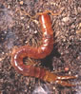Centipedes are flattened, segmented worms with 15 or more pairs of legs--one pair per segment. They hatch from eggs laid during the warm months and gradually grow to their adult size. Centipedes are third-level consumers, feeding only on living animals, especially insects, spiders and invertebrates such as worms.

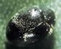Mites are related to ticks, spiders, and horseshoe crabs because they have in common six leg-like, jointed appendages. Some mites are small enough to be invisible to the naked eye, while some tropical species are up to a half-inch in length. Mites reproduce very rapidly, moving through larval, nymph, adult, and dormant stages. They attack plant matter, but some are also second-level consumers, ingesting nematodes, fly larvae, other mites, and springtails.
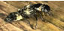Rove Beetles are the most common beetles in compost. While feather-winged beetles feed on fungal spores, the larger rove beetles prey on other insects. Beetles are easily visible insects with two pairs of wings, the more forward-placed of these serving as a cover or shield for the folded and thinner back-set ones that are used for flying. These beetles prey on snails, insects, and other small animals. The black rove beetle is an acknowledged predator of snails and slugs. Some people import them to their gardens when slugs become a garden problem.
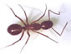Ants feed on a variety of material, including aphid honeydew, fungi, seeds, sweets, scraps, other insects, and sometimes other ants. Compost provides some of these foods, and it also provides shelter for nests and hills. They will remain only while the pile is relatively cool. Ants prey on first-level consumers, and may benefit the composting process by bringing fungi and other organisms into their nests. The work of ants can make compost richer in phosphorus and potassium by moving minerals from one place to another.

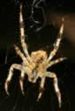Spiders feed on insects and other small invertebrates.

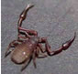Pseudoscorpions are predators which seize victims with their visible front claws, then inject poison from glands located at the tips of the claws. But don't panic! Pseudoscorpians are so small, their prey include tiny nematode worms, mites, larvae, and small earthworms.

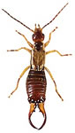Earwigs are large predators, easily seen with the naked eye. They move about quickly. Some are predators, others feed chiefly on decayed vegetation.

