“Cootie Catchers”

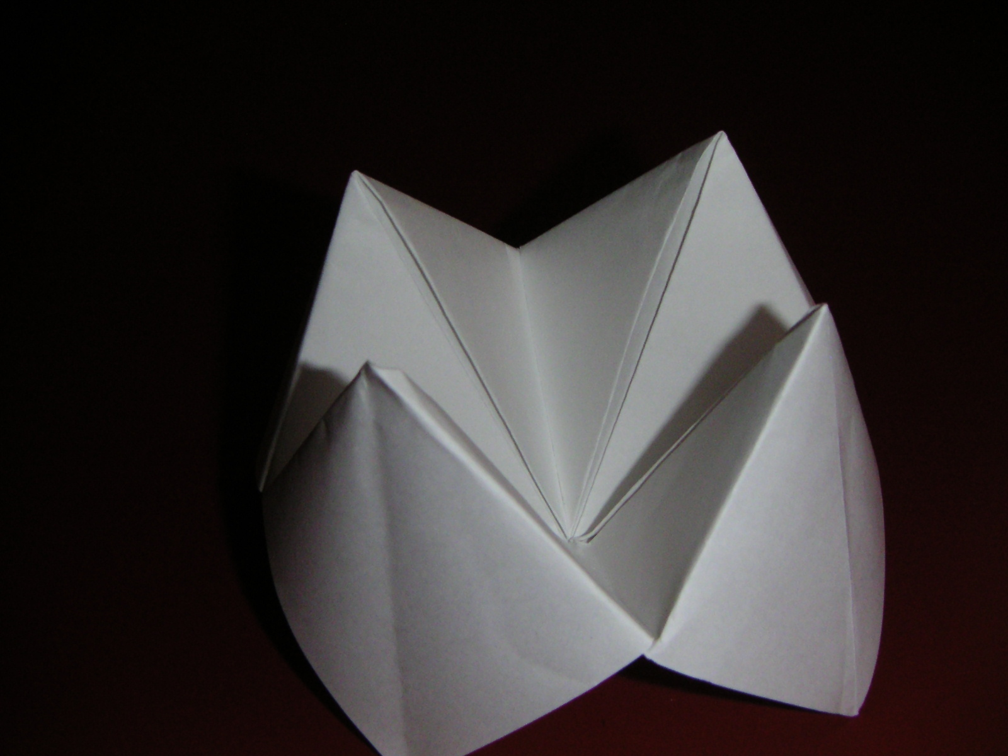
Summary:
This activity is designed for the students to do some manual work consisting of paper folding as well as come up with their own problems regarding any subject they are currently studying. After students create their “cootie catcher” or as I have known it, their “fortune teller” they can pass it around to other students and they can solve each other’s problems. This is useful when we want the students to practice quick thinking skills and to have some responsibility over their own learning.
Subject:
- Math:
  - Depending on the material you wish to include in this project, this activity can cover a wide range of TEKS.
Grade Level:
- Target Grade: 6
- Upper Bound:7
- Lower Bound:5
Time Required: - Two class periods
- 45 minutes to create “cootie catcher”
- 45 minutes to solve the problems
Activity Team/Group Size: The students can work individually in creating their own “cootie catchers” but can work in pairs to create problems and solve each other’s math problems.

Materials:
- White paper
- Markers or crayons (optional)
- Scissors
Reusable Activity Cost Per Group [in dollars]: $ 0
Expendable Activity Cost Per Group [in dollars]: $ 0

Learning Objectives:
- The objective of this activity is to have students take responsibility of what they learn and what others learn. They have the opportunity to create a little game that can be passed around to their classmates in order for everyone to solve problems that their peers have created. This can be much more interesting for them than working on worksheets. When they actually have a say into what they learn, they are more willing to participate. This activity can be used for many topics, ranging from proportional fractions, multiplication, division, ratios, etc.
Lesson Introduction / Motivation:
The first thing you should ask your students is if they know what a “cootie catcher” is, you will be surprised as to how many students have heard of these before (they are usually used by kids for other reasons such as fortune telling, etc.). After they finish talking about what they remember of what “cootie catchers” are then let them know that we will be using them in order to practice solving each others math problems. Usually you will get a student or two who know how to create these “cootie catchers” and they will be more than willing to help the rest of the class.
Lesson Plan:
I will include the instructions in creating the “cootie catchers” along with pictures detailing every step so that you can visualize the final product. The pictures are in the attached Power Point Presentation.
- Fold a white sheet a paper diagonally so that two adjacent sides are touching.
- With a pair of scissors, cut the remaining section of paper.
- Unfold the paper and then fold all corners of the square to the center.
- Turn the new folded paper over (folded sides down) and then again fold all the corners to the center.
- Fold the new square in an upward motion to get the desired product.
- Place the questions or math problems under the flaps so that students can answer each other’s problems.
Lesson Closure:
At the end of the activity, it might be a good idea to ask the students how they liked the activity to see if it can be helpful in the future with other topics. The students love hands-on activities and this is a great way to let them have some freedom as well as helping them understand the material.
Assessment:
The students will each solve each other’s problems so it will be a good idea if the students that created the problems also create their own answers so that you can keep track that they understand the concepts.

Lesson Scaling:

The beauty of this activity is that it can be used in a wide range of topics and students. I am pretty sure though, younger students will probably get more excited in creating these.

Troubleshooting Tips:
This can be a pretty complicated activity for those of us that do not know how to create our own “cootie catcher.” I suggest that you ask students if any of them know how to create one so that they can help the rest of the class. I also suggest that the person heading this activity have practice creating one or more of these so that he/she can help the students.
Keywords:
- Mathematics
Authors:
Graduate Fellow Name: Tanya Mendez
Teacher Mentor Name: Kevin Bradford
Undergraduate Fellow Name: Dina Mundela
Date Submitted: 12/16/2007
Date Last Edited: 12/16/2007
Please email us your comments on this lesson:
E-mail to ljohnson@cvm.tamu.edu
Please include the title of the lesson, whether you are a teacher, resident scientist or college faculty and what grade you used it for.

Teacher’s Comments:

