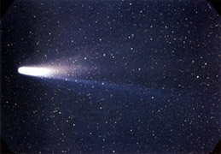
NAME : _____________________

Date : _______________________

Impacts in Space!

ACTIVITY ONE:

- How do you think that the Size of the Meteor is going to impact the size of the Crater?

Meteorite Size | Crater Diameter (cm)
Meteorite Size | A | B | C | Average
Small
Medium
Large

- Were there any differences between the craters? ______________________

_______________________________________________________________________

Similarities? __________________________________________________________

ACTIVITY TWO:

- How do you think that the Distance of the Meteor is going to impact the size of the Crater?

Meteorite Distance | Crater Diameter (cm)
Meteorite Distance | A | B | C | Average
10 cm
50 cm
100 cm

- Were there any differences between the craters? ______________________

_______________________________________________________________________

Similarities? __________________________________________________________

- Draw what one of your craters looked like.
Label prominent features of the Crater.

The Sky is
Falling!!!

