What BEAK-ame of Darwin’s finches?
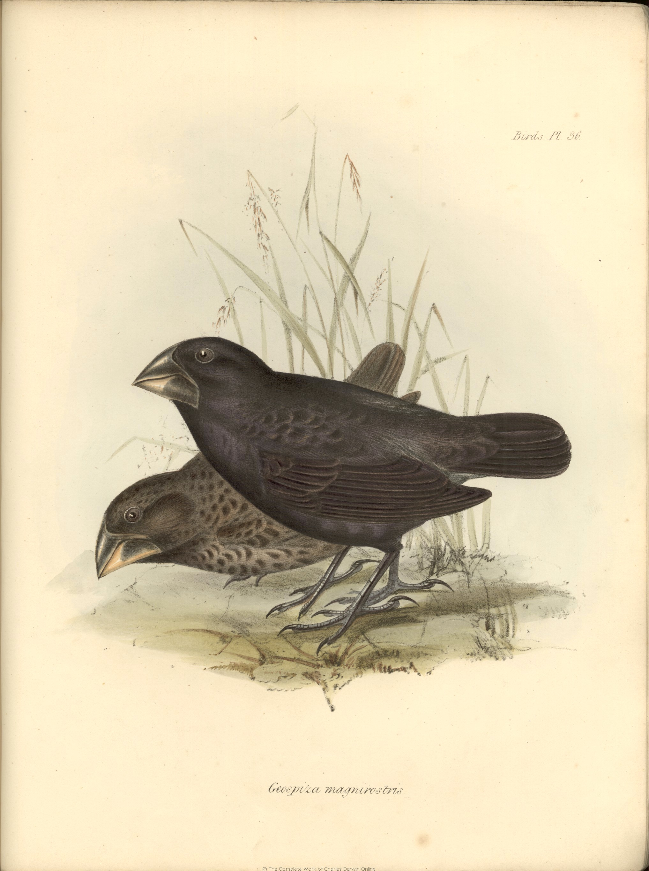

Summary:
Medium ground finches are one of the endemic (found nowhere else) finches that are found on the Galapagos Islands. Charles Darwin collected specimens from different islands, and they were identified as 14 different species; seven of these were ground finches. Medium ground finches are all about the same size (10–20 cm) and have similar plumage. The most important differences between species are in the size and shape of their beaks, and the beaks are highly adapted to different food sources. Darwin used these differences as supporting evidence for his theory of natural selection.
Subject:
- Science: 7.11C
Grade Level:
- Target Grade: 7
- Upper Bound: 8
- Lower Bound: 6
Time Required: 60 minutes
Activity Team/Group Size: 1

Materials:
- Plastic spoons, plastic forks, tongue depressors, toothpicks
- Plastic bags
- Dried peas/bean mix, uncooked pasta noodles, OR
- Twizzlers, Starburst, M&Ms, Skittles
Reusable Activity Cost Per Group [in dollars]: ~$10
Expendable Activity Cost Per Group [in dollars]: ~$15

Learning Objectives:
Understand and identify some changes in genetic traits that have occurred over several generations through natural selection and selective breeding
Lesson Introduction / Motivation:
Different kinds of beaks have evolved to eat different kinds of food; this way, the finches do not have to compete for food in the same area. [Mini-activity: play ‘pin the beak on the bird’ to help match beak forms to food type – see attached handout]
Lesson Plan:
ADAPTED FROM PEARSON EDUCATION’S INVESTIGATIVE LAB ACTIVITY “BIRDS ON AN ISLAND”
- Scatter the “food” in an open area
    - Skew the amounts of food – if the tongue depressors are best for getting Twizzlers, or the spoon is best for the M&Ms, etc., make the amount of one type of food more than any of the others, giving one kind of beak an advantage.
- Each student will receive a utensil (their “beak”) and a plastic bag (their “nest”)
- Each student will place their bag in a specified area, and be allowed a given amount of time to collect “food,” and return it to their “nest,” following these rules:
a. Students may not use their hands except to hold the plastic utensil
and open the plastic bag
b. Students must retrieve food from the designated food area; students may not push other “birds,” deliberately knock the food out of the other “birds’ beaks,” or steal food from the other “birds’ nests.”
c. Students must put their nest in the same general area as the other
birds’ nests.
d. Do not eat any of the food.
e. Students may only pick up one item of food at a time.

- At the end their permitted time, have the students count how many pieces of food they have.

Number of food pieces collected | Outcome
Less than 5 | Does not survive
5-10 | Survives but does not reproduce
11-15 | Survives and has 1 offspring
16-20 | Survives and has 2 offspring
21-25 | Survives and has 3 offspring
- Students who did not ‘survive’ may come back as the offspring of a ‘surviving’ classmate, if the classmate gathered enough food to ‘reproduce’ – have them switch out utensil ‘beaks’ to the same utensil as the surviving species. Repeat the process until the majority of students have become one type of bird – this is how medium ground finches became the dominant kind of finch on
Lesson Closure:
Hold a discussion: why one type of beak was ‘selected for’? Correlate to the different species of finches living on the different islands.
Assessment:
Finish the lesson with an art assignment: describe an environment to the class, and the students will design and draw a bird beak based on what kind of food they think will be available in that environment.

Vocabulary / Definitions:
- Natural selection: a process resulting in the survival of those individuals from a population of animals or plants that are best adapted to the prevailing environmental conditions. The survivors tend to produce more offspring than those less well adapted, so that the characteristics of the population change over time, thus accounting for the process of evolution
- Endemic: belonging exclusively or confined to a particular place
- Divergence: evolutionary process by which organisms descended from a common ancestor tend to acquire different forms when living under different conditions.
Background and Concepts for Teachers:
- Darwin’s theory of natural selection
- Form and function
Lesson Scaling:
For younger students, only have them do two types of ‘beak’ in the activity. Older students can do the activity, then record, graph, and analyze the data afterward.

Lesson Extension:
Have the students do an art project where they design a new species of bird. Where does it live? What kind of adaptations does it have? Adaptations do not need to be limited to beaks: legs, feet, wings, and coloration are all adaptive characteristics in birds. The students can present their birds to the class and describe how the bird is well-adapted to its habitat.

Safety Issues:
If this activity is indoors, make sure none of the students are running around or bumping into each other. If you are using the candy, you’ll want to be careful about allergies.

References:
- http://www.doc.ic.ac.uk/~kpt/terraquest/galapagos/wildlife/island/finch.html
- http://albert.sacredsf.org/user/kendall/biology/biol%20cycle%203/labs/natsel_lab.pdf
- http://books.google.com/books?id=8l5OImG50EcC&pg=PA40&lpg=PA40&dq=changes+in+genetic+traits+in+medium+ground+finches&source=bl&ots=ZMNqKHTZoE&sig=dutLIEUjNBB52cpTkOKUKqKZJgA&hl=en&ei=Nlm4TYrJL8S5tgfxo7TeBA&sa=X&oi=book_result&ct=result&resnum=6&ved=0CDIQ6AEwBTge#v=onepage&q&f=false
- http://www.normanbirdsanctuary.org/beak_adaptations.shtml
- http://knight.noble-hs.sad60.k12.me.us/content/exploringLife/text/chapter14/concept14.4.html
- http://www.galapagos-islands-tourguide.com/galapagos-ground-finch.html

Keywords:
- Charles Darwin
- endemic
- natural selection
- divergence
Authors:
Undergraduate Fellow Name: Katelyn Wilson
Please email us your comments on this lesson:
E-mail to ljohnson@cvm.tamu.edu
Please include the title of the lesson, whether you are a teacher, resident scientist or college faculty and what grade you used it for.

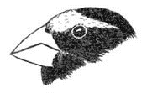 | A cone shaped bill is found in many birds such as finches and grosbeaks. It is a strong beak used for cracking seeds.
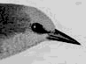 | Thin, slender, pointed beaks are found mainly in insect eaters. They are used to pick insects off leaves, twigs, and bark. This warbler is a good example.
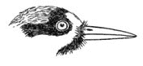 | Woodpeckers have strong beaks which taper to the tip, forming a chisel for pecking holes in trees for food or nests. Most feed on insects which live under the bark.
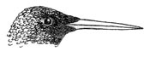 | Hummingbirds have long, tubular bills that resemble straws, which they use to sip nectar from flowers.
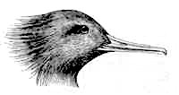 | Mergansers, specialized for eating fish, have sharp tooth-like structures on the edge of the bill to hold fish tightly.
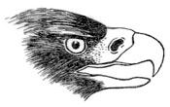 | Hawks, owls, and other birds of prey which catch and kill live prey have sharp, "hooked" beaks. These are used to bite the skull or neck and also to tear the body into pieces small enough to swallow.
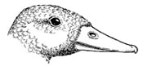 | The edges of a Mallard's bill are fringed to strain plants, seeds, and small animals from mud and water.
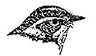 | Beaks which are flat and wide at the base are found in birds which catch insects in flight, such as flycatchers. These birds also often have "whiskers," which are actually modified feathers, at the corners of the mouth, which effectively widens the mouth opening, allowing more effective capture of prey.

