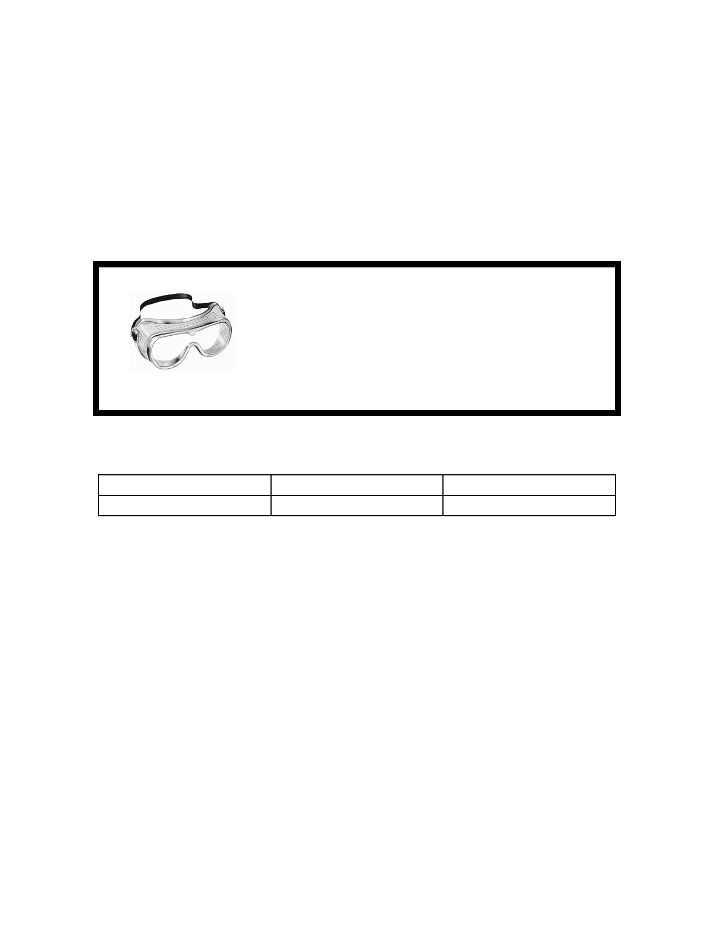

Name _________________________

What’s that Mineral? - Lab Activity

**Purpose:** To use the physical properties of minerals to identify 10 minerals.

**Goggles need to be worn at all times. Thin plate glass will be used during the lab.**

**Glass plates will break easily. Do NOT hold the**

**glass plate while doing the experiment. Keep glass flat on lab table to prevent getting cut!**

**Materials:**

mineral tray streak plates penny

steel nail glass plate goggles

**Procedure:**

1. Test each mineral for the following properties and then determine the mineral by using the identification chart given:

1. **Color** - Identify and record the color on your data chart.
2. **Luster** - Determine if the mineral is **metallic (M) or**

**non-metallic (NM)**. If metallic, that means it looks like a metal. Write it like this: ( **M-** shiny or dull). If it is non- metallic, then classify it as: **NM -** glassy, or resinous (like amber), or greasy, or pearly, or dull or earthy. Record the data in your data table.



1. **Streak** –If you are testing a dark mineral, use white streak plate, if testing a light mineral, use black streak plate. Record the color of the streak on the data chart.
2. **Hardness** - Use Moh's Hardness Scale below to determine the approximate hardness of the mineral. Record the data.

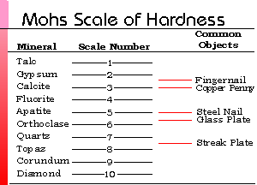

1. **Breakage** - Determine the break for each mineral either cleavage or fracture. When a mineral breaks along smooth, definite surfaces, **cleavage** occurs. When a mineral breaks unevenly, **fracture** occurs. Record the data.

**Data Table**:

|  |  |  |  |  |  |
| --- | --- | --- | --- | --- | --- |
| **Color** | **Luster** | **Streak** | **Hardness** | **Cleavage?** | **Mineral** |
|  |  |  |  |  |  |
|  |  |  |  |  |  |
|  |  |  |  |  |  |
|  |  |  |  |  |  |
|  |  |  |  |  |  |
|  |  |  |  |  |  |
|  |  |  |  |  |  |
|  |  |  |  |  |  |
|  |  |  |  |  |  |
|  |  |  |  |  |  |



**Questions:** Using the information from your lab, answer the following questions in **COMPLETE SENTENCES**.

1. Which mineral was the hardest to identify? Why?
2. Which mineral was the easiest to identify? Why?

3. Which physical property was the most useful in identifying your

minerals? Why?

4. Which physical property was the least useful in identifying your

minerals? Why?