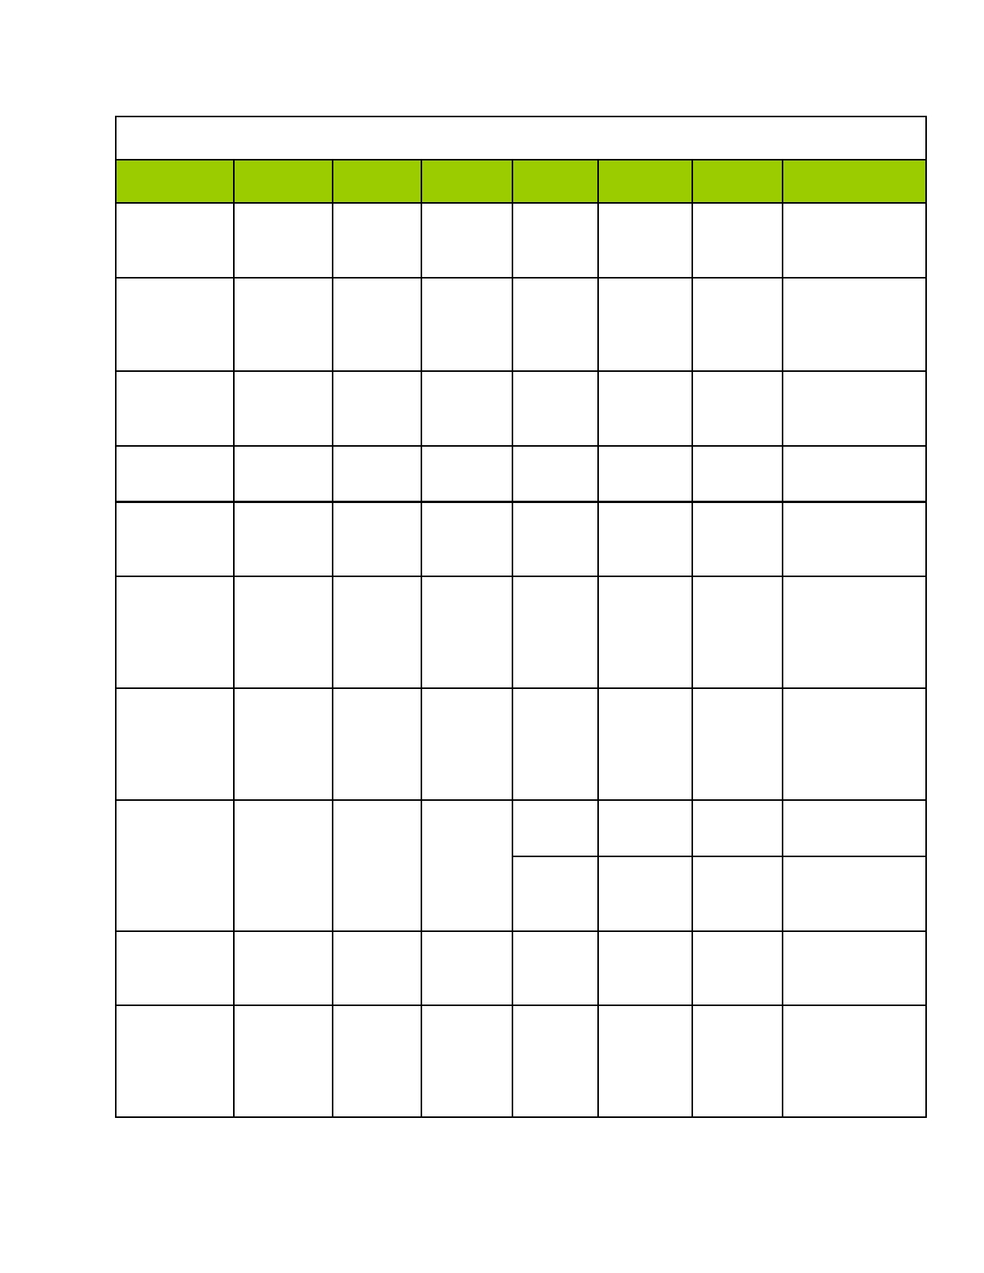Minerals with a Nonmetallic Luster (glassy, pearly, earthy, transparent)

Mineral
(formula)
Bauxite
(mixture of hydrous Al
oxides)

Gypsum
(CaSO4·2H20)

Muscovite
(KAl3Si3010
(OH)2)

Halite (NaCl)

Calcite
(CaCo3)

Flourite (CaF2)

Color

Gray, red,
white, brown

Colorless,
gray,
white, brown
White, light
gray,
yellow,
rose, green
Colorless,
red, white,
blue
Colorless,
white, pale
tints
Colorless,
white, blue.
Green.
Red,
yellow,

Streak

Gray

White

Colorless

Colorless

Colorless.
White

Colorless

Hardness

1-3

2

2.5

2.5

3

4

Density
(g/mL)

1.0 - 3.0

1.0 - 3.0

1.0 - 3.0

1.0 - 3.0

1.0 - 3.0

2.0 - 4.0

Crystal System

None

Monoclinic

Monoclinic

Cubic

Hexagonal

Cubic

Breakage

None

Cleavage

Cleavage

Cleavage

Cleavage

Cleavage

Uses

Source of
aluminum, used
in paints
Used in
preparation of
Plaster of Paris,
dry wall for
building
Used as an
insulator in
electrical
equipment
Salt, very soluble
in water; a
preservative
Fizzes when HCl
is added; frequently florescent

Some are
fluorescent, used
in making steel

Orthoclase
(KAlSi308)
purple
Colorless,
white to
gray,
green, yellow

Colorless

6

1.0 - 3.0

Monoclinic

Cleavage 2 planes meet at
90º

Different types make up over 60% of Earth's
crust;
manufacturing of
ceramics

Augite
(Ca(Mg,Fe,Al)
(AlSi)206

Quartz (SiO2)
Dark green
to black

Colorless,
various
colors

Colorless

Colorless

6

7

2.0 - 4.0

1.0 - 3.0

Monoclinic

Hexagonal

Cleavage

Fracture
Found in igneous
rocks; square or
8 - sided
Used in glass
manufacture,
electronic equipment

Garnet
(Mg,Fe,Ca)3
(Al2Si3O12)

Corundum
(Al2O3)
Red,
brown, black, Ggeen
Colorless,
blue,
brown, green, white, pink

Colorless

Colorless

7.5

9

2.0 - 4.0

3.0 - 5.0

Cubic

Hexagonal

Fracture

Fracture

Used in jewelry;
a birthstone

Transparent
crystals used as gems called ruby
red, sapphire blue, abrasive

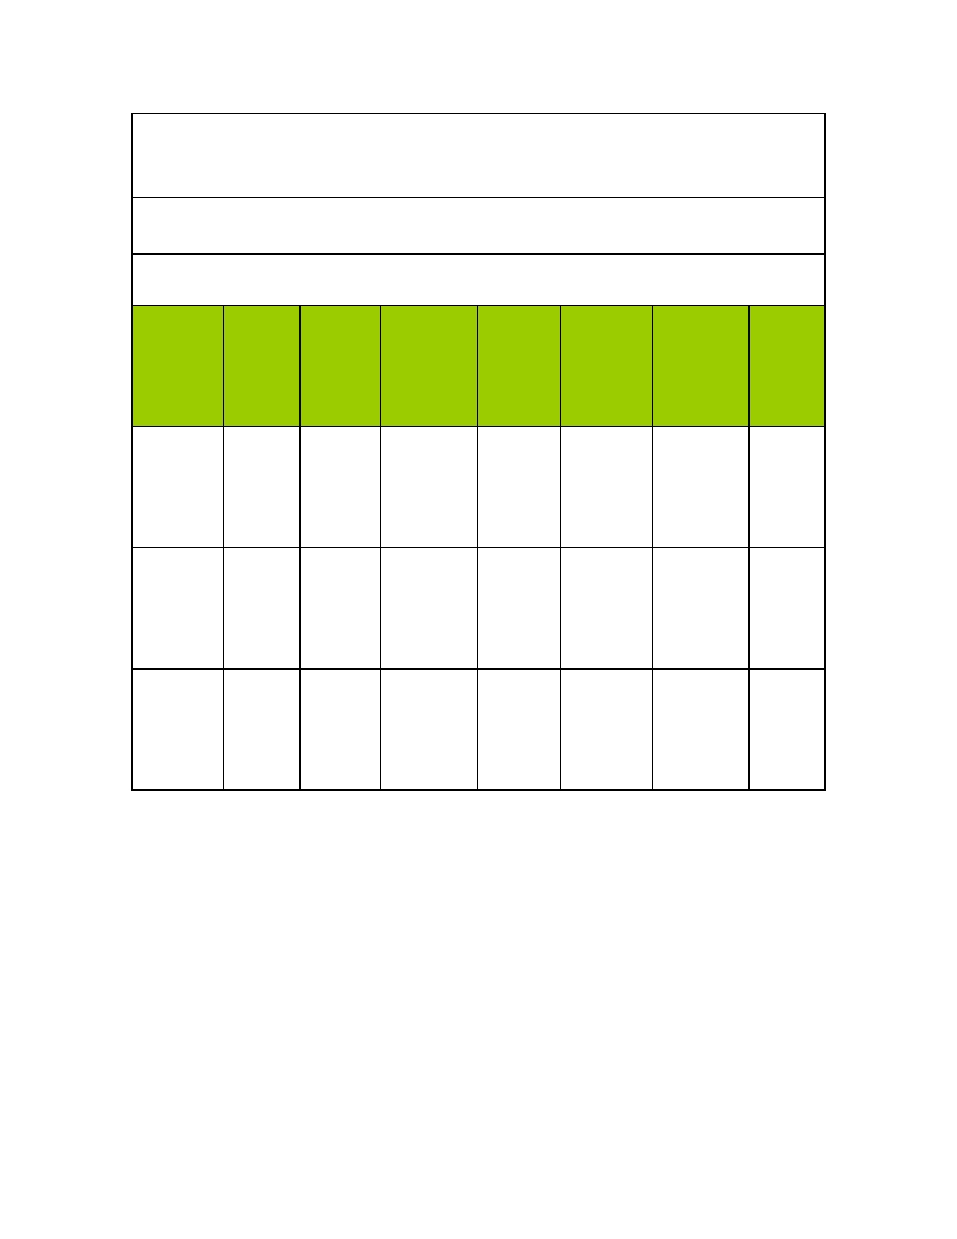MINERAL IDENTIFICATION CHART

Use this chart after all identification tests to determine your mineral!

Minerals with a Metallic Luster (looks like a metal)

Mineral
(formula)

Color

Streak

Hardness

Density
(g/mL)

Crystal System

Breakage

Uses

Pencil

Graphite
(C)

Galena
(PbS)

Pyrite (FeS2)
Black to
gray

Gray

Light,
brassy yellow
Black to
gray

Gray to
black

Greenish
black
1-2

1-2

6.5
1.0 - 3.0

6.0 - 8.0

4.0 - 6.0
Hexagonal

Cubic

Cubic
Cleavage

Cleavage

Fracture
lead,
Battery
poles

Source of lead, Used in pipes, fishing sinkers

Source of iron, "fool's gold"

