Thermal Energy Lesson introduction
Demonstrations with Fire
Safety advisory!
Safety goggles must be worn at all times. Closed toe shoes and long pants are recommended. Long hair must be tied back when using open flames.
Know the location of the fire blanket, fire extinguisher, fire alarm, and evacuation routes. Have a bucket of water on hand just in case. Remind students to not try this at home without adult supervision.
There are seven short, quick demonstrations and all can be viewed on YouTube if materials or safety is a concern – if you want to perform these demonstrations, materials, instructions, and discussion points are listed below as well as YouTube video links for you to watch.
- Teabag Rocket http://www.youtube.com/watch?v=GkkrXxJ4db8 start at 0:22
- Colorful Convection Currents http://www.youtube.com/watch?v=RCO90hvEL1I
- CO₂ & O₂ Convection http://www.youtube.com/watch?v=Pjklnza6Imk
- Heat Conduction in Balloons http://www.youtube.com/watch?v=zih8_BqolS0
- Matchstick Levitation http://www.youtube.com/watch?v=L-i-WLf6kPg

- Teabag Rocket

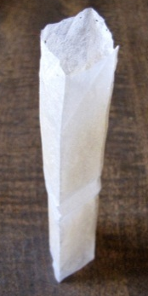
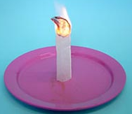
Teabag Rocket Materials:

- Scissors
- Paper teabag
- Match

Teabag Rocket Instructions:

- Using a paper tea bag (not cloth, it will feel like coffee filter material) cut the teabag just under the staple.
- Empty out the tea inside and unfold the bag.
- Stand the bag up on a fire proof surface (e.g., non-flammable plate) that has been cleared of anything capable of catching fire.
- Light the top of the tea bag.
- Gather up ashes and dispose of them in a water bucket to ensure embers are extinguished.
Talk about it: The flame created by burning the teabag heated the air inside the teabag cylinder. When the air inside the cylinder was heated, energy was transferred to individual pieces of air called air molecules. The air molecules moved around more quickly and spread out to take up more space. This means that the air molecules were further apart from each other and therefore the air was less dense. The warmer, less dense air rose above the cooler, denser air. When the teabag burned, the teabag turned into ash and smoke. The smoke lifted away and all that was left was the ash. Ash is light, so it doesn’t require much force to lift it. The rising of the less dense (heated) air inside the teabag had enough force to lift the ash of the teabag. This is the same principle behind hot air balloons.
- Colorful Convection Currents
Colorful Convection materials:
- 4 empty, cleaned and identical glass bottles ~9.5 fl oz (roughly the size of Starbucks Frappuccino coffee drinks)
- Two different colored liquid food dyes
- 2 laminated playing cards
- A pitcher of hot water and a pitcher of cold water

Colorful Convection instructions:
- Add one food dye color to 2 bottles and fill with cold water.
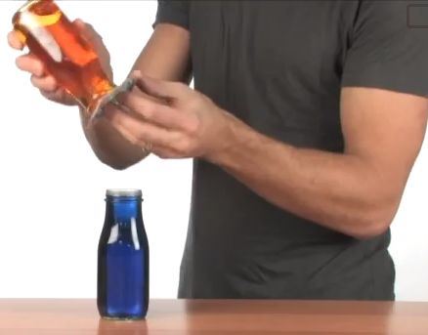
- Add the second food dye color to the remaining two bottles and fill with hot water.
- Place one card on top of a hot water bottle and holding it secure at the lid to prevent water from spilling out, turn the bottle upside down and balance on top of a cold water bottle.
- Repeat step 3 but with a cold water bottle on top and a hot water bottle on bottom.
- Swiftly pull out the card, carefully lining up the bottles to prevent spills.
Talk about it: This is an example of atmospheric convection. The heat of the hot water and the cool temperature of the cold water in the 1st pair do not mix because heat rises and cold sinks in. In the 2nd pair, where initially the heat is at the bottom while the cold is at the top, the heat moves upwards in a convectional cycle. The warm water molecules have more energy and move around at higher rates than cold water molecules. This causes them to have less density compared to the cold water molecules, resulting in the warm water molecules to rise up in the 2nd pair.
- CO₂ & O₂ Convection
CO₂ & O₂ Convection materials:
- 3 tall, skinny candles (birthday candles) of differing lengths
- Empty clear, glass jar tall enough to cover the candles
- Lid of the jar
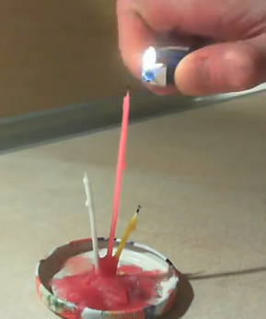
CO₂ & O₂ Convection instructions:
- Melt the candles down to three different lengths one at a time over the lid. The lid will act as a drip pan and catch the melted wax as it falls.
- Blow out the candle and adhere the candle to the still soft melted wax on the lid so that it stands erect.
- When all three are standing, light them.
- Place the empty jar upside down over the candles and into the lid.
Talk about it: Burning candles consume oxygen. Flame causes combustion of waste in the form of carbon dioxide (CO2) and miniscule amounts of water (H₂O). Carbon dioxide is heavier than air but convection currents that cause carbon dioxide accumulates at the top of the jar. Therefore, the candle goes out from highest to lowest, as the jar fills with carbon dioxide from the top to the bottom.
- Heat Conduction in Balloons
Spinning candle materials:
- Small candle in a jar (not in a jar is fine too just skip step 9 & 10)
- Cup of water
- Two regular balloons
- Safety goggles
- A plate or drip pan to catch any water
- Two paperclips (optional)
Heat Conduction in Balloons instructions:
- Light the candle.
- Blow up first balloon to normal size and either tie it off or use a paperclip to shut it.
- Slowly lower balloon to candle flame till it pops (should pop around 2 inches away from flame.)
- Relight the candle if it blew out.
- Pour some of the water into the second balloon ~ 4-5 tablespoons.
- Finish blowing up the second balloon to normal size and tie it off or use a paperclip to shut it.
- Move balloon above the candle flame about 1.5-2 inches away and hold it there for 5 seconds. Notice the balloon does not pop even though it is the same distance as the first balloon.
- Pull the balloon away and have students feel the bottom, it’s not hot even though it was so close to a flame.
- Now place the balloon directly on the lip of the jar so that no air can get in. The balloon should extinguish the flame.
- Pull the balloon up and a vacuum should keep the jar attached to the bottom of the balloon.
Talk about it:
The first balloon popped because the candle melted the rubber of the balloon making a small hole and letting the air escape in a great big pop. This first balloon is the regular balloon. The second balloon has water in it. Water is a great conductor of heat. The water absorbs the heat from the balloon so that the balloon doesn’t melt and thus doesn’t pop.

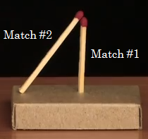
- Matchstick Levitation
Matchstick Levitation materials:
- 3 matches
- A matchbox
Matchstick Levitation instructions:
- Empty out of the matchbox.
- Poke a small hole through the bottom of the matchbox to prop up a single match.
- Lean a second match against the first one.
- Use the third match to light the middle of the second, leaning match.
- Blow out the flames after the second match rises and observe.

Talk about it: The H₂O and CO₂ formed from the flame (combustion) are hotter than the air surrounding the matches and lift/curl the remaining ashes (carbon).

