Does it Sink or Float? All about Density and Buoyancy

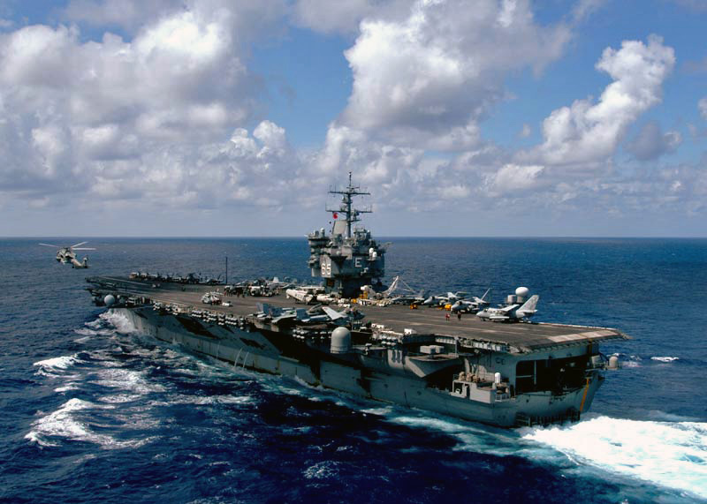
Summary:
Students will be given the opportunity to directly measure densities of liquids and how the buoyant force on a submersed object depends upon the density of the liquid. The concept that density is a physical property of a material will be reinforced by asking students to identify liquids by their density.
Time Required:
~50 minutes, plus ~20 minutes for the “Properties of Liquids” PowerPoint
Activity Team/Group Size: 2-4

Materials:
- Water balloons (5 per group)
- 3 Clear plastic containers or large beakers (500 mL or greater)
- Graduated cylinders
- Triple beam balance
- Water displacement chambers (1 per group)
- Thread or fishing line
- Paper Towels
- Salt (Preferably Kosher)
- Water
- Density cubes (or irregularly shaped objects of a known composition)
- Drilled spheres (density cubes could be altered to work here as well)
- Mystery liquids (minimum of five):
  - Isopropyl Alcohol (91% minimum)
  - Mineral oil
  - Honey
  - Corn Syrup
  - Coke
  - Diet Coke (any soda and diet soda except Dr. Pepper work well)
  - Dish soap
  - Any other commonly available liquid will also work.
- Vegetable oil
- Spring balance capable of measuring 0.1 Newton
Reusable Activity Cost Per Group [in dollars]:
All of the materials in this lab are reusable throughout the day, and should cost no more than ~ $12 in total.
Expendable Activity Cost Per Group [in dollars]:
Dependent on choice of liquids for activity, but ~ $3/group including balloons. *Note, these are reusable throughout an entire day.*

Learning Objectives:
- Explain the concept of density.
- Explain the concept of buoyancy.
- Measure the density of materials and identify these materials based on their density.
- Measure the buoyant force on materials and establish the relationship between the buoyant force on an object and the density of the liquid..

Lesson Introduction / Motivation:
As an introduction to buoyancy and density, the PowerPoint, “Properties of Liquids” may be used.
When students enter the class, have two large containers at the front of the room. One should contain freshwater (tap or distilled water), the other should be filled with saltwater. Make sure the containers are deep enough so that a 12 oz. soda can may be completely submerged in the vessel. Ask the students to guess what will happen if a diet soda and a regular soda are placed in the saltwater bath. Drop the cans in the bath and they should float to the top. Remove the sodas and ask what will happen in the fresh water bath. Place the sodas in the fresh water bath and the regular soda should sink to the bottom while the diet soda floats. Ask for explanations from the class, then explain that the diet soda contains less sweetener than the regular soda (aspartame is twice as sweet as sugar, but the two weigh almost the same amount). Since the diet soda is less dense than water, it floats. Meanwhile the regular soda is slightly more dense than water, due to the extra sweetener, and sinks. **Please try this demo before the first class to make sure the salt content is sufficient to make the regular soda float.**
Lesson Plan:
Preparation:
1.) Fill the balloons with the mystery liquids ahead of time. Be careful not to introduce air into the balloons as bubbles will affect the density measurements. Measure the density of liquids directly with a graduated cylinder and scale. Also make sure to label the balloons and record their material on a master list.
2.) Prepare the saltwater, freshwater, and oil baths by filling the container of your choice with enough liquid to completely submerse the filled balloons. The freshwater and saltwater baths should be large enough to submerge a 12 oz soda can..
3.) Prepare the freshwater and corn syrup columns for the buoyancy measurements by filling a large graduated cylinder or other clear container more than half full with the appropriate liquid. **Note, make sure the mouth of whatever container is used is wide enough to accommodate the density cubes, drilled spheres, or irregularly shaped objects whose buoyant force will be measured.
4.) Place 5 balloons, a water displacement chamber, a 500 mL beaker, a graduated cylinder, about 2 feet of fishing line or thread, two density cubes (or irregularly shaped materials), two drilled spheres, and a triple beam balance at each group’s station.
Directions:
This lesson is best broken up into two parts. Time should be divided such that students have approximately 15 minutes for the first part of the lab and 25+ minutes for the second half.
Part I: Measuring Density and Buoyant Forces
In this part, students will measure the density of a solid material and will observe the buoyant force on an object.
Density Measurement:
- Divide students into their lab groups.
- Demonstrate how the water displacement chamber and other lab equipment work if necessary.
- Direct students to find the mass of their samples.
- Ask students to find the volume of their samples using the water displacement chamber. (Note: if using a cube, measuring with a ruler is a less accurate option.)
- Have students calculate the density of their samples and record this value on their worksheet.
Buoyancy Measurement:
In this part of the activity, students will directly observe the buoyant force on an object.
- Ask students to tie a string around one of their density samples (or drilled spheres) so that it may be suspended from the spring scale.
- Direct students to record the initial weight of their sample on their worksheet.
- Ask students to submerge their sample in a water bath and to record the new weight on the scale.
- Ask students to submerge their sample in the corn syrup (or other high density liquid) bath and ask them to record the weight on the scale.
- Using the worksheet, have the students calculate the buoyant force on their object.
Part II: Mystery Liquids
Once the students have demonstrated their ability to use the necessary equipment, they are ready for the inquiry portion of this lab. Call the students attention to the balloons at their table and direct them to do the following:
  - rank their balloons in order of decreasing density,
  - measure the density of at least one sample, and
  - identify one sample based on their density measurement. (For this, it is helpful to have a list of the materials with their densities accessible to the students.)
The idea is to allow students to use all of the available materials to solve their problem. The simplest solution is to use the freshwater, saltwater, and oil baths to rank the balloons based on density, and then to use the water displacement chamber to do the direct measurement of the liquid’s density. A good group can get results within 5% of the actual liquid density by subtracting the mass and volume of the latex balloon from their measurements.
Lesson Closure:
With the last five minutes of class, ask groups to share their results by writing them on the board. Let the students know which liquids are in their balloons and make any corrections needed.
Assessment:
The impact of the lesson will be obvious from the results shared with the class. Collecting the worksheets is also helpful.

Vocabulary / Definitions:
- Buoyancy: The ability of a liquid to exert an upward force (opposing gravity) on an object.
- Density: The mass per unit volume of a material.
Prerequisites for this Lesson:
- An introduction to the concept that density is the mass per unit volume of a material.
- An intuitive understanding that less dense materials float on top of more dense liquids.
Lesson Scaling:

For more advanced classes, have the students write up their procedure and try to get them to remove the mass and volume of the balloon from their density calculations. Asking for more density measurements is also an option.

For slower classes, only require one density measurement and suggest the use of the fresh water, salt water, and oil baths to rank the density of the mystery liquids.

For less motivated classes, offer a prize to the group that correctly identifies their mystery liquid. Use the difference between your calculated density and the student’s results as a tie breaker if more than one group correctly identifies their liquid.

Safety Issues:
The only safety issues arise from the liquids in the balloons. As long as these are innocuous, the lesson is safe.

Troubleshooting Tips:

If demonstrations using the freshwater bath do not go according to plan, try using distilled water in place of tap water. Likewise, if objects do not exhibit the correct buoyancy in the salt bath, add more salt. Iodized salt is generally much more dense, but leads to a murky liquid.

When using corn syrup, or any highly viscous liquid, for the buoyancy measurement, students should be careful to hold their spring balance still or false readings will occur. Arranging a support for the spring scale to hang on will eliminate this problem.

References:
- Density and Buoyancy Worksheet
Keywords:
- Science
- Density
- Buoyancy
Authors:
Graduate Fellow Name: Kyle Damborsky
Teacher Mentor Name: Catherine Johnston
Undergraduate Fellow Name: Barclay Bell
Please email us your comments on this lesson:
E-mail to ljohnson@cvm.tamu.edu
Please include the title of the lesson, whether you are a teacher, resident scientist or college faculty and what grade you used it for.

Teacher’s Comments:

