Desert Pocket Mouse: A Tiny Soldier
Activity Worksheet: Of Mice and All Other Organisms

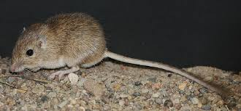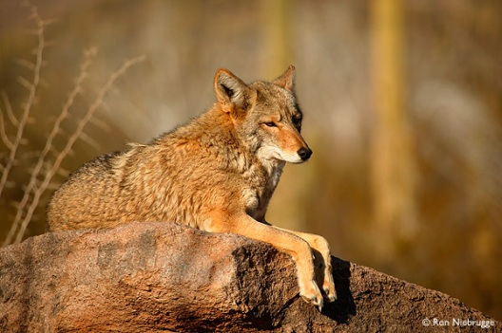

The Rock Pocket Mouse lives in a desert ecosystem: The Valley of Fire in New Mexico, United States. The mouse’s main predators are Owls, Hawks, Snakes, Coyotes, and Foxes.

1. The mouse relies on camouflage to hide and escape from predators.
a. If the mouse’s fur is typically light brown, what does that mean about the color of the desert terrain? How does this help the mouse to survive?

b. What other traits could also help the Rock Pocket Mouse survive?

c. How are these traits (fur color and other traits you came up with) adaptations?

2. Most of the Rock Pocket Mouse population is light brown, yet there are a few mice that are black. The population distribution looks like this:

a. Why are some of the mice black? Where did they come from? (hint: your answer should include the words mutation and variation)

b. Would black mice survive better or worse than brown mice? Why?

c. Compare the fitness of the brown mice to the black mice.

3. Now, suppose there was a volcanic eruption that left a significant portion of the terrain black instead of brown.
a. This means for predators it is harder/easier to spot black mice and harder/easier to spot brown mice. (Circle correct answer for each)

b. Explain how the fitness of the brown and black mice would change:
Black Mouse –

Brown Mouse –

c. Compared to the mouse population before the eruption, the next generation of Rock Pocket Mice will have more/less brown mice and more/less black mice after the eruption. (Circle correct answer for each) Why?

d. Indicate (using colors or labels) what the Rock Pocket Mouse population would look like in terms of fur color in 1000 years, assuming the terrain remains black:

Conclusion Questions:

4. Do the mice have a color preference for their fur? Why does their fur color matter?

5. Is natural selection a random process? Why or why not?

