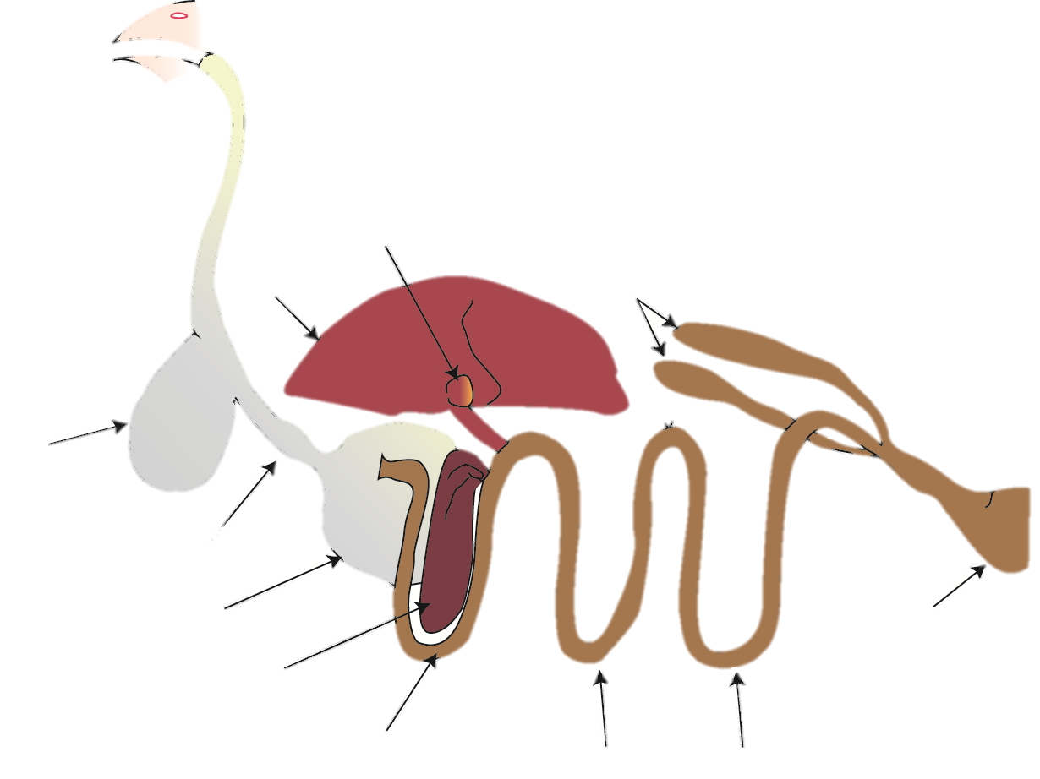
Poultry Digestive System Labeling Quiz ANSWERS
10._____
Ileum
Esophagus
2.___________
Mouth
1. _________
8. __________
Gall Bladder
Liver
Ceca
12._______
11.__________
14._____
Vent
Cloaca
13._________
9. _________
Jejunum
7. ________
Duodenal Loop
6. ___________
Pancreas
5. _________
Ventriculus
4._________
Proventriculus
Crop
3._______

