The Perfect Blend
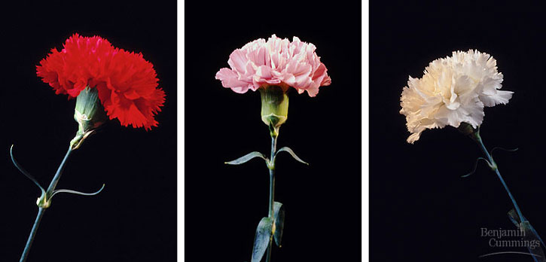Summary:
The lesson is designed to help with the understanding of incomplete dominance through comparison with the other forms of genetic dominance. The students will further their understanding of incomplete dominance by working on some Sponge-bob related worksheets.
Subject:
- Science:
  - TEKS 7.14(A)
    - Define heredity as the passage of genetic instructions from one generation to the next generation.
  - TEKS 7.14(B)
    - Compare the results of uniform or diverse offspring from sexual reproduction or asexual reproduction.
  - TEKS 7.14(C)
    - Recognize that inherited traits of individuals are governed in the genetic material found in the genes within chromosomes in the nucleus.
Grade Level:
- Target Grade: 7
- Upper Bound: 8
- Lower Bound: 6
Time Required: 1 class period
Activity Team/Group Size: individual or small groups

Materials:
- Prezi lesson
- SpongeBob activity
- SpongeBob worksheet
Reusable Activity Cost Per Group [in dollars]: $0

Expendable Activity Cost Per Group [in dollars]: $0

Learning Objectives:
- Understanding of incomplete dominance
Lesson Introduction / Motivation:
An individual’s phenotype is the physical manifestation of that individual’s genes. Everyone is made up of unique gene combinations. These combinations can take on interesting forms when one gene doesn’t dominate and mask the appearance of another gene. Showing the Prezi presentation will help students understand the differences between the different types of dominance.
Lesson Plan:
The students will first find the genotypes and phenotypes for SpongeBob’s Poofkin flowers. Then they will find the genotypes and phenotypes of the Goober Jellyfish.

Lesson Closure:
Finish up the lesson with the SpongeBob genetics review worksheet. Collect the worksheets and discuss the lesson and activities with the students. Show students some other examples of incomplete dominance that occur in nature.
Assessment:
Grade the worksheets using the answer keys provided

Vocabulary / Definitions:
- Homozygous- When an individual has two copies of the same allele for a particular trait.
- Heterozygous- When an individual has two different alleles for a particular trait.
- Dominant- An allele or gene masks the effect of the recessive allele or gene. This is what shows in the individual’s phenotype.
- Recessive- An allele or gene that’s phenotype isn’t expressed because it is masked by the dominant allele or gene.
- Incomplete Dominance- A kind of dominance that occurs in heterozygotes where the dominant allele is only expressed partially. This leads to offspring with intermediate phenotypes.
- Allele- One member or a pair of genes occupying a specific spot on a chromosome that controls the same trait.
- Genotype- The set of genes in an organism/an individual’s genetic makeup.
- Phenotype- The physical appearance of an organism as a result of interaction between the individual’s genotype and the environment.
- Complete Dominance- When the dominant allele completely masks the effect of the recessive allele in heterozygous conditions.
- Codominance- When the alleles of a gene pair in a heterozygote are fully expressed thereby resulting in offspring with a phenotype that is neither dominant nor recessive.
Background and Concepts for Teachers:
- Knowledge and understanding of basic genetics and the different types of dominance.
Lesson Extensions:

Possibly do other activities or lessons that relate to other aspects of genetics.

Safety Issues:

- None

Multimedia Support and Attachments:
- http://sciencespot.net/Media/gen_spbobincdom.pdf for the SpongeBob incomplete dominance activity sheet
- http://sciencespot.net/Media/gen_spbobreview.pdf for the SpongeBob genetics review sheet
- https://prezi.com/secure/00cf8da02a14a6a9739bf3f4a82fa131bff35892/ for Prezi
References:
- http://www.biology-online.org/ for definitions
- http://sciencespot.net/ for the activities and review
Keywords:
- Genetics
- Incomplete dominance
- Codominace
- Complete dominance
Authors:
Graduate Fellow Name: ___
Teacher Mentor Name: ___
Undergraduate Fellow Name: Katie Clark
Date Submitted: ___
Date Last Edited: ___
Please email us your comments on this lesson:
E-mail to ljohnson@cvm.tamu.edu
Please include the title of the lesson, whether you are a teacher, resident scientist or college faculty and what grade you used it for.

Teacher’s Comments:

    - Using RR (for the red flower) and WW (for the white flower), make a punnett square representing incomplete dominance. What color will the offspring be?

    - Using RR (for the red flower) and WW (for the white flower), make a punnett square representing codominance. What will the offspring look like?

    - Using Rr (for the red flower) and Ww (for the white flower), make a punnett square representing complete dominance. What percentage of offspring will be red and what percentage of offspring will be white?

