Biome in a Box
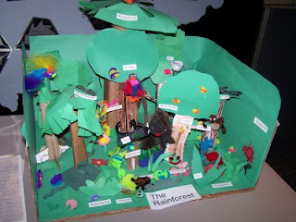

You will each be assigned a biome that we discussed in class. You must do further research on your biome, and use the information you find to create a diorama of your biome. A diorama is a scene, often found scaled down to a miniature size, displayed in three dimensions. Use a shoebox, or a box of similar size, and construction paper, markers, crayons, and any kind of craft or recycled material you want to make a visual representation of what your biome looks like.

When doing your research, find out as much as you can! Some questions to consider are:
- What is the climate like?
- Does your biome have different seasons?
- What is the yearly precipitation like?
- What organisms can be found in your biome?
- What does the landscape look like?

The more detailed you are, the more interesting your diorama will be.

