Ecosystem Flip Book

In this activity, you will create a flip-book with each page showing a different level of the ecosystem. You will have pages for the terms: organism, population, community, and ecosystem.
- Take two pages of regular computer paper. The idea is to make two folds, one in each piece of paper, so that there are four sections that increase in length as each flap of paper is folded back to reveal the one beneath. Make a ‘short fold’ on one piece of paper, and a longer fold on the other paper. Here are some pictures to illustrate how to fold the papers:
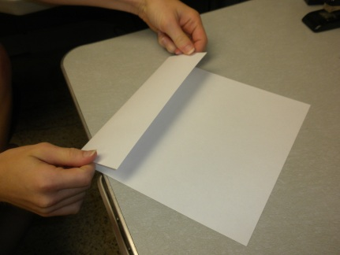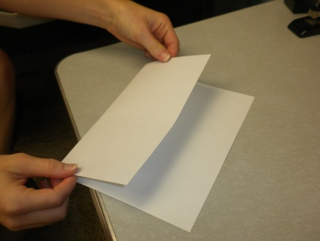

Once the papers are folded, insert the long fold piece into the short fold piece, so their folds are now together, and you have four flaps of paper:
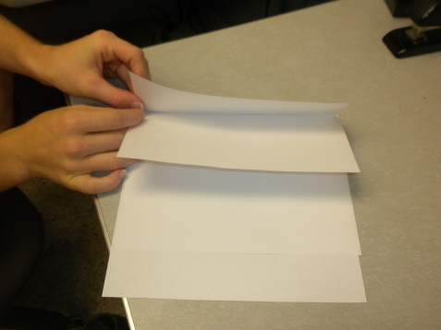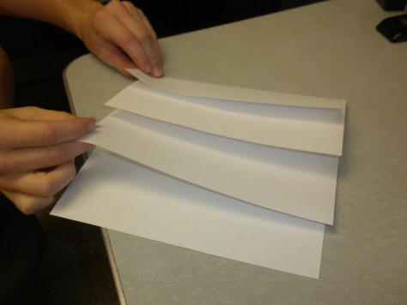

- The top flap of your paper, the smallest flap, is for your smallest level of the ecosystem – an individual organism. Write the definition of organism, but make sure to leave some open space. Then, choose an organism and draw it in the space left on that flap. Your organism can be a plant or an animal, anything you want as long as it is living.
- The second flap is for the next level: a population. Write the definition of population, and then draw a population of your chosen organism.
- Next up is the third level of the ecosystem – the community. Write the definition of community and draw a community that includes other organisms that your chosen organism might interact with.
- The last fold is for the entire ecosystem. Draw your community and add in any nonliving elements that might be found in your ecosystem that your community may need or interact with.
- You have your Ecosystem Flip Book!

