I Spy an Ecosystem!
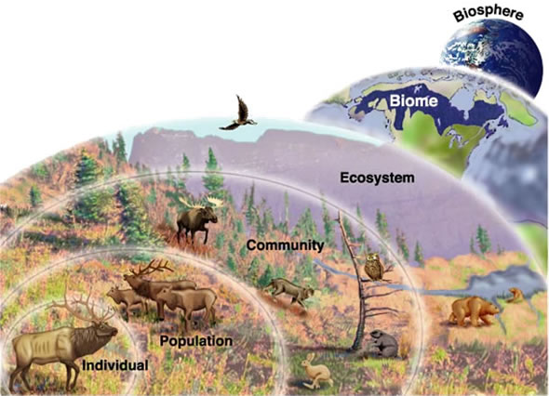

Summary:
Studying ecology is all about looking at how organisms are related to one another and the environment surrounding them. It can be helpful to break down ecological systems into a hierarchical organization. From an individual organism to the biosphere, there are many different ecological levels. This lesson goes through the levels of ecosystem organization (organism, population, community, ecosystem, biome, and biosphere) and includes creative activities for students to increase understanding of ecosystem organization. The hierarchy can even be expanded to include levels of organization within an organism (such as cell, tissue, organ, etc.) and also levels greater than the biosphere.
Subject:
Science: TEKS 6.12 E and F.
Describe biotic and abiotic parts of an ecosystem in which organisms interact. Diagram the levels of organization within an ecosystem including organism, population, community, and ecosystem.
Also applicable: TEKS 6.12 C and D
Grade Level:
- Target Grade: 6
- Upper Bound: 8
- Lower Bound: 6
Time Required: one 45-60 minute lesson, with possible extensions
Activity Team/Group Size: individual, with group activity extensions

Materials:
- White printer paper
- Colored pencils/markers/crayons
- Stapler and staples/hole punch and brads
- Ecosystem Organization PowerPoint
- Biomes PowerPoint
- Biome in a Box Activity Sheet
- Build Your Own Ecosystem Activity Sheet
- Ecosystem Earth Activity Sheet
- Ecosystem Flip Book Activity Sheet
Reusable Activity Cost Per Group [in dollars]: ~$10
Expendable Activity Cost Per Group [in dollars]: ~$1

Learning Objectives:

- Describe biotic and abiotic parts of an ecosystem
- Diagram the levels of organization within an ecosystem
Lesson Introduction / Motivation:
Have your students paint a mental picture while you read a prompt. An example prompt is below. (~3-5 mins)
- “Everyone close your eyes and imagine that you are outside somewhere in nature. It can be anywhere you want; a field, a garden, or a forest… Really think about where you are and paint a mental picture. What do you hear? What do you feel? What do you smell? Are there animals? Plants? What does the landscape look like? Take a minute and try to think about as many details about where you are as possible.” Give your students about a minute to contemplate their environment. “Now I want you to think about everything in your environment that is alive. List them on your paper. What plants and animals do you see or hear?” Give your students a minute to list out the living things. “Close your eyes one more time and think about the things in your environment that are not alive. Are there rocks? What kind of soil is there? What is the weather like? Is there water? Make a separate list of these things on your paper.”
Lesson Plan:
- Once finished with the quick introductory activity, go through the Ecosystem Organization PowerPoint provided with this lesson. (~20-25 mins)

- Have the students complete the Ecosystem Flip Book activity (~20-25 mins) – handouts are included in this lesson, and directions are also given below:
  - Take two pages of regular computer paper. The idea is to make two folds, one in each piece of paper, so that there are four sections that increase in length as each flap of paper is folded back to reveal the one beneath. Make a ‘short fold’ on one piece of paper, and a longer fold on the other paper.
  - Once the papers are folded, insert the long fold piece into the short fold piece, so their folds are now together, and you have four flaps of paper.
  - Once the papers are folded, insert the long fold piece into the short fold piece, so their folds are now together, and you have four flaps of paper:
  - The top flap of your paper, the smallest flap, is for your smallest level of the ecosystem – an individual organism. Write the definition of organism, but make sure to leave some open space. Then, choose an organism and draw it in the space left on that flap. Your organism can be a plant or an animal, anything you want as long as it is living.
  - The second flap is for the next level: a population. Write the definition of population, and then draw a population of your chosen organism.
  - Next up is the third level of the ecosystem – the community. Write the definition of community and draw a community that includes other organisms that your chosen organism might interact with.
  - The last fold is for the entire ecosystem. Draw your community and add in any nonliving elements that might be found in your ecosystem that your community may need or interact with.
Lesson Closure:
- Students now have a study tool that helps them remember the levels of organization in an ecosystem in a visual way. Hold a wrap-up discussion while they are finishing their flipbooks, reiterating the concept of a hierarchy and the hierarchical levels of the ecosystem.

Assessment:
In groups or on their own, have students design and artistically depict their own ecosystem, using the information covered in the lesson. Make sure they include all levels that are required to make an ecosystem – organism, population, community, and ecosystem (including biotic and abiotic factors). Have the students be creative – their ecosystem can be anywhere, even another planet! On the back, have students list the biotic and abiotic factors in their ecosystem.

Vocabulary / Definitions:
- Ecology – the branch of biology studying the relationships and interactions between organisms and the environment
- Ecosystem – a defined area that includes all living organisms and nonliving factors
- Hierarchy – a system of things ranked one above the other
- Organism – a single living thing
- Population – a group of organisms of the same kind
- Community – all organisms in a given area
- Biosphere – the largest of all ecosystems – the Earth
- Biomes – small regions (bigger than ecosystems, smaller than the biosphere) that have distinct characteristics
Lesson Scaling:

This lesson can be scaled up by going into more detail and covering more in-depth concepts such as ecological niches, and organism adaptations that correspond to different niches. This lesson can also be separated into two separate lessons or time can be added with the extension activities, giving students more time to process and understand the material.

Lesson Extensions:

(Each activity below will either require between 30 and 60 minutes to complete, or are good options for take-home assignments. All activities are attached to this lesson.)

- Build Your Own Ecosystem activity
  - This activity requires a lot of planning ahead on the instructor’s part, but students use what they’ve learned about what goes into an ecosystem, and an ecosystem’s biotic and abiotic parts, and create an ecosystem in a closed container, which can either be kept in the classroom, or each student can make their own and take it home!
  - http://www.examiner.com/article/rainy-day-gardening-project-for-the-kids
- Ecosystem Earth activity
  - An extension to this lesson, this activity incorporates working as a group and public speaking skills. As a group, students design and present an original ecosystem or world, using the information they learned about the levels of organization within an ecosystem.
- Biome PowerPoint
  - This PowerPoint goes through different biomes of the world and introduces basic information about each biome.

- Biome in a Box activity
  - Students use what they learned about biomes in an art project, creating dioramas of different biomes.
References:
- http://www.mysciencebox.org/ecoorg
- http://www.physicalgeography.net/fundamentals/9d.html
- http://www.goldiesroom.org/Note%20Packets/22%20Ecology/00%20Ecology--WHOLE.htm
- http://www.neok12.com/php/watch.php?v=zX407650585245017500070a&t=Ecosystems
- http://www.blueplanetbiomes.org/world_biomes.htm
- http://www.neok12.com/quiz/ECOSYS03

Keywords:
- Ecology
- Ecosystem
- Organism
- Population
- Community
- Biotic
- Abiotic
- Biome
- biosphere
- Interdependent
- Food web
- Species
- Hierarchy
Authors:
Undergraduate Fellow Name: Katelyn Wilson

