Summary:
This activity is designed to show an example of how the body maintains homeostasis. The students will specifically demonstrate how the kidneys regulate body fluid.

Grade Level:
- Target Grade: 6-8
Time Required: 1 Class Period
Activity Team/Group Size: 4 individuals

Materials:

- Plastic cups(2 per group)
- Pen
- Plastic or metal tray
- Water
- Towels

Learning Objectives:
- Feedback mechanisms
- Homeostasis
Lesson Introduction / Motivation:
Review the feedback mechanism lesson plan and go over the feedback mechanism PowerPoint with the students.

Lesson Plan:
This activity is a simple demonstration of how the kidneys regulate fluid. Explain to the students if the body takes in too much fluid the kidneys will filter out the excess water to the bladder to be excreted.

Procedure:

- Gather all materials needed for the experiment.

- With the pen, poke 3-4 holes in a horizontal line in the middle of a plastic cup.

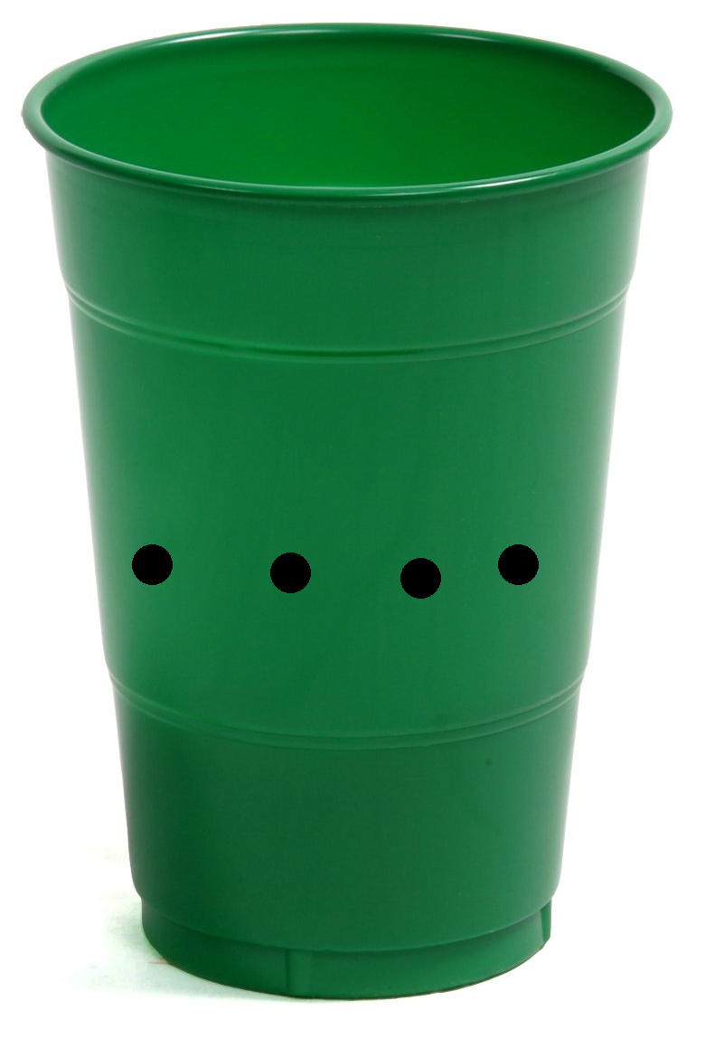

- Place the plastic cup with holes on the tray.

- Fill the other plastic cup with water and fill the cup on the tray ¼ of the way full. If there is not enough water in the cup to make it to the holes this would resemble dehydration. The cup has no way of getting water besides you pouring it in just as the body has no way to get water besides from what we drink or eat.

- Fill the cup with water up to the holes. This would resemble the body being in homeostasis.

- Now pour more water into the cup so the water level temporarily goes over the holes. The water should leak out of the cup into the tray. This resembles the body having an excess of fluid so the kidneys remove the extra fluid to achieve homeostasis.

- Next pour the water out into the sink. Clean and dry all the materials.

Lesson Closure:
Make sure the students understand what the kidney was doing in the exercise and that this is one example of feedback mechanisms and how the body continually regulates itself to maintain homeostasis.
Assessment:
Walk around the classroom and make sure students are participating in the demonstration and understand its purpose.

Safety Issues:
Be careful when poking holes with the pen.

Other documents:
- Student worksheet
- Student handout
Keywords:
- Homeostasis
Authors:
Graduate Fellow Name: ___
Teacher Mentor Name: ___
Undergraduate Fellow Name: Chris Prigmore
Date Submitted: ___
Date Last Edited: ___
Please email us your comments on this lesson:
E-mail to ljohnson@cvm.tamu.edu
Please include the title of the lesson, whether you are a teacher, resident scientist or college faculty and what grade you used it for.

Teacher’s Comments:

