Summary of Lesson:
Students will review the PEER web site tutorial on immunity. Students will study a stained smear of blood cells, make drawings to distinguish the various types of white blood cells, and perform a differential white blood cell count.

Objectives:
Students will be able to:
- Identify from blood smears red blood cells and the following types of white cells: lymphocytes, neutrophils, and eosinophils.
- Perform a differential white blood cell count.
- Explain the function of the white blood cell types.

Lesson Summary:
Students will examine blood smears and distinguish and count the various types of white blood cells.

Grade Level: Grades 6-8 (could be scaled up for 9-10)

Standards:

Texas | National
Science:  6-8.1 (A) Demonstrate safe practices during field and lab investigations  6-8.2 (B) Collect data by observing and measuring  6-8.2 (E) Construct visuals using tools to organize, examine, and evaluate data  7.9 (A) Identify the systems and functions of the human organism  8.6 (A) Describe interactions among systems in the human organism | Science:  A: Science As Inquiry, Abilities Necessary To Do Scientific Inquiry  F: Science in Personal and Social Perspectives  E: Science and Technology, Abilities of Technological Design  C: Life Science, Structure and Function in Living Systems
Health:  6.3 (C) List noncontagious and hereditary diseases, prevention, and treatment  7-8.3 (C) Know risk factors linked with contagious and noncontagious diseases  7-8.3 (D) Summarize the facts related to HIV infection and STDs | Health:  Standard 1: Students will comprehend concepts related to health promotion and disease prevention to enhance health.  Standard 3: Students will demonstrate the ability to access valid information and products and services to enhance health.

Time Required: 1-2 class periods.
Materials needed:
1. Immunity PowerPoint Presentation
2. Microscopes
3. Pre-prepared blood smears

Suggested pre-requisite activities:

1. Have the students study the PEER Web-site curriculum on immunity at http://peer.tamu.edu/curriculum_modules/OrganSystems/Module_1/index.htm

Activity:

Students will study pre-prepared, stained smear of blood cells. Sources where you can buy slides of stained blood include:
- http://www.hometrainingtools.com/product_categories/148/products/3481-human-blood-slide-wright-s-stain-smear
- http://www.enasco.com/product/SL10208M
- http://www.naugraexport.com/bimages/slides.html

(Deleted the paragraph about making slides)

Have students draw and color pictures of the various cell types they see. With each drawing, they should note the magnification and include descriptions of the cell types. These should include the red blood cells (which will be red and the most numerous cell type). The most conspicuous white blood cell types will be:
- lymphocytes (round) ― some directly attack microbes, others make antibodies.
- neutrophils (nucleus will be fragmented to various degrees; nucleus is C-shaped in young forms)― phagocytosize foreign cells and microbes. Will be attracted by chemicals from dead cells and microbes present in tissue and migrate to the source of infection (as in pimples, splinter wounds).
- eosinophils (contain red granules) ― these increase during allergy responses and internal parasite infestations. Function not always clear.
- Monocytes ― largest of all white cells. They eventually leave the blood to become large phagocytic cells in tissues.

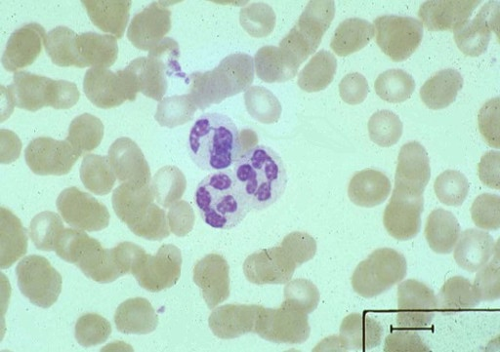 | 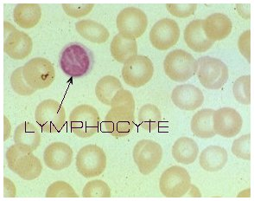
Neutrophil (cells in background are red blood cells). Note that the nucleus appears to be broken into pieces. Younger forms will not show such break up. | Lymphocyte. Note the intact nucleus which occupies most of the cell space.

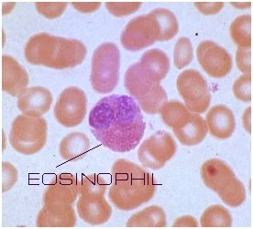 | 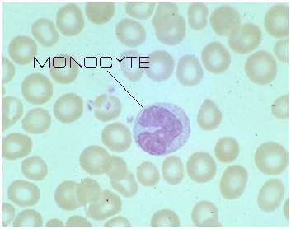
Eosinophil. Nucleus has two lobes and many red granules are in the cytoplasm | Monocyte. Largest white cell (note it is about twice the size of red cells). Nucleus usually has one indentation.
Photos obtained from http://www.fortunecity.com/greenfield/rattler/46/blood.htm

Have the students examine 100 white cells and record the number of lymphocytes,
neutrophils, eosinophils, and monocytes, and report the percentages of each. They may see some cell types they don’t recognize (such as basophils ) but these numbers are usually so low they can be ignored for our purposes here. Physicians may sometimes order a “differential white blood cell count” in which the different kinds of white cells are counted.

Point out that the fragmentation of the neutrophils indicates the age of the cell. Older neutrophils will have more fragments. This has clinical significance. If a person has an infection, and most of the neutrophils are highly segmented, it may be that the white blood cell production system is becoming exhausted and is not making many young neutrophils.

Assessment:
Grade for completion of the drawings and results of the count of different types of white cells.

Extension
1. The CELLs alive site has interesting immune-system videos for sale.

2. A unique immunity video game, at the high school level, has been produced by the Federation of American Scientists and can be found at http://fas.org/immuneattack/ It is a very large file (over 500 MB) and will take some time to download.

3. Have students prepare a short report on the procedure that technicians use to count the total number of white blood cells.

Resources:
http://peer.tamu.edu/curriculum_modules/OrganSystems/Module_1/index.htm

