Don’t Touch Me!—Demonstrating Turgor Pressure in the “Sensitive Plant” Mimosa pudica
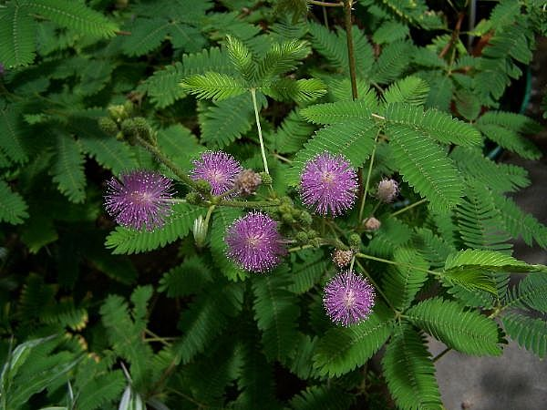

Summary:
In this activity, students will learn about the feedback mechanisms that plants use to maintain equilibrium using turgor pressure. Students will use critical thinking and problem solving skills to investigate the turgor response in M. pudica to different stimuli.
Subject:
Science TEKS:
8.2 (A) Plan and implement investigative procedures including asking questions, formulating testable hypotheses, and selecting/using equipment.
8.6 (B) Identify feedback mechanisms that maintain equilibrium of systems such as body temperature, turgor pressure, and chemical reactions.

Grade Level:
- Target Grade: 8
- Upper Bound: 9
- Lower Bound: 7
Time Required: Prep time: ~6-8 weeks to grow plants
Actual class time: 1-2 class periods

Activity Team/Group Size: Depending on the size of the class groups of 2-4 students can be created to investigate the effect of whichever stimulus they choose on the plants.

Materials:
- Enough M. pudica plants for each group to have one
- A variety of stimuli for students to choose from:
  - Examples include:
    - Toothpick
    - Feather
    - Scissors
    - Heat
    - Cold
    - Strong light
    - A box to make it dark for the whole plant
    - Their own fingers to touch the plant (with various levels of force)
Expendable Activity Cost Per Group [in dollars]:
~ $10.00 (Packet(s) of M. pudica seeds, Dixie cups to grow them in, potting soil)

Learning Objectives:
- To understand what turgor pressure is and its importance for plants.
- To learn feedback mechanisms that maintain equilibrium of systems.
- To use independent research to develop a hypothesis about the reaction of this particular plant to different stimuli and design an experiment to test it.
- To analyze their findings and hypothesize why this particular plant reacts to stimuli the way it does.
Lesson Introduction / Motivation:
Bring in a completely wilted (but still living) plant and a healthy, well watered plant and ask the students what the differences between the two are, leading them into a discussion about how one is droopy and one is not and how this can occur.
Lesson Plan:
The M. pudica seeds need to be planted 6-8 weeks prior to using them for experimentation, otherwise they will not react to stimuli at all (normal response being various levels of instantaneous wilting away from obnoxious stimuli—if touched gently, just a leaf or two will curl up, if touched with more force the entire branch, or even plant can wilt. However, if the entire plant is caused to wilt, it takes awhile for the plant to come back to normal, so it would be best to caution students to start small and gentle and work up to bigger stimuli).
Day 1:
- Go through the introductory exercise presented above with the students, getting them to brainstorm about what it is that keeps plants upright.
- Present a lecture on feedback mechanisms that maintain equilibrium in systems, with the example of turgor pressure and its importance in plant growth and rigidity.
- After the class lecture, explain the activity:
  - The class will be divided into groups of 2-4 students
  - Each group will choose three of the objects on display to use to touch a plant with—or they can think of something else that they would like to expose a plant to.
  - After each group has chosen their objects, demonstrate with a M. pudica plant that just a tiny touch will cause it to fold its leaf over.
  - Caution the students that if they are too rough with their plants the experiment will not work.
  - Have each group develop a hypothesis about how the plant will respond to their specific stimuli.
  - Hand out one plant to each group.
  - Have the students apply their stimuli gently at first, then with more force if they are using something like a toothpick or something hard.
  - Have them record their observations on the “Observation and Analysis worksheet”.
  - After they have tested their hypothesis, have each group come up with reasons why these plants respond to stimulus the way they do (possibilities include: removing themselves temporarily from stressful situations—such as animals grazing on them or a way to deter plant parasites from attacking them if they wilt as soon as the pest bites them) and how it might occur (certain stimuli such as touch and heat cause electrical outbursts from the cell affected—these impulses pass from cell to cell, causing each one to release its vacuole’s contents and essentially “wilt”).
  - Students can record their answers (these further hypotheses) to these questions on their Observation and Analysis worksheet and turn these in.
Lesson Closure:
Open up a class discussion about the students’ thoughts/opinions to the questions posed at the end of the Observation and Analysis worksheet. Discuss additional experiments that could be done to figure out HOW the plant wilts on command.
Assessment:
The main goal of this lab is to demonstrate turgor pressure in an unusual, inducible manner. Students should be able to understand what turgor pressure is and how it is involved in maintaining equilibrium in plants after this lab. The lesson closure involving the class discussion can help the teacher direct their thoughts to considering exactly how vacuoles and hydrostatic pressure are involved in keeping a plant up-right and how turgor pressure plays a key role in plant growth.

Vocabulary / Definitions:
- Turgor pressure—the pressure generated when plant cells take up water and store it in their vacuoles causing the cell to expand, pushing it against other cells. This pressure is required for cell expansion and growth and helps keep the plant standing upright, instead of falling over.
Background and Concepts for Teachers:
- For more information on thigmonasty (the actual process M. pudica undergoes to cause it to wilt, this is a good link.
- This company actually sells kits and provides additional support for experiments involving these plants. They would definitely be a good site to check out before doing this activity.
- There are a couple of books available to view through google books that can be seen here and here that explain turgor pressure in a little more detail than the students need to know, but it’s good background information.
Lesson Scaling:
If there is not enough time to make this an entire activity, but you still want a good demonstration of turgor pressure in action, this could be used just as a teacher demonstration to accompany a lecture on maintaining equilibrium in systems.

Additionally, if more time is available, the students could grow the plants themselves at the beginning of the year to investigate the other basic processes involved in plant growth. This would be an on-going activity where basic plant processes involving growth and germination could be explored initially, and then the plant could be used to demonstrate turgor pressure later.

Safety Issues:
It is VERY important that the students start out with gentle stimuli, otherwise the whole plant will wilt and no other observations can be recorded.

Additionally, some of the stimuli, such as heat, bright light, or scissors should be handled with extreme care.

Finally, if a student is allergic to plants, perhaps advising them against touching it with their fingers would be necessary.

Troubleshooting Tips:
It might be necessary to have a few extra plants, in case some of the groups are injudicious with the amount of force they use with their plant.

Also, the first leaves that sprout from the plant will not respond to stimuli; this is why it is necessary to wait 6-8 weeks for full growth to occur. If this is not an option, perhaps a full-grown plant could be purchased from a gardening specialty store.

Multimedia Support and Attachments:
- “Observations and Analysis” Worksheet
References:
Picture of Mimosa pudica http://www.ehow.com/how_5058513_grow-mimosa-pudica-sensitive-plant.html

Background on electrical impulses by M. pudica http://ecsmeet6.peerx-press.org/ms_files/ecsmeet6/2009/04/23/00002391/00/2391_0_art_1_kmk7kn.pdf

For information on what the plant does (thigmonasty) http://dic.academic.ru/dic.nsf/enwiki/2263971

More information on plants transpiration/growth http://www.hcs.ohio-state.edu/hcs300/pstrans.htm

Place to buy seeds http://www.ecrater.com/product.php?pid=2710042

Company that markets these plants and has all kinds of other experiments you can use them for http://www.ticklemeplant.com/faq.htm

Keywords:
- Turgor pressure
- System equilibrium
- Plants
Authors:
Graduate Fellow Name: Lauren Schilling
Teacher Mentor Name:
Undergraduate Fellow Name:
Date Submitted:
Date Last Edited:
Please email us your comments on this lesson:
E-mail to ljohnson@cvm.tamu.edu
Please include the title of the lesson, whether you are a teacher, resident scientist or college faculty and what grade you used it for.

Teacher’s Comments:

