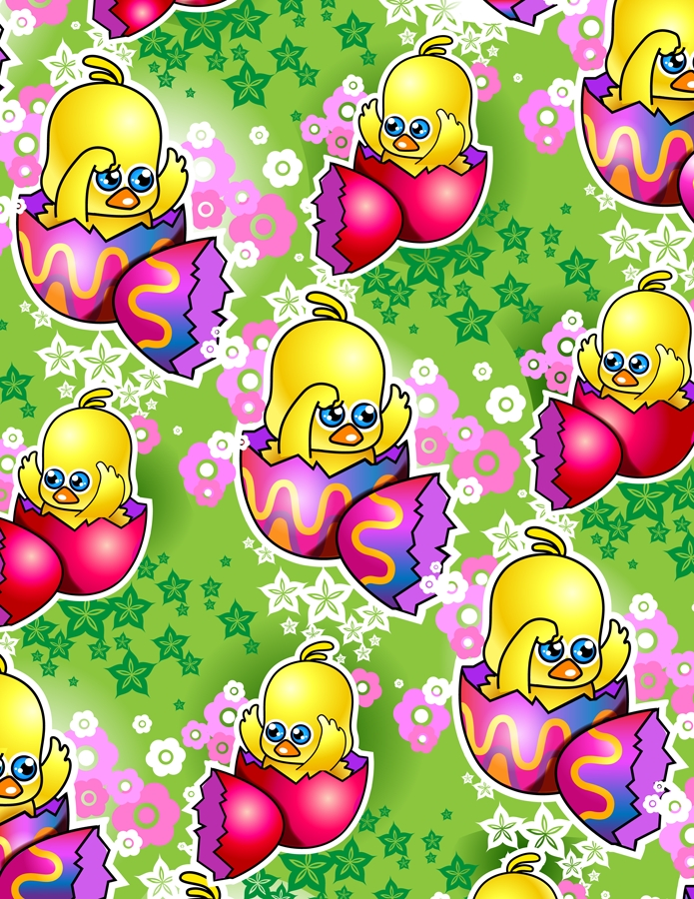
Easter Egg Genetics

(Adapted from “Easter Egg Genetics Activities” by Liz LaRosa, http://www.middleschoolscience.com/)

Summary:
After a PowerPoint lesson about genetics, traits and Punnett Squares, students will use Easter Eggs with different colored halves to understand and complete their own Punnett Squares.
Subject:
7.10 Organisms and environments. The student knows that reproduction is a characteristic of living organisms and that the instructions for traits are governed in the genetic material. The student is expected to:
(A) define heredity as the passage of genetic instructions from one generation to the next generation;
(B) compare the results of uniform or diverse offspring from sexual reproduction or asexual reproduction; and
(C) recognize that inherited traits of individuals are governed in the genetic material found in the genes within chromosomes in the nucleus.

Grade Level:
- Target Grade: 6, 7
- Upper Bound: 5
- Lower Bound: 9
Time Required: 50 minutes
Activity Team/Group Size: 3-4

Materials:
- Easter Egg Genetics Worksheet
- Purple, Orange, Pink, Blue, Green, and Yellow Easter Eggs (equal amounts)
- Purple, Orange, Pink, Blue, Green, and Yellow cotton pompoms (small size; four pompoms need to fit in each Easter Egg)
Reusable Activity Cost Per Group [in dollars]: $5

Learning Objectives:
- In small groups, the students will be able to apply their knowledge of genetics and traits to understand and complete several Punnett Squares.
Before the Lesson:
Separate all of the egg halves and put them into sets. Set 1 should have Purple, Orange, and Pink egg halves, and Set 2 should contain Blue, Green, and Yellow egg halves. Reassemble the eggs within each set (an egg half from Set 1 cannot be combined with an egg half from Set 2), making sure that every egg is composed of 2 different colored halves. Find the four different offspring color possibilities for each particular egg pair. Then, put four pompoms of corresponding colors in that egg (example, a Purple egg half and an Orange egg half = 2 Purple (PP), 2 Orange (Pp) offspring, so that egg would contain 2 Purple pompoms and 2 Orange pompoms). If you feel it is necessary to prevent your students from opening their eggs right away, seal the eggs at their connection with scotch tape. Arrange the desks so that they are set-up in groups of three or four.
Lesson Introduction / Motivation:
Ask students if people tell them that they look like their parents or not. Then ask if any of them have siblings who look like them or who look nothing like them. After listening to their stories, explain that things like eye color, hair color, body shape, and other features are decided by genetics. Each of these things is a trait, and traits are passed down from parents to children.
Lesson Plan:
Present the PowerPoint presentation. Ask the students if they have any questions. Go around the room and have each student draw two Easter Eggs from a basket. Make sure that they understand that they are not to open them until you give them permission (they should raise their hands after filling out the Punnett Square so that you can check to make sure they have done the activity before finding the answer inside of the egg). Pass out the Easter Egg Genetics Worksheet and allow the students to begin. Walk around the classroom to make sure they are on task.
Lesson Closure:
Tell students to attempt the challenge question at the end of their worksheet for homework (give them extra credit if they at least attempt it). Also ask students to write a one page journal entry about their family history and some traits that have been passed down through generations. They should also mention what traits they believe they have inherited, and from who. They can use their family members as resources on this information.
Assessment:
Grade students’ short answers on the worksheet for correctness. Assess the students’ ability to grasp the information based on completeness of their answer and the depth of their answer.

Multimedia Support and Attachments:
- See attachment for PowerPoint
Keywords:
- Genetics
- Traits
- Punnett Square
- Genotypes
- Phenotypes
Author:
Undergraduate Fellow Name: Jillian Van Zandt
Please email us your comments on this lesson:
E-mail to ljohnson@cvm.tamu.edu
Please include the title of the lesson, whether you are a teacher, resident scientist or college faculty and what grade you used it for.

Teacher’s Comments:

