Ecological Relationships Quiz
The following questions are comprised of multiple choice, matching, true-false, or fill in the blank. Please choose the best answer for each question.

- What is the proper definition for the term population dynamics?
  - Organism competition
  - The pattern of any process or interrelationship that affects the growth or change in a population
  - How loud or quiet a population of organisms are
  - A hierarchical order of population levels

- An organism capable of making organic compounds from inorganic molecules is called a(n) _______.
  - Producer
  - Consumer
  - Predator
  - Animal

- The organism in the question above can also be called a(n) _______________.

- What is a consumer?
  - An organism that makes its own food
  - An organism that obtains food by feeding on other organisms
  - A heterotroph
  - b and c

- True or false. All of the following organisms are consumers: beetle, blue whale, horse, chickadee, bacteria, bobcat, tuna, oak tree.

- True or false. Decomposers eat living organisms.

- Food chains begin with
  - An autotroph
  - A heterotroph
  - A decomposer
  - A consumer
- Which of the animals in the following food chain is the secondary consumer?
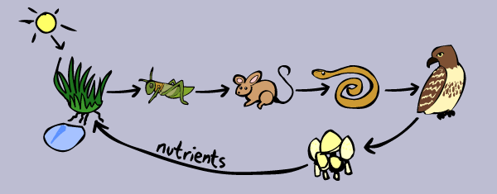
  - Snake
  - Mushrooms
  - Mouse
  - Grasshopper

- A food web is made up of
  - Only tertiary consumers
  - Only autotrophs
  - Food chains
  - Only one type of organism

- List the two types of aquatic ecosystems.

- What is the first level of a food web/chain?
  - Primary consumer
  - Secondary consumer
  - Predator
  - Autotroph

- An example of a predator is
  - Snake
  - Iguana
  - Orca whale
  - Both a and c

- The sparrow in the powerpoint is an example of what kind of organism?
  - Herbivore
  - Carnivore
  - Omnivore
  - Producer

- An omnivore eats both _______________ and _________________.
- A bobcat is a _________________ while a snowshoe hare is the bobcat’s ____________.

- As the prey population _____________, the predator population _______________ until there are too many predators, and the prey population ______________. (increases or decreases)

- A __________ is an organism that grows, feeds, and is sheltered on or in a different organism while contributing nothing to the survival of that organism.
  - Host
  - Consumer
  - Transfer host
  - Parasite

- In a host-parasite relationship, which organism is the beneficiary of the relationship?
  - Host
  - Parasite

- A habitat does NOT include which of the following four resources:
  - Food
  - Light
  - Space
  - Water

- What happens as a result of scarcity of resources?
  - Drought
  - Overabundance
  - Extinction
  - Competition

