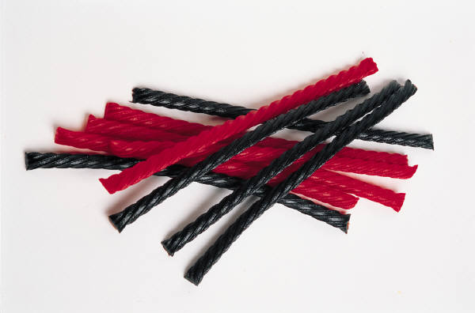
Equivalent Fraction Licorice

Look at your large red pieces of licorice. Notice that if you put two of them together, it is as long as the whole piece of licorice. Can you guess what equivalent fractions this represents?

1 = 2
2
One whole piece = Two ½ pieces or

How many large brown pieces are in a whole piece?
What equivalent fractions does this represent?

How many rainbow pieces are in a whole piece?
What equivalent fractions does this represent?

How many small black pieces are in a whole piece?
What equivalent fractions does this represent?

How many small red pieces are in a whole piece?
What equivalent fractions does this represent?

How many small brown pieces are in a whole piece?
What equivalent fractions does this represent?

Notice that if you put 2 rainbow pieces together, you get one large red piece.
What equivalent fractions does this represent?
2 = 1
4 2
Two ¼ pieces = One ½ piece or

How many small red pieces are in a large red piece?

What equivalent fractions does this represent?

How many small red pieces are in a rainbow piece?
What equivalent fractions does this represent?

How many small black pieces are in a large brown piece?
What equivalent fractions does this represent?

How many small brown pieces are in a large brown piece?
What equivalent fractions does this represent?

Try to see how many small brown pieces make up one small black piece. Does it fit evenly?

Now try to see how many small brown pieces make up two small black pieces.

What equivalent fractions does this represent?

How many small brown pieces make up two large brown pieces?
What equivalent fractions does this represent?

How many rainbow pieces make up three large red pieces?
What equivalent fractions does this represent?
What kind of fractions are these?

How many small red pieces make up 3 rainbow pieces?
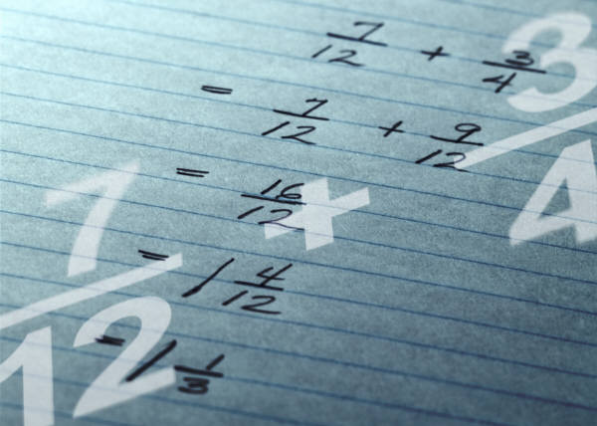
What equivalent fractions does this represent?

