Ethylene Experiment
We know that the plant hormone ethylene is released in gas form and can affect nearby plants.
What we want to know is, “How does this happen?”
Materials needed
4, 1gallon Ziploc bags
1 paper plate
1 permanent marker
3 ripe bananas
2 bruised/browning bananas
3 ripe apples
2 bruised/soft spot apples
camera (optional)
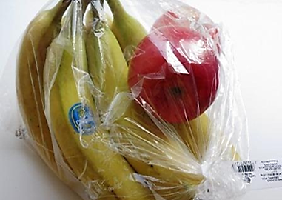
You will want to purchase ripe fruit that is ready to eat and will not go bad in the next 24 hours. The bruised fruit should not be decomposing or already rotten; they should be just entering this phase

Preparing the experiment
- Place 1 ripe banana and 1 ripe apple on the paper plate. Leave the plate of fruit on a surface where it will not be in direct sunlight or excessive heat. A table top at room temperature will be fine. Label the plate with a permanent marker, “(group #) _____ A”.
- In the first Ziploc bag, insert 1 ripe banana and 1 ripe apple. Release some air and zip the bag shut. Label this bag with a permanent marker, “(group #) ____ B”. Place this bag where it will not be in direct sunlight or heat.
- In the second Ziploc bag, insert 1 ripe banana and 1 bruised apple. Release some air and zip the bag shut. Label this bag with a permanent marker, “(group #) ____ C”. Place this bag where it will not be in direct sunlight or heat.
- In the third Ziploc bag, insert 1 bruised banana and 1 ripe apple. Release some air and zip the bag shut. Label this bag with a permanent marker, “(group #) ____ D”. Place this bag where it will not be in direct sunlight or heat.
- In the fourth and last Ziploc bag, insert 1 bruised banana and 1 bruised apple. Release some air and zip the bag shut. Label this bag with a permanent marker, “(group #) ____ E”. Place this bag where it will not be in direct sunlight or heat.

The experiment
After preparing the fruit for this experiment, the last step is to observe and make conclusions about ethylene. Let the fruit sets sit for 3-5 days. Observe the fruit every 24 hours and take notes on how each set changes. If you choose, take a picture each day and compare the pictures after completing the experiment. On the final day of this experiment, determine which fruit set was affected by ethylene the most and discuss with your group why. From this experiment, we can learn about two things, “Does trapped ethylene (in a Ziploc bag) increase the effects of senescence?” and “Do bruised fruit give off more ethylene than ripe fruit?”

Questions
Controls
Variables
Hypothesis

Observations:
Each day, record your observations for each of the fruit sets.

 | Set A | Set B | Set C | Set D | Set E
Day 1
Day 2
Day 3
Day 4
Day 5
What did we learn?

