Forensic Math Worksheet

- Using the graph below, how long (in hours) was the elevator operator dead before they found him? Normal body temperature is 37 ºC (or 98.6ºF). To convert between ºC and ºF, use the equation:
F = C x 9/5 + 32

2.) How many seconds is this?

3.) Based on the time when they found him, at what time did he die?

4.) The equation for the graph is also shown on the graph. Solve for x using variables.

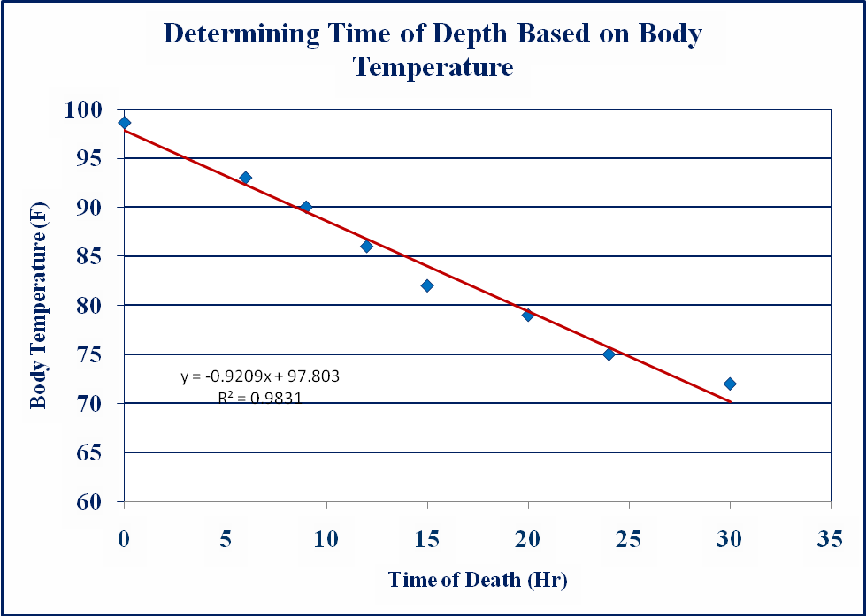

5.) Based on the equation, if someone was dead for 15 hours, what would body temperature be?

6.) Based on your findings, who do you think is the murderer? Why?

7.) Do you think the data you gathered for your scatter plot is an accurate way to find the suspects height? What evidence is there to support your claim?

8.) Based on your understanding of a linear relationship, or best-fit line, what can you conclude about the relationship in the graph below? Would you have a linear correlation? Would the correlation value be positive, negative, or near 0? How can you tell?

